ANIMAL RIGHTS IN ISLAMIC, CHRISTIAN AND JEWISH SHARIA (LAW)
حقوق الحيوان في الشريعة الإسلامية والنصرانية واليهودية باللغة الإنجليزية

Written by
Ahmad Al-Amir

Translated by
European Islamic Research Center (EIRC)
المركز الأوروبي للدراسات الإسلامية

WWW.ISLAMLAND.COM
INDEX
Introduction
Chapter one
Islamic perspective on animals
Chapter two
Animal rights in Islam
Chapter three
Violation of animal rights in other societies
Chapter four
Animals rights in Christianity and Judaism
Chapter five
Slaughtering in Islamic Sharia, Christian sharia and Jewish sharia (law)
Chapter six
Animal rights at slaughter
Chapter seven
The right not be slaughtered

Introduction
In the Name of Allah, Ar-Rahmân (the Most Gracious), Ar-Rahîm (the Most Merciful)
All praise belongs to Allah, the Lord of all the worlds, Who sent Muhammad (ﷺ) as a Messenger of glad tidings and as a warner, as well as to call the whole world to the Path of Allah, and as a bright light. May Allah’s Blessings and peace be upon him, his family and his Companions.
Among the greatness of the merciful Islamic law (Sharia) is that it preceded for about 1400 years all the international organizations that concerned with animal rights. It established for the animal such rights that the entire world had only recently noticed in the 20th century. God willing, we will list some of them in this book.
If this is the case with the animal, showing it mercy and kindness, and establishing many rights for it, how is the case then with the human being, whether Muslim or non-Muslim? The Islamic law is a law of mercy and rights and it gives importance in giving everyone his rights regardless of his lineage, race, color or religion.
However, the greatest right recognized by the Islamic law and it calls mankind to it, is the right of Allah the Almighty; the Creator of mankind and animals. If the human rights and animal rights organizations were truly honest in the search for rights and calling people to it, they would have been interested first in the right of God Almighty, the Creator of mankind and animals.
The right of Allah is made clear in what was reported by Mu‘âdh bin Jâbal (may Allah be pleased with him) that the Prophet ﷺ asked him: “Do you know the right of Allah upon His servants?” I said: “Allah and His Messenger know better” He said: “The right of Allah upon His servants is that they should worship Him alone and should not associate partners with Him”.
(Sahîh Al-Bukhâri)

Author.,

Chapter One
Islamic perspective on animals
Islam maintains a moderate position in its view of animals. It did not exaggerate in raising its status, as did some other religions that raised the status of some animals to the status of a god, such as those who worship cows and mice in India, and neither did it degrade the status of animals nor strip its rights, as did some countries and cultures that allowed the violation of animal rights.
Rather, Islam recognized many rights to animals and warned severely of any infringement to those rights. Islam explained the wisdom and objectives of their creation in this universe, and that in their creation is a great blessing for us, because of what we benefit from them. Allah; the Almighty says explaining His bounties upon us:
{ He has created the heavens and the earth with truth. High is He, Exalted above all that they associate as partners with Him. (3) He has created man from Nutfah (mixed drops of male and female sexual discharge), then behold, this same (man) becomes an open opponent. (4) And the cattle, He has created them for you; in them there is warmth (warm clothing), and numerous benefits, and of them you eat. (5) And wherein is beauty for you, when you bring them home in the evening, and as you lead them forth to pasture in the morning. (6) And they carry your loads to a land that you could not reach except with great trouble to yourselves. Truly, your Lord is full of Kindness, Most Merciful. (7) And (He has created) horses, mules and donkeys, for you to ride and as an adornment. And He creates (other) things of which you have no knowledge. (8) And upon Allâh is the responsibility to explain the Straight Path. But there are ways that turn aside (such as Paganism, Judaism and Christianity). And had He willed, He would have guided you all (mankind). (9) He it is Who sends down water (rain) from the sky; from it you drink and from it (grows) the vegetation on which you send your cattle to pasture. (10) With it He causes to grow for you the crops, the olives, the date-palms, the grapes, and every kind of fruit. Verily! In this is indeed an evident proof and a manifest sign for people who give thought. (11) And He has subjected to you the night and the day, and the sun and the moon; and the stars are subjected by His Command. Surely, in this are proofs for people who understand. (12) And whatsoever He has created for you on the earth of varying colours [and qualities from vegetation and fruits (botanical life) and from animals (zoological life)] Verily! In this is a sign for people who remember. (13) And He it is Who has subjected the sea (to you), that you eat thereof fresh tender meat (i.e. fish), and that you bring forth out of it ornaments to wear. And you see the ships ploughing through it, that you may seek (thus) of His Bounty (by transporting the goods from place to place) and that you may be grateful. (14) And He has affixed into the earth mountains standing firm, lest it should shake with you; and rivers and roads, that you may guide yourselves. (15) And landmarks (signposts during the day) and by the stars (during the night), they (mankind) guide themselves. (16) Is then He, Who creates as one who creates not? Will you not then remember? (17) And if you would count the favours of Allâh, never could you be able to count them. Truly! Allâh is Ghafûr (Oft-Forgiving), Rahîm (Most Merciful). (18) And Allâh knows what you conceal and what you reveal. (19) Those whom they (the polytheists) invoke besides Allâh have not created anything, but are themselves created. (20) (They are) dead, not alive; and they know not when they will be raised up. (21) Your God is One God (Allâh, none has the right to be worshipped but He). But for those who believe not in the Hereafter, their hearts deny (the faith in the Oneness of Allâh), and they are proud. (22) }
(An-Nahl 16:3-22)
One of the aspects of Islam’s honoring of animals is that the names of some chapters of the Glorious Qur’ân are {The chapter of the Cow, The Cattle, The Bee, The Ant, The Spider, The Elephant).
One of the illustrious companions (of the Prophet Muhammad ﷺ) used to be nicknamed as: “Abu Huraira” (the one who has the cat). The Prophet ﷺ called him several times with this nickname saying: “Aba Hir” (Oh, the owner of the cat).
CHAPTER TWO
ANIMAL RIGHTS IN ISLAM
1- The right to walk in the paths:
Imam Abu Isehâq Ash-Shirâzi was once walking on a road in the company of some of his disciples, and when they saw a dog, a disciple of Imam Abu Isehâq scared it away but the Imam prevented him saying: “Don't you know that the road is shared between me and it?!”

2- The right to talk to it politely:
‘Imrân bin Al-Husâin (may Allah be pleased with him) reported that: “While the Prophet (ﷺ) was on a journey, there was a woman of the Ansâr riding a camel, and she felt bored from the camel (because the camel was slow in walking), where upon she cursed it. The Prophet (ﷺ) heard this and said, “Take off all what is on its back and release it (as punishment for the woman who cursed it), for it has been cursed (thus because the woman cursed it).”
(Sahîh Muslim)

3- The right of not being sexually harassed:
Ibn ‘Abbâs (may Allah be pleased with him) reported that the Prophet (ﷺ) said: “May the curse of Allah be upon whoever has sexual intercourse with an animal”.
(Al-Hâkim)

It is worth mentioning here that the “Independent” and “Dailymail” newspapers published on the 9th June 2016 one article that stating that the Supreme Court of Canada has ruled that there is nothing wrong with sexual exploitation of pets by their owners as long as there is no penetration.

4- The right of caring for it and protecting it from getting lost:
‘Ali bin Abi Tâlib (may Allah be pleased with him) said: “I saw ‘Ûmar ibn Al-Khattâb (may Allah be pleased with him) jogging, I said: “Oh leader of the believers, where are you going?” He said: “A camel from the camels of charity got strayed and run away and I am searching for it” I said: “(With such act you are doing now) You have made the responsibility (of governing the Muslim nation) to become heavier on any Caliph who will come after you (after they will hear how carful you are for the Muslims money and the money of the charity)” He said: “Oh father of Al-Hâsan, do not blame me, for by the One (i.e. Allah) Who sent Muhammad with the Prophethood, were a young goat to be taken (stolen or encounter any harm) on bank of the Euphrates river, ‘Ûmar would be held accountable because of it on the Day of Resurrection”
(Ibn Al-Jâwzi: Manâqib pp:161)

Dawud bin ‘Ali said: “‘Ûmar may Allah be pleased with him said: “If a lost sheep under my care were to die on the banks of the Euphrates, I would expect Allah the Exalted to question me about it on the Day of Resurrection.”
(Abu Nu‘âim: Al-Hîlya 1/53)

5- The right of not be burdened with works beyond its capability:
Abu ‘Uthmân Athâqafi narrated: “(The Caliph) ‘Ûmar bin ‘Abd Al-‘Azîz had a worker who was working with a mule, everyday the worker was bringing to him one dirham as gain from the work. He came one day with one and half dirham, about which ‘Ûmar asked: “What happened today (i.e. from where you got this extra half dirham)?” He said: “The market was good today and there were a lot business and work.” He said: “So you have exhausted the mule today, hence, make it rest for three days.”
(reported by Abu Nu‘âim in Hîlyatu As-Sâlihîn)

It is reported in the Book “Ihyâ’ Ulûm Ad-Deen” that Abu Ad-Dardâ’ (may Allah be pleased with him) said while he was dying to a camel of his: “Oh you camel, do not complain from me to your Lord (Allah in the Day of Judgment). Indeed, I have never burdened you with any work beyond your capability”

The Caliph ‘Ûmar bin Abd Al-‘Azîz (may Allah have mercy on him) wrote to the governor of Egypt: “It has reached me that in Egypt are camels used for transporting goods, and that they are been loaded with thousand (1000) pound of weight, hence, when this my letter reached you, I don’t want any camel to be loaded with more than six hundred (600) pound”
(Sîratu ‘Ûmar bin Abd Al-‘Azîz according to the report of Imam Mâlik bin Ânas and his companions) by Abu Muhâmmad Al-Mâsri pp:141.

6- The right of not taken as a chair:
Mu‘âdh bin Ânas Al-Jûhani (may Allah be pleased with him) said: “Once the Messenger of Allah (ﷺ) passed by a people who were sitting on their animals, he said: “Ride them while they are in a good health and leave them in a good health, and do not take them as chairs for your conversations on the ways and markets, for might a riding animal be better than its rider, and glorifying Allah more than him”
(Âhmad, and authenticated by Al-Albâni in Sahîha 21)

The Prophet (ﷺ) said: “Don’t take the backs of your animals as pulpits, for Allah has made them subject to you only to convey you to (far) towns (and places) which you could not have reached without great hardship, and He made the ground for you (to fulfil your needs), so conduct your business on it.”
(Hadîth Sahîh, reported by Abu Dawud)

7- The right of not being psychologically tortured:
Abd Allah bin Mas‘ûd (may Allah be pleased with him) said: "Once we were on a journey with the Prophet (ﷺ), and he went to answer the call of nature. During his absence, we saw a bird with its two young ones, and we took its two young ones. The mother bird was circling above us in the air, beating its wings in grief. In the meantime, the Prophet (ﷺ) came back and said: ‘Who grieved this for its young ones? Return its young ones to it.’ He also saw an ant village that we had burnt. He asked: ‘Who has burnt this?’ We replied: ‘We.’ He said: ‘It does not befit anybody to punish with the fire except the Lord of the fire.’.”
(Hadîth Sahîh, reported by Al-Bukhâri in “Al-Âdab Al-Mûfrad”)

8- The right of not being physically tortured:
Jâbir bin Abd Allah (may Allah be pleased with him) narrated that the Prophet (ﷺ) passed by a donkey which has been branded on its face and he said: “May Allah curse who branded it.”
(Sahîh Ibn Hibbân)

Jâbir bin Abd Allah (may Allah be pleased with him) said: “The Prophet (ﷺ) prohibited beating the animal on the face, and branding on the face.”
(Sahîh Muslim)

Ibn ‘Ûmar (may Allah be pleased with him) said: “The Prophet (ﷺ) cursed the one who mutilate an animal.”
(Sahîh Al-Bukhâri)

The Prophet said: “The merciful people are shown mercy by Ar-Rahmân (the Most Merciful, Allah), therefore, show mercy to those who are on earth and the One Who is in the heaven shall show mercy to you.”
(Sahîh, reported by Abu Dawud)

9- The right of not being used as a shooting target:
Sa‘eed ibn Al-Jubair (may Allah be pleased with him) said: “Ibn ‘Ûmar happened to pass by some young men of Quraysh tribe, who had tied a bird and were shooting arrows at it. They had agreed with the owner of the bird that each arrow that they miss, it will get into his possession. As soon as they saw Ibn ‘Ûmar, they scattered away. Thereupon, Ibn ‘Ûmar said: “Who has done this? May Allah curse who did this. Verily, Allah’s Messenger (ﷺ) has invoked curse upon whoever takes anything that has a soul as a shooting target.”
(Sahîh Muslim)

10- The right of not being killed without a reason:
Abd Allah ibn ‘Amr reported: The Messenger of Allah (ﷺ) said: "‘There is no person who kills a sparrow or anything larger for no just reason, but Allah, the Almighty and Sublime, will bring him to account regarding this.’ It was said: ‘O Messenger of Allah, what does ‘just reason’ mean?’ He said: ‘That he slaughters it and eat it, and not just cut off its head and throw it away (i.e. he killed it for playing).’."
(An-Nasâ’i & Al-Hâkim)

11- The right of leniency with it, giving it food and water:
The Messenger of Allah (ﷺ) said: “‘Once a man suffered from thirst while he was walking on a journey. He found a well, and went down into it and drank water from it. On coming out of it, he saw a dog panting and licking the ground because of excessive thirst, so he said, ‘This dog is suffering from the same state of thirst as I did.’ He climbed down into the well, filled his shoe with water, and caught it in his mouth as he climbed up. Then he gave the dog to drink. Allah appreciated his (good) deed, so He forgave him.’ It was said, ‘O Messenger of Allah! Is there a reward for us in serving (the) animals?!’ The Prophet (ﷺ) said: ‘Yes, there is a reward for serving any living being.”
(Sahîh Al-Bukhâri)

The Messenger of Allah (ﷺ) said: "A woman entered the
(Hell) Fire because of a cat which she had tied, neither giving it food nor setting it free to eat from the vermin of the earth, until it died."
(Sahîh Al-Bukhâri)

Sahl bin Al-Handhalîa reported: “Once the Prophet (ﷺ) passed by a camel whose belly was sticking to its back (because of hunger), whereupon he said: ‘Fear Allah in regard to these animals who cannot talk (to complain about their hunger or thirst). Ride them while they are fit, and eat them when they are fit.’.”
(Abu Dawud)

Abd Allah bin Jâ‘far bin Abi Tâlib reported: “Once the Prophet (ﷺ) entered a garden of a man from the Ansâr (the inhabitants of Medina), and he saw there a camel. When the camel saw the Prophet (ﷺ), it started weeping tenderly producing yearning sound and its eyes flowed. The Prophet (ﷺ) came to it and wiped its head, so it calmed down and stopped weeping. The Prophet (ﷺ) then said: ‘Who is the owner of this camel? Whose Camel is this?’ A young man from the Ansâr came and said: ‘This is mine, O Messenger of Allah.’ The Prophet (ﷺ) said: ‘Do you not fear Allah regarding this animal that Allah has put in your possession? Verily, it has complained to me that you keep it hungry and load it heavily which fatigues it.’.”
(Abu Dawud)

The Messenger of Allah (ﷺ) said: "No Muslim plants a tree or sows seeds, and then a bird, a human or an animal eats from it, but is regarded as a charity for him."
(Sahîh Al-Bukhâri)

It’s been reported that ‘Udâi bin Hâtim was cutting the bread into small pieces and giving it to the ants, saying: “They are our neighbours and have right over us.”
(Reported by An-Nâwawi in Tahdhîb Al-Asmâ’)

12- The right of loyalty towards it:
‘Umrân bin Al-Hasîn reported: “A woman from the Ansâr (the inhabitants of Medina) and Al-‘Adbâ’ (the she-camel of the Prophet (ﷺ)) have been captivated (when the polytheists raided the pasturing animals of Medina). The two hands of the woman had been tied with ropes. The people (who captured the woman) used to leave their camels in front of their houses for rest at night. One night the woman could to untie her hands from the ropes and hasted towards the camels. Whenever she got near any camel, the camel started to make noise, so she left it until she got near Al-‘Adbâ’. It did not make any noise; it was docile and experienced. She rode upon its back and drove it away and she went off. When they (the polytheists) learned about it, they chased her, but they couldn’t catch her. The woman vowed to Allah, that if He saved her on this camel, she would sacrifice this camel (giving its meat to the poor people). As she reached Medina, the people saw her and they said: ‘Here is Al-‘Adbâ’, the she-camel of the Prophet (ﷺ).’ Then the woman told them that she had vowed that if Allah saved her on its back, she would sacrifice it. The people went to the Prophet (ﷺ) and informed him of what happened. Whereupon the Prophet (ﷺ) said: ‘Subhân Allah (Glory be to Allah)!! How bad is such a reward she wants to reward it!! She vowed to Allah that if He saved her on its back, she would sacrifice it!! A vow to do an act of disobedience (towards Allah), must not be fulfilled, nor a vow to do something over which one has no right or authority!!”
(Sahîh Muslim)

Al-Mîswar bin Makhrama reported: “Al-Qaswâ’ (the she-camel of the Prophet (ﷺ)) knelt down while the Prophet was on its back. The people said to it: ‘Go on, go on.’ But it didn’t respond to them, so they said twice: ‘Al-Qaswâ’ has become stubborn and refused to walk! (such phrase is considered as insulting towards the she-camel, like if they say that it become disobedient or has a defect)’ But the Prophet (ﷺ) answered them (defending the fame of the she-camel): ‘Al-Qaswâ’ has not become stubborn, and that is not a characteristic of hers; rather, she has been restrained by He Who restrained the elephant (the elephant of Abraha Al-Ashram who came to destroy the Ka‘ba, and Allah made it to kneel down and to not move).”
(Sahîh Al-Bukhâri)

CHAPTER THREE
VIOLATION OF ANIMAL RIGHTS IN OTHER SOCIETIES
1- Male chick culling:
Every year 200 million male chicks are killed at a day old, after coming out of the egg. The reason for this is that in capitalist countries the male chicks are considered as an economic burden without any anticipated benefit from them. Because males cannot produce eggs, and they are not used for meat because they do not grow fast enough, so they are considered as useless in egg industry and meat industry, due to this they are exterminated in an inhumane manner such as the following:
1- Maceration: The chicks are minced alive in an industrial macerator.
2- Suffocation: The chicks are placed in large numbers alive in plastic bag that will be closed tight until they die from suffocation.
3- Gases or gas mixtures: Carbon dioxide is used to induce unconsciousness and then death.
4- Cervical dislocation: By breaking the chick's neck.
5- Electrocution: An electric current is passed through the chick's body until it is dead.

2- Eating animals whilst they are alive (Served alive):
In Japan eating sea animals whilst they are a live is known as “Ikizukuri” which means “prepared alive”, where a fish is sliced without killing it, then it is served to customers whilst its heart still beats and its mouth still opens and closes. In China, “Yin Yang fish” dish is considered as the most popular fish dishes, where a fish is a deep-fried whilst it is still alive, without frying its head, then it is served alive to customers whilst its head still moves. In Denmark, “Noma” restaurant serves its customers with dishes of food with a live black ant on them as starters. In Japan, a frog’s belly is open and cleaned of its intestines whilst it is still alive, it is then cut into pieces alive and served to customers whilst the head is a live and shaking. In the year 2012 in Florida, USA, eating competition was held for eating live crickets, immediately after the competition, the winner died out of suffocation (Asphyxia).

3- Skinning live animals for fur:
There is a video in circulation in the social media that exposes one of the fur farms in China, whereby this farm skinning the animals whilst they are alive for their fur.

4- Docking the tails and Cropping the ears of some breeds of dogs:
Most of the owners of some dog breeds such as Dobermann, Pit Bull and Boxer, are docking their dogs’ tails and cropping their ears whilst they are puppies. Tail docking occurs in one of two ways:
1- Constricting the blood supply to the tail with a rubber ligature for a few days until the tail falls off.
2- Cutting the tail with surgical scissors or a scalpel.
Tail docking is done mostly for cosmetic purposes, and this makes animal rights activists call for the criminalization of such terrible practice.
At the international level, 25 European countries that have ratified the European Convention for the Protection of Pet Animals, have banned docking and cropping because they consider the practices unnecessary, painful, cruel or mutilation. However, some countries that ratified the convention made exceptions for tail docking, and those countries are: (France, Germany, Luxembourg, Denmark, Czech Republic, Portugal).

5- Devocalization (Debarking):
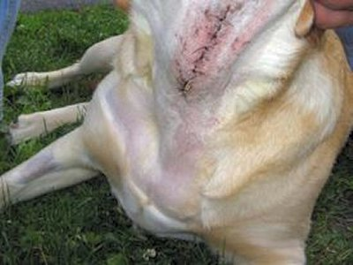
Devocalization is a surgical procedure performed on dogs and cats, where tissue is removed from the animal’s vocal cords to permanently reduce the volume of its vocalizations, to prevent it from disturbing its colleagues or neighbours. Such a practice is banned from all the European countries that have ratified the European Convention for the Protection of Pet Animals. However, in United States, this practice is legal in all the states, and it is banned only in Massachusetts by state law in 2010 and in Warwick, Rhode Island, by city ordinance in 2011. Legislation to ban devocalization of dogs and cats in New York State is underway.

6- Declawing (Onychectomy):

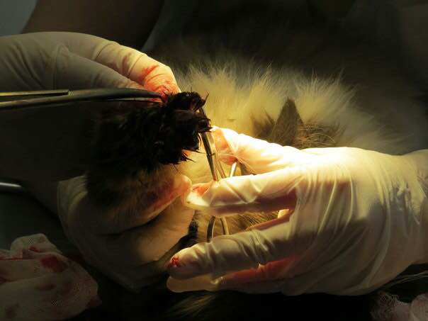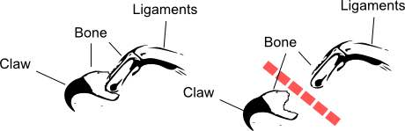
Declawing is an operation to remove an animal's claws surgically by means of the amputation of all or part of the distal phalanges, or end bones, of the animal's toes. Because the claw develops from germinal tissue within the third phalanx, amputation of the bone is necessary to fully remove the claw. The reason behind declawing is to prevent damage to household possessions by scratching.
In the United States of America, statistics indicate that 25% of domestic cats have been declawed, due to either the desire of cats’ owners, or some privately-owned apartment buildings in the U.S. ban cats unless they have been declawed.
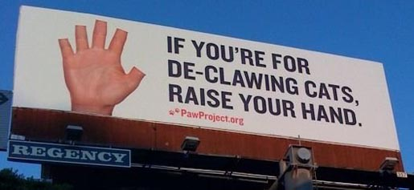

7- Zoosadism:
Zoosadism is pleasure derived from cruelty to animals, either by burning, booting, squashing, or killing them. Zoosadism is part of the Macdonald triad, a set of three behaviours that are considered a precursor to sociopathic behaviour, those three behaviours are: 1. Arson or fire-setting, 2. Cruelty to animals, 3. Enuresis.
Zoosadism towards insects is also exhibited by some. The classic example of this is the person who amuses himself by pulling off a fly's wings or burning it. The Roman historian Suetonius, in his The Twelve Caesars, claimed that the Emperor Domitian amused himself by catching flies and impaling them with needles.

8- Spain and Bullfighting (Blood sport):
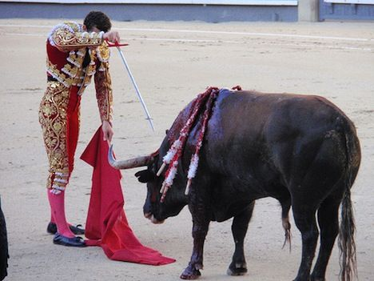
Bullfighting is also known as Blood sport, where a large number of bulls be released in the streets that lead to the bullring. The bulls run behind the people trying to gore them. Many people get injured putting their life in danger. After the bulls reach the bullring, only one bull will be released inside to be confronted by one toreador. The toreador tries to plant sharp arrows in the body of the bull, one arrow after the other, enjoying the sight of blood dripping from the body of the bull and the excruciating pains that he causes them to the bull. After the toreador finishes planting all his arrows and the bull becomes exhausted and covered with blood, the toreador withdraws his sword to stab and kill the bull without any mercy or compassion. After the killing of the bull, four mules enter the bullring to pull the bull outside where the butcher is waiting, who in turn cuts its flesh and directs it for sale.

9- Animal fighting competitions:
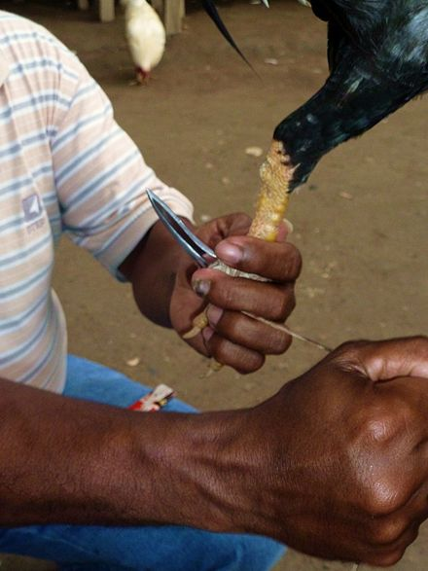
They are betting competitions, such as cockfighting, dog fighting, insect fighting and ram fighting. They are the most brutal combat competitions where one animal fights another fiercely to death. These competitions have been expanded as an investment field in some countries to make profits from them, for example, some farms who are specialized in breeding fighting roosters, injecting the roosters with banned steroids in order to strength their bodies abnormally for competitions. Worse than this, is that they remove the rear natural spur of the rooster and tie in its place a metal spur (called gaffs) or knives, in order to make as much as possible damages to the body of the opposite rooster in the competition.

10- Whaling in Denmark:
Whaling is the activity of hunting whales, each summer around 800 whales and dolphins are slaughtered in Faroe Islands, Denmark. Animal welfare organizations criticize the slaughter as being cruel and unnecessary, and due to this, the Faroese people try to improve the slaughtering methods in order to make them more humane.
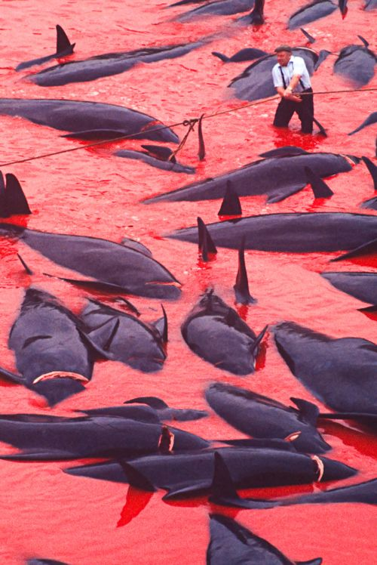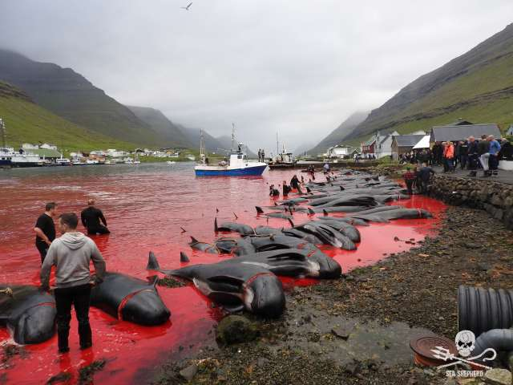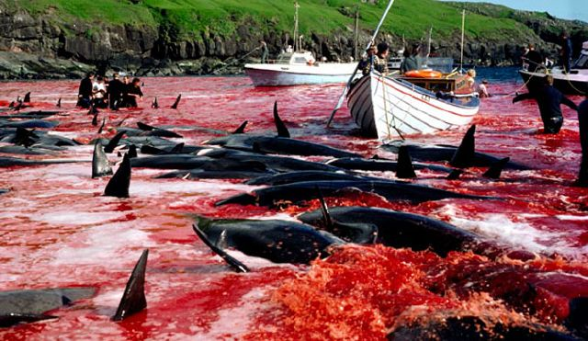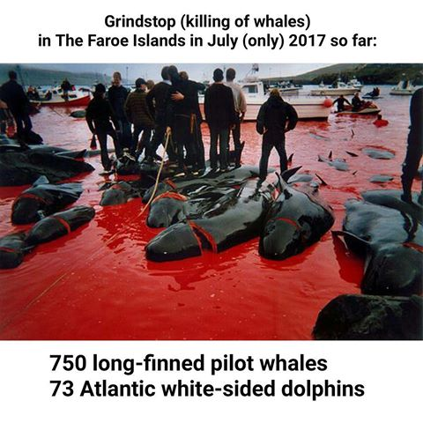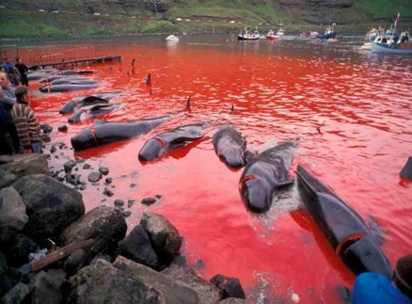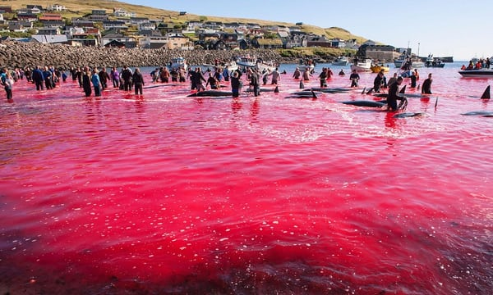
CHAPTER FOUR
ANIMALS RIGHTS IN CHRISTIANITY AND JUDAISM
1 Samuel chapter 15 verse 3:
“Now go and smite Amalekites, and utterly destroy all that they have, and spare them not; but slay both man and woman, infant and suckling, ox and sheep, camel and ass.”
Joshua chapter 6 verse 16-21:
“¹⁶ And it came to pass at the seventh time, when the priests blew with the trumpets, Joshua said unto the people, Shout; for the Lord hath given you the city. ¹⁷ And the city shall be accursed, even it, and all that are therein, to the Lord: only Rahab the harlot shall live, she and all that are with her in the house, because she hid the messengers that we sent. ¹⁸ And ye, in any wise keep yourselves from the accursed thing, lest ye make yourselves accursed, when ye take of the accursed thing, and make the camp of Israel a curse, and trouble it. ¹⁹ But all the silver, and gold, and vessels of brass and iron, are consecrated unto the Lord: they shall come into the treasury of the Lord. ²⁰ So the people shouted when the priests blew with the trumpets: and it came to pass, when the people heard the sound of the trumpet, and the people shouted with a great shout, that the wall fell down flat, so that the people went up into the city, every man straight before him, and they took the city. ²¹ And they utterly destroyed all that was in the city, both man and woman, young and old, and ox, and sheep, and ass, with the edge of the sword.”
Deuteronomy chapter 21 verse 1-4:
“¹ If one be found slain in the land which the Lord thy God giveth thee to possess it, lying in the field, and it be not known who hath slain him: ² Then thy elders and thy judges shall come forth, and they shall measure unto the cities which are round about him that is slain: ³ And it shall be, that the city which is next unto the slain man, even the elders of that city shall take an heifer, which hath not been wrought with, and which hath not drawn in the yoke; ⁴ And the elders of that city shall bring down the heifer unto a rough valley, which is neither eared nor sown, and shall strike off the heifer's neck there in the valley.”
Exodus chapter 13 verse 11:
“¹¹ And it shall be when the Lord shall bring thee into the land of the Canaanites, as he sware unto thee and to thy fathers, and shall give it thee, ¹² That thou shalt set apart unto the Lord all that openeth the matrix, and every firstling that cometh of a beast which thou hast; the males shall be the Lord's. ¹³ And every firstling of an ass thou shalt redeem with a lamb; and if thou wilt not redeem it, then thou shalt break his neck: and all the firstborn of man among thy children shalt thou redeem.”
Mathew chapter 8 verse 28:
“²⁸ And when he was come to the other side into the country of the Gergesenes, there met him two possessed with devils, coming out of the tombs, exceeding fierce, so that no man might pass by that way. ²⁹ And, behold, they cried out, saying, What have we to do with thee, Jesus? art thou come hither to torment us before the time? ³⁰ And there was a good way off from them a herd of many swine feeding. ³¹ So the devils besought him, saying, If thou cast us out, suffer us to go away into the herd of swine. ³² And he said unto them, Go. And when they were come out, they went into the herd of swine: and, behold, the whole herd of swine ran violently down a steep place into the sea, and perished in the water.”
CHAPTER FIVE
SLAUGHTERING IN ISLAMI, CHRISTIAN AND JEWISH SHARIA (LAW)
As we mentioned in the beginning of this book that Islam stands a moderate position with regards to animals. It neither sanctify animals and raise them to the status of a god nor detract from their value and status. It did not exaggerate in not approaching animals like what Vegetarians who don't eat meat do, nor it exaggerate in eating meat, rather, Islam stands a moderate position, such a position that explains to us that animals have been created by Allah for many reasons, objectives and benefits. One of those benefits is to use their meat as food for humans, and this necessitates killing them for the direct benefit of eating their meat. However, Allah did not leave us to invent and experiment ways and means to kill animals, as this would leave the door open to torture the animals! Rather, Allah; the Exalted, has revealed to us a Sharia (law) which shows us the ways and the etiquette of killing animals for direct benefit.

Definition of slaughter:
Slaughter is the passing of a very sharp knife swiftly on the throat of an animal to cut its two carotid arteries whilst it is alive. Cutting the trachea (windpipe) and the oesophagus (food pipe), is more complete and better for the slaughter process. The butcher should not cut beyond that, so he should not cut the spinal cord or amputate the head except after the complete death of the animal.

Criticism against Islamic slaughter:
We often hear harsh criticism from some non-Muslims for the method of Islamic slaughter, but to refute this criticism should be mentioned the following points:
1- Usage of the term “Islamic slaughter”:
This term “Islamic slaughter” is often used by some non-Muslims to criticize Islam in general, trying to create a false picture and misconception that Islam is the only religion that invented slaughter, while other religions, cultures and civilizations do not slaughter animals!
However, in reality, slaughter is the main method that been used from humans since thousands of years ago and till today. Thus, all the prophets, such as Adam, Noah, Abraham, Moses, Jesus, and Muhammad (peace and blessings of Allah be upon all of them) have slaughtered animals to eat their meat. They neither used electrocution (which was discovered lately), nor gas suffocation, nor strangling (hanging with a rope), nor breaking the neck, nor smashing the head with a stone etc.
Thus, whoever says that the “Islamic slaughter” is not a humane method, then he criticized not only Islam, but all divine religions, and all Messengers and prophets of Allah (peace be upon all of them).

2- Protecting human health:
Islam didn’t enact any law or rules except what is in the interest of human beings and protecting them from any serious diseases. Thus, slaughtering animals before eating their meat is the healthiest way for humans, as slaughter, as we mentioned before, is the passing of a very sharp knife swiftly on the throat of an animal to cut its two carotid arteries that deliver blood to the brain, and this method forces the heart continuously to push more blood towards the brain that is suffering from lack of blood supply.
This process makes the animal to get rid of all of its blood from the cut in its throat, and so his body is clean, almost free of blood.
As for the health benefit of having the animal free of blood, it is that blood is the swamp of germs and microbes, so when a tainted blood of an animal reaches to the human, it transfers to him as well all the germs and microbes that it carries within it.
Many non-Muslims who tried the meat that is slaughtered according to the Islamic way, have found a significant difference in the meat’s shape and cleanliness during its boiling and cooking. As the meat that is not slaughtered according to the Islamic way, has some of its blood has clotted between muscle membranes, and during boiling that meat, a lot of unclean foam comes out from the muscle membranes, and flows on the surface of the boiling water.
However, during boiling meat that were slaughtered according to the Islamic way, the water is almost clean and has the least of such foam.

3- Other methods to killing an animal other than the Islamic slaughter method are inhumane methods:
Such methods are of two kinds:
A) Stunning or dazing before slaughter:
Some non-Muslims criticize the Islamic slaughter method saying that the animal must be stunned or dazed before slaughter it! However, in fact, Islam did not generally prohibit “stunning” the animal before slaughter, as long as certain conditions have been taken into account: 1) Stunning should not lead to the death of the animal, as this makes the animal a dead meat with coagulated blood, 2) It should not cause some blood clotting even with slaughter, 3) It should have a practical benefit in not making the animal to feel the slaughter process and to not be just as an extra pain and suffering for the animal before the slaughter process.
But in fact, these conditions are not met in the stunning methods currently used in the West. These methods that have recently been invented and have nothing to do with stunning or dazing the animal before slaughter, rather, they double its pain and greatly harms humans. They cause the clotting of some blood in the body of the animal, so some bacteria and germs that exist in this blood reach to human through the consumption of this meat. Some of these methods are:
Electrical stunning:
Electrical stunning is done by sending an electric current through the brain of the animal before slaughter, to create a shock and abnormal alert to the brain cells, causing deformities of brain cells and creating a state of non-distinguishing. There are doubts about if the practitioners of these methods are fully aware about their defects and the problems resulting from them.
One of their defects is that the strength of the electric shock cannot be calculated in proportion to the strength and weakness of each individual animal, the electric shock on a weak animal may cause his immediate death, and thus it becomes a dead animal with clotted blood and its flesh becomes more dark and speckled. As for strong animal, the electric shock may neither cause its death nor its sufficient unconsciousness, rather, it may cause it complete paralysis while its full consciousness remains as it is! Therefore, the animal has been tortured first by the electric shock and then be subjected to slaughter!
Moreover, the electric shock has disrupted the heart movement and the blood flow, causing blood clotting in the veins, bleeding in the muscle tissues and the lack of natural muscle contractions that squeeze the blood and push it out of the body, which is the case in the Islamic slaughter method.
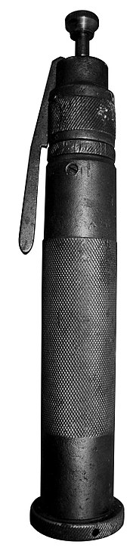
Stunning with the captive bolt pistol:
This pistol fires from its barrel an iron bolt that bounces back to the pistol barrel after hitting the animal's head. The pistol nozzle is placed on the animal's head between its eyes and ears, aiming at his brain. The bolt penetrates the skull of the animal, enters the cranium, and catastrophically damages the cerebrum and the cerebellum.
There is a video in circulation in the social media that exposes a secret investigation that has been filmed inside a slaughterhouse in the United States, where a horse was hit on his skull by the captive bolt pistol, but the movement of the horse after that strike showed that it was not fainted and was well aware of the pain. Then the horse was hung from his leg and then stabbed in the neck with a knife, but also the movement of the head of the horse after the stabbing with the knife revealed that it was still aware of all the pain and had not been fainted.
Therefore, stunning with the captive bolt pistol is considered to be a failed method, because it is very painful to the animal, and does not cause unconsciousness in the required sense. Rather, it multiplied the pain of the animal, moreover, the animal may die from that trauma and thus its blood gets clotted inside its body which becomes dangerous to the human consumption.
Worth mentioning, that in many cases, the butcher after hitting the animal with the captive bolt pistol, carry out an act called "Pithing" to destroy the animal’s central nervous system, where he inserts a needle or metal rod into the hole made by the pistol in the skull of the animal, and then he is moving that rod up and down constantly in order to cause the greatest possible destruction of the brain and upper spinal cord aiming to kill the animal.
At the beginning of the process, the animal muscles will contract violently, which means that it is not fainted by the effect of the captive bolt pistol, and then it becomes completely paralyzed due to brain damage and then dies.
Worth mentioning, that both the European Union and the United States have banned the importation of any animals killed by Pithing, because of the effective role of Pithing in the transmission of mad cow disease, because the wire or rod inserted into the animal's brain pushes parts of its infected brain cells into its body, therefore, the infection be transferred to the other parts of its body. In the United Kingdom, this operation (Pithing) has been criminalized since 2001 for fear of transmission of mad cow disease.
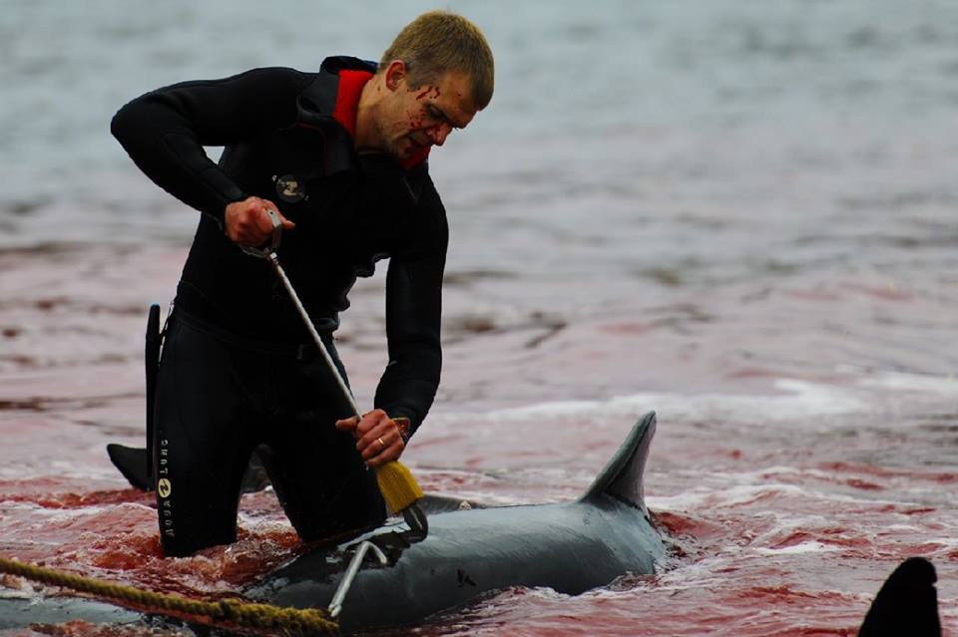
Pithing for a whale
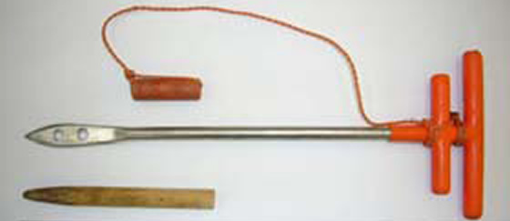
Pithing tool
Worth mentioning, that there is a type of captive bolt pistol that is non-penetrating. It does not cause a hole in the animal’s skull, but its strike is strong enough to break the skull without penetrate it. However, this pistol is less reliable at causing unconsciousness than penetrating types; however, it has undergone a resurgence of popularity due to concerns about mad cow disease.
Gas stunning:
The same video we have mentioned earlier, that has been filmed inside a slaughterhouse in the United States, exposed that how a big number of pigs were crammed into a narrow single cage, where they been exposed to a carbon dioxide. The video exposes how much pain they felt from the long period of suffocation, and how some of them have died from suffocation. Moreover, after they been exposed to this suffocation, they were hanged from their feet and stabbed in the neck, but the movement of some pigs made it clear that the gas was not sufficient to make them unconscious and that they regained their consciousness. Thus, they were first tortured with suffocation and then they been stabbed in the neck.

B) Killing without slaughter:
Islam has greatly protected animal rights. Thus, it legislated slaughter in order humans do not resort throughout history to invent ways to kill the animal, such ways that make the animal to suffer the most severe torture. However, humans have invented many ways to kill animals rather than slaughter, among which are:
Hanging:
Some animal rights activists have posted a video on the internet that exposes a pig been hanged in a farm in the United States. The video shows how pain the pig has suffered from hanging for minutes with a cord that was tied from up in an agricultural tractor until it died.
Burning:
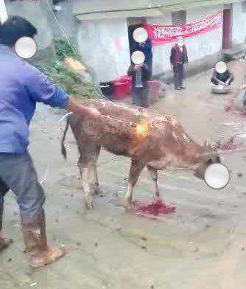
Another video that was filmed in China exposes a cow been burnt whilst it was alive and standing on its feet, where a man used a gas tube and kept the fire on the back of the cow for minutes and then on its face for minutes with the cow trying to escape from that torment to no avail.
Breaking the neck:
It is used more with poultry, where the neck of the hen is twisted many times until it breaks and the hen dies.
Crushing the head with a stone or hammer:
Where they hit the animal’s head with a stone or hammer to break its skull.
Suffocation:
Where the animals been exposed to a carbon dioxide for several minutes until they die from suffocation.
Electrocution:
Where a strong electric current be sent through the brain of the animal until it dies.
As we see, all of these methods cause the animal's blood not to go outside its body, which poses a threat to human health. Therefore, these methods are forbidden in Islam and it is not permissible to eat the meat of the animal that died through them. The prime condition for making animal’s meat lawful for eating in Islam is that its blood went out of its body.
The Prophet (ﷺ) said: “You may eat an animal if it was slaughtered by any means which causes the blood to gush out, and the Name of Allah has been mentioned immediately before the slaughter. Do not slaughter with bones or Abyssinians knives.”
(Sahîh Al-Bukhâri)

4. Scientifically, the slaughter is the least painful:
Scientific research has stated that slaughter is the least painful for the animal than any other method. The moment of pain is only the moment when the knife moves quickly on the animal's neck. It is a non-conscious moment of the animal, such as someone who injures himself during shaving or even gets injured in a quick accident. But for other methods, scientific research has shown that it is the most painful for animals, because of the defects each of them is characterized with.

5. Slaughter is better than cutting the animal's head:
In a video entitled "The most merciful way to kill a hen" a European woman working in the butcher's profession explained the faster and more merciful way -as she claimed- to kill the hens. She put a chicken in a something like a funnel that was hanged on the wall. The funnel allows the hen's body to pass from its wide higher aperture and it allows only the hen’s head to go out from its small lower aperture. Thus, the hen is in an upside-down position, with her legs up and her head down going out of the lower aperture. Then the woman turned the hen's neck slightly to the left and placed the knife on the side of the hen's neck, then with just one move, she cut the hen’s head.
However, in comparison with that method and the Islamic method of slaughter, Islamic slaughter is better, because the heartbeat in normal condition is 80 beats per minute, and this doesn’t increase except in state of danger, where it reaches to 180 beats per minute, after a nervous signal from the brain to the pituitary gland which is responsible for hormones in the body. But in the case of cutting the head completely, the brain will not send any signals to the pituitary gland to speed up the heartbeat and accelerate blood flow. Therefore, cutting the head completely is not the best and most healthy way to human.

Since the subject of this book is animal rights, it is enough speaking about Islamic way of slaughter and its benefits, in comparison with other methods of killing. Whoever seeks more information, he can resort to any of the scientific research on this regard that is published on the internet.
It is sufficient to conclude by the saying of the Prophet (ﷺ): "Whoever has been appointed a judge, has been slaughtered without a knife (i.e. with other mean than a knife)."
(Abu Dawud)
It means that the one who has appointed a judge, he carries a heavy responsibility, which is similar to if his neck was slaughtered by other mean than a knife, and this depict how savage is the slaughter by means other than a knife.

CHAPTER SIX
ANIMAL RIGHTS AT SLAUGHTER
Even at slaughter, the animal has many rights according to the Islamic Sharia (Law), some of these rights are:
1- The right not to see the knife and not to sharpen it before it:
Abd Allah bin Abbas (may Allah be pleased with him) narrated: “The Messenger of Allah (ﷺ) once passed by a man who placed his foot on the side of a sheep’s neck and was sharpening his blade while the sheep was looking towards him. So, The Messenger of Allah (ﷺ) said, “Why have you not done it before this (laying it down)? Do you want to make it die for several times?!”
(Al-Hâkim)

2- The right to be slaughtered in the best and most merciful way:
Thus, the knife must be very sharp in order the animal to not feel pain as much as possible during slaughtering.
The Prophet (ﷺ) said: “Verily Allah has prescribed Ihsân (perfection) in all things. Thus, if you kill, kill in the best manner; and if you slaughter, slaughter in the best manner. Let the one of you who wants to slaughter to sharpen his blade well and to not make the animal he slaughters to suffer.”
(Sahîh Muslim)

It was narrated by Qûrra bin Iyyâs: “A man said: “O Messenger of Allah, when I slaughter a sheep I become very merciful to it.” Or he may have said, “When I intend to slaughter a sheep, I feel mercy towards it, so, I don’t slaughter it.” Then the Messenger of Allah (ﷺ) said twice, “If you show mercy to a sheep, Allah will show you mercy as well.”
(Al-Bukhâri in Al-Âdab Al-Mûfrad)

The Prophet (ﷺ) said: “Anyone shows mercy, even to a sparrow during slaughtering it, Allah will show him mercy on the Day of Judgment.”
(As-Sîlsila As-Sahîha)

3. The right not to be driven for slaughtering in an inappropriate way:
Muhâmmad ibn Sirîn narrated that ‘Ûmar (may Allah be pleased with him) saw a man pulling a sheep from its leg to slaughter it, and he said to him: “Woe to you, drive it to death, with the best manner.”
(Reported by Al-Mundhiri and graded it as authentic (Sahîh or Hasan), but Al-Albâni graded it as weak in Daîf At-Targhîb)

Ibn Qudâmah (may Allah have mercy on him) said: “He (i.e. the one who intend to slaughter an animal) should not catch it violently, nor should he pull it to slaughter violently, nor slaughter it in the presence of another (animal)”
(Look ‘Awn Al-Ma‘bûd)

4. The right to not be slaughtered in the presence of another animal:
The Muslim Scholars have agreed that it is one of the etiquette of slaughtering: not to slaughter an animal in the presence of another.
(The Encyclopaedia of Jurisprudence (10/221)

CHAPTER SEVEN
THE RIGHT NOT BE SLAUGHTERED
Some may wonder about this right; how can the animal have the right not to be slaughtered?!
As we mentioned earlier, the slaughter of an animal must be for a direct benefit for the purpose of food. In a few cases the animal has the right not to be slaughtered, even if it is for food. Some of these cases are:
1. If the owner of the animal has benefited from it a great benefit:
The Prophet (ﷺ) said to an owner of a camel: “‘It (the camel) has told me that you used it for working and transferring the water for years, and now when it became old, you want to slaughter it?!’ The man answered: ‘By the One Who has sent you with Truth as a Prophet, you have said the truth that I wanted to slaughter it. But by the One Who has sent you with Truth, I will not do it.”
(Ahmad)

‘Umrân bin Al-Hasîn reported: “A woman from the Ansâr (the inhabitants of Medina) and Al-‘Adbâ’ (the she-camel of the Prophet (ﷺ)) have been captivated (when the polytheists raided the pasturing animals of Medina). The two hands of the woman had been tied with ropes. The people (who captured the woman) used to leave their camels in front of their houses for rest at night. One night the woman could to untie her hands from the ropes and hasted towards the camels. Whenever she got near any camel, the camel started to make noise, so she left it until she got near Al-‘Adbâ’. It did not make any noise; it was docile and experienced. She rode upon its back and drove it away and she went off. When they (the polytheists) learned about it, they chased her, but they couldn’t catch her. The woman vowed to Allah, that if He saved her on this camel, she would sacrifice this camel (giving its meat to the poor people). As she reached Medina, the people saw her and they said: ‘Here is Al-‘Adbâ’, the she-camel of the Prophet (ﷺ).’ Then the woman told them that she had vowed that if Allah saved her on its back, she would sacrifice it. The people went to the Prophet (ﷺ) and informed him of what happened. Whereupon the Prophet (ﷺ) said: ‘Subhân Allah (Glory be to Allah)!! How bad is such a reward she wants to reward it!! She vowed to Allah that if He saved her on its back, she would sacrifice it!! A vow to do an act of disobedience (towards Allah), must not be fulfilled, nor a vow to do something over which one has no right or authority!!”
(Sahîh Muslim)

2. If the animal has a continuing benefit:
Abu Hurâira (may Allah be pleased with him) reported: “The Prophet (ﷺ) went to visit a man from Al-Ansâr. The man picked up a knife to slaughter a sheep for the Prophet (ﷺ). The Messenger of Allah said to him: ‘Don’t slaughter a milch sheep.’.”
(Sahîh ibn Mâjah)
Al-Qâdi ‘Aiâd commented on the word “a milch sheep” that it contains an evidence that the pregnant cattle should also not be slaughtered, nor the cattle for plowing.

WWW.ISLAMLAND.COM

May the peace and blessings of Allah be upon him.
http://www.islamland.com/books/view/translation_of_the_meanings_of_the_noble_quran_in_the_english_language_1432798922
The inhabitants of Medina.
A brand made by a hot metal with which the owner identifies his donkey.
i.e. by cutting some of its limbs such as nose, ears while it is still alive or even when it is dead except for using as food.
Docking is the removal of portions of an animal's tail.
Cropping is the removal of part or all of the pinnae or auricles, the external visible flap of the ear, of an animal; it sometimes involves taping to make the ears pointy.
The treaty was signed in 1987 and became effective on 1 May 1992.
A cockspur is a bracelet (often made of leather) with a curved, sharp spike which is attached to the leg of the bird.
The carotid arteries are major blood vessels in the neck that supply blood to the brain, neck and face. There are two carotid arteries, one on the right and one on the left.
Percussive stunning.
The inhabitants of Medina.

