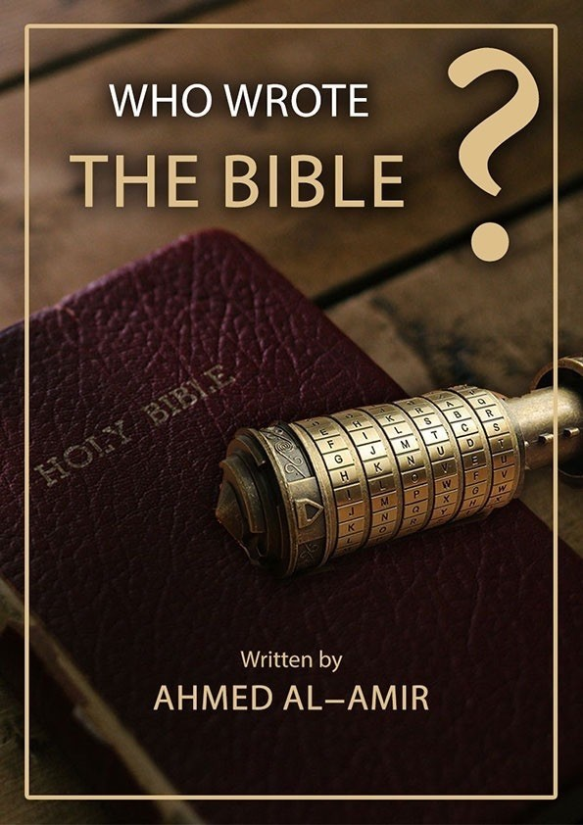

WHO WROTE THE BIBLE?

Written by

Ahmed Al-Amir

©All rights reserved

Contents
Introduction
Irenaeus, Polycarp, Papias
New Testament Canonicity
The Ten Papyri from the second century
There is no so-called the original Gospel of the Four Gospels
Anonymous Epistles within the New Testament
A quick tour in the history of the New Testament
The Gospel of John and the Greek Philosophy
Were the scribes of the four Gospels, disciples of Jesus Christ?
Who wrote the Gospel according to Matthew’s account?
Who wrote the Gospel according to John’s account?
Did the Holy Spirit inspire the four Gospels?
Confessions of the Gospel of Luke
The Church admits that there are forged additions in the New Testament
The Gospel of Jesus Christ
Who wrote the Old Testament?
Loss of the Torah (Old Testament)
Loss of a large number of the Bible's Books

Introduction

Searching for God’s Path:
In my early twenties, I have started my journey of exploring the world. I have visited many countries around the world and have learnt about many different cultures and customs. I was shocked by the extent difference between the religions. I saw the Buddhist monks distancing themselves from the worldly life and devoting themselves to worshipping their god, Buddha. I saw the Christian monks isolating themselves in the monasteries and devoting themselves to worshipping their god, Jesus Christ. I saw those who worship trees, stones, cows, mice, fire, money and other inanimate objects, and I saw those who do not believe in the existence of God or they do believe in the existence of God, but they say, “We do not know anything about him.”
I liked to hear from each one his point of view about what he worships. I found that Buddhists believe that Buddhism is the straight path, and the other religions are the path of error, and Christians believe that worshiping Christ and following the Gospel is the way of salvation, and atheists do not believe in the existence of Paradise or fire.
The global statistics indicate that there are around 2 billion Buddhists around the world, 2 billion Christians around the world, 2 billion Muslims around the world, and millions of atheists around the world.
Hence, since not all of these religions may be true religions, so, only one of them is right, and the others are false.

The Creator God of this universe is only One God, and the religion He sent to people is only one religion. Religion means ‘the path to God,’ and the path to the One God is only one path, which is to worship Him alone without associating to Him any partner and not to add any innovation to His religion.

Who is this God, the Creator, and what is His true religion?
Before taking a road by car, you should first make sure that it is the right direction, otherwise, losing time, effort, and money without any meaning. By the same token, in this worldly life, we must first make sure that we are on the right path leading to the House of Bliss in the Hereafter.
Did Buddhist monks make sure before they devote their lives to worshipping Buddha that they are on the right path, or they just spent their lives uselessly in following a religion that is not the true religion of the Creator?
Did Christian monks make sure before they devote their lives to monasticism and to worshipping Christ that this is the way of salvation and that their Bible is the real word of the Creator?
Did atheists make sure that there is no God of the universe and the universe came out of nothing or the universe had created itself, and neither there is a death, nor a Heaven, nor a Fire, and the virtue is equal to the vice, and the criminal who had not been held accountable for his crimes in the worldly life will not also be held accountable after his death?
To answer these questions, I tried through this book to help those who search for truth, focusing primarily on Christianity due to its many followers.
Since Christianity, its doctrine, and teachings are based on the Bible, we should first ascertain the origin and truthfulness of the Bible. Is the Bible the real word of the Creator, or is it the word of ordinary human beings and the Christians sanctified it?

The Importance of the Bible:
The importance of the Bible stems from many factors:
1) It has around 2 billion Christian followers around the world.
2) On it, the church has established its foundation stone and doctrine, and through it, it charted a path towards salvation.
3) On it, the church has established its version about Jesus’s life and the incidents that took place with him.
4) Some world leaders and members of parliaments may cite passages from it in international conferences or parliamentary sessions.
5) Some state leaders may cite passages from it to declare war or to conclude a peace agreement.
6) Some priests may rely on it to prove their views regarding gay marriage, whether with permitting or prohibition.
7) Morning queue in Christian countries' schools, starts by reading passages from the Bible for the children.

Who wrote the Bible?
Christians believe that the first five books (Pentateuch) of the Old Testament were written by Prophet Moses, and the rest of the books of the Old Testament were written by the prophets who came after him, and the Old Testament since the time of Moses, never been changed or lost at any time.
Christians also believe that the four Gospels of the New Testament were written by the disciples of Jesus, who were eyewitnesses to the incidents, and the Church has conclusive evidence that those four Gospels were written by them.
Christians also believe that these four Gospels were written by inspiration from the Holy Spirit and that they are God’s word, not a human word.
Christians also believe that these Gospels were written in the land of the incidents (Palestine) and that the original copies of these Gospels exist and are kept in the church’s library.
Christians also believe that Jesus had no gospel with him during his lifetime on earth.
Therefore, we will discuss, God willing, those points that Christians believe in regarding the Bible in the coming chapters.
Author.,

Chapter One

Irenaeus, Polycarp, Papias
These three names are the keywords to know who wrote the four Gospels. These three names are the basis of the ecclesiastical tradition in attributing the four Gospels to the disciples of Christ.
Ecclesiastical Tradition: What has come to the present Church of the writings of the early Church Fathers.

Irenaeus:
The Church has little information about him, his personality, and his life. Nevertheless, the church claims that he was the bishop of Lyon, France, born in 140 CE and died in 203 CE, (but the year of his birth and also the year of his death is controversial and probably unknown). He likely born in Asia Minor from Greek parents (but the place of birth is also disputed).
Irenaeus was the first to confront other Christian groups calling them ‘heresies’, such as Gnosticism and Montanism. He studied Greek poetry, language, and philosophy.
The Church calls him "The father of ecclesiastical tradition," and also "The father of Christian theology;" he is the first to lay the foundation of Christian theology and Christian doctrine. He is the primary and only source on which the Church relies to prove that the Gospel scribes are the disciples of Christ. He was the first to point out that the scribes of the Gospels are the disciples of Christ in his book "Against Heresies," written in 180 CE.
Eusebius of Caesarea (who lived between the third and fourth centuries and was called the father of ecclesiastical history because of his work in recording the history of the early Church) in his book "Church History" stated that Irenaeus has mentioned in his book "Against Heresies" the following:
"Matthew also issued a written Gospel among the Hebrews in their own dialect, while Peter and Paul were preaching at Rome and laying the foundations of the Church. After their departure, Mark, the disciple and interpreter of Peter, did also hand down to us in writing what had been preached by Peter. Luke also, the companion of Paul, recorded in a book the Gospel preached by him. Afterwards, John, the disciple of the Lord, who also had leaned upon His breast, did himself publish a Gospel during his residence at Ephesus in Asia."
The Deception:
The writings of Irenaeus were all lost, but a Latin translation of his five books "Against Heresies" was found, and an Armenian translation of his book "The Demonstration of the Apostolic Preaching" was discovered in 1904 CE. In these two works alone, the Church finds the elements of the Christian theological system. In other words, the Church has built its doctrine based on a Latin and an Armenian translation of the books of Irenaeus and has never seen the original. The Church even does not know who translated those books and whether they were honest in their translation or not. Moreover, the Church itself has very little information about Irenaeus himself.
In his book "Against Heresies," Irenaeus claimed that when he was young, he attended sermons for a saint named Polycarp the Martyr, and that he (Polycarp) was a disciple of John the son of Zebedee, the disciple of Christ. Irenaeus also claimed that Polycarp has mentioned that the Gospel of John was written by his teacher, John, the disciple of Christ. He also claimed that Polycarp had a companion named Papias, and that Papias stated that the Gospel of Matthew was written by Matthew, the disciple of Christ, and the Gospel of Mark was written by Mark, the disciple of Peter.
The New Testament, according to Irenaeus, contains the Gospel of "The Shepherd of Hermas," which the Church considers it Apocrypha. Therefore, how did the Church believe Irenaeus regarding the canonicity of the four Gospels and then belie him regarding the Gospel of "The Shepherd of Hermas" considering it Apocrypha?

Polycarp:
The Church knows nothing about him except what Irenaeus mentioned in his book "Against Heresies," that Polycarp was a disciple of John, the disciple of Christ, and he was the one who mentioned that the Gospel of John was written by John, the disciple of Christ. Thus, Polycarp is the only connection between the disciples of Christ, who lived in the first century, and the early Church Fathers, who lived in the second century.
Tertullian also mentioned that Polycarp was a disciple of John, but his testimony was only a quote from what Irenaeus has said, because Tertullian was born one year before the death of Polycarp, that is, he never saw him; therefore, his testimony is not considered.

Papias:
The Church knows nothing about him except what Irenaeus mentioned in his book "Against Heresies," that Papias was a companion of Polycarp, he was a hearer of John, the disciple of Christ, he was a bishop of Hierapolis, and he was the one who mentioned that the Gospel of Matthew was written by Matthew and the Gospel of Mark was written by Mark, the disciple of Peter.
Eusebius of Caesarea mentioned in his book "Church History" that Papias has pointed out that the writer of the Gospel of Matthew was a person named Matthew:
"Thus Matthew wrote the divine sayings in Hebrew, and every one interpreted them to the best of his ability."
Eusebius of Caesarea also stated that Papias has pointed out that the writer of Mark's Gospel was a person named Mark who was one of Peter's disciples:
"Mark, being the tongue of Peter, wrote precisely, albeit in no order, everything he remembered about what Jesus said or did, because he did not listen to the Lord nor follow him, but later, as I said, he followed Peter, who made his teachings conform to the needs of his listeners, without intending to make the Lord's conversations related."
The Church also knows about Papias that he wrote five books under the title "Interpretation of the Lord's sayings," but these books were all lost, and only a few excerpts were recorded in the writings of Irenaeus (which also were lost).
Unfortunately, the only source from which the Church derived its information about Papias was what Irenaeus claimed. Furthermore, when one of the Church Fathers was writing about Papias, he was only quoting what Irenaeus said about him.
In his book "Church History," Eusebius of Caesarea stated:
"Irenaeus referred to these five books written by Papias as the only work written by Papias. Irenaeus said: "These things are attested by Papias, an ancient man who was a hearer of John and a companion of Polycarp, in his fourth book. For five books have been written by him." But Papias himself in the preface to his discourses by no means declares that he was himself a hearer and eye-witness of the holy apostles, but he shows by the words which he uses that he received the doctrines of the faith from those who were friends of the Apostles."
As we can see, Eusebius himself belied what Irenaeus said regarding Papias.
What Irenaeus said: "Papias, an ancient man ... and a companion of Polycarp," suggests that he was telling a fairy tale, in which he tried to identify someone who is already unknown, and this makes us question the existence of a person named Papias.
There is no evidence of his existence nor his writings nor that he was a disciple of John, the disciple of Christ, but the claim of Irenaeus.
Had Papias ever had any companions or disciples? Is there any Church had heard about him during his lifetime and not only through the writings of Irenaeus? Is it reasonable that such a person of such importance and prestige neither was famous nor his writings were widespread among churches? Even the excerpts quoted by Irenaeus in his writings and ascribed them to Papias, assume that Irenaeus had the writings of Papias in his hand to quote them.
Nevertheless, as long as those books were never preserved, and no one mentioned its existence except Irenaeus, then they never existed at all, and those excerpts were from the thought of Irenaeus himself.
In his book "Church History," Eusebius of Caesarea stated:
"The same writer (Papias) gives also other accounts which he says came to him through unwritten tradition, certain strange parables and teachings of the Saviour, and some other more mythical things. To these belong his statement that there will be a period of some thousand years after the resurrection of the dead, and that the kingdom of Christ will be set up in material form on this very earth. I suppose he got these ideas through a misunderstanding of the apostolic accounts, not perceiving that the things said by them were spoken mystically in figures. For he appears to have been of very limited understanding, as one can see from his discourses. But it was due to him that so many of the Church Fathers after him adopted a like opinion, urging in their own support the antiquity of the man; as for instance, Irenaeus and anyone else that may have proclaimed similar views."
As we can see, that Eusebius criticized Papias and blamed him for the following things:
1- Papias merged in Christianity strange parables and teachings and some other more mythical things as part of the oral tradition.
2- Papias appears to have been of minimal understanding, as one can see from his discourses.
3- Papias was a chiliast or millenialist, believing that “there will be a period of some thousand years after the resurrection of the dead, and that the kingdom of Christ will be set up in material form on this very earth.”
4- Due to Papias so many of the Church Fathers after him adopted a like opinion and became millenialists, for instance, Irenaeus, Justin Martyr, Tertullian, Methodius of Olympus, and others.
The Millennial Kingdom:
The Millennial Kingdom belief is a literal interpretation of the book of Revelation, that Christ would return to earth to rule for 1000 years, and his believers would rise among the dead (which is called the first resurrection) to rule with him for 1000 years, while others will rise from the dead only at the last great resurrection, and the wicked would perish and peace would spread in that millennium.
In fact, The Millennial Kingdom belief was derived from the Jewish Apocryphal writings that were written one or two centuries before Christ. This belief prevailed in most Churches, but few Church Fathers resisted that belief, such as: Origen of Alexandria, Dionysius of Alexandria, Eusebius of Caesarea, Basil of Caesarea, Gregory of Nyssa, also St. Augustine of Hippo resisted that heresy and considered that anyone who believed in the doctrine of Papias is deviant from faith.
Later, the doctrine of the Orthodox and the Catholic Church regarding the Millennial Kingdom was changed and became that the Millennial Kingdom belief must be understood in its symbolic rather than literal sense, and that that Kingdom had already begun from the time of Christ, and the present Church is the Kingdom of Christ on earth. As for the Protestant Church, to this day, it still believes in the Millennial Kingdom literally.
Back to the figure of Papias, was he a real figure or just a figment of Irenaeus's Imagination?
Responding to this: Irenaeus has claimed that Papias had heard the "Millennial Kingdom" in its literal sense from John, the disciple of Christ; in contrast, the early Church stated that this is heresy and there is no "Millennial Kingdom" in its literal sense. Therefore, as long as it is unreasonable that John, the disciple of Christ, had mentioned such heresy; then, what Irenaeus had said about Papias was just a myth, and Papias was just an imaginary figure of the imagination of Irenaeus that never exist in reality.
The question that arises now is:
Why did Irenaeus may lie and fabricate fictitious figures that are Polycarp and Papias, claiming that they were hearers of John, the disciple of Christ, and then ascribing to them that they mentioned that the Gospel of John was written by John, the disciple of Christ?
The answer is:
Irenaeus was most resistant to what he called "heresies" that appeared in the second century. In his responses to those heresies, Irenaeus relied primarily on John's gospel. Thus, he likely attributed falsely this gospel to John, the disciple of Christ, then made up the character of Polycarp and claimed that Polycarp was his teacher and that Polycarp was a disciple of John, the disciple of Christ. He likely made this to make his argument before people appear the right one and to prove the doctrine that he considers the right one and refutes the arguments of other priests that oppose his idea and methodology.
One may say:
"It is unreasonable that Irenaeus could lie such an unforgivable lie, ascribing an unknown gospel to John, the disciple of Christ, creating illusory figures such as Polycarp and Papias."
The answer is:
The Theologians affirm that early Christians did not believe that to ascribe an anonymous gospel to a disciple is an act that involves deception or fraud. Whoever did that act did not feel that he was lying regarding Christ or the faith, but rather, he felt that he was lying for the sake of Christ and for affirming the doctrine that he believed to be the right one.
At the time that Irenaeus was holding a gospel in his hand and attributed it to John, the disciple of Christ, many senior priests were also holding many other gospels in their hands and attributed them to the disciples of Christ.
Irenaeus was criticizing those other Gospels mentioning that they are Apocrypha, and its attribution to the disciples of Christ is a forgery.
Thus, whoever says that "It is unreasonable that Irenaeus could lie such an unforgivable lie, ascribing an unknown gospel to John, the disciple of Christ," is supporting -without realizing- Irenaeus and opposing his opponents, who were also senior priests.
In other words, he is accusing them of lying and that they ascribed forgery Gospels that were in their hands to the disciples of Christ, without having heard neither their arguments nor the arguments of Irenaeus, and without having any real knowledge about any of them.

Summary of this chapter:
1) The Church has little information about Irenaeus.
2) The Church has no copies of the books of Irenaeus.
3) The Church has based its doctrine and information regarding the four Gospels scribes on a Latin and Armenian translation of the books of Irenaeus.
4) The Church neither know who translated those books, nor if they were trustworthy.
5) Both Polycarp and Papias are unknown figures, and none of the early Church Fathers knew them, except Irenaeus.
6) Eusebius of Caesarea stated that Papias was a man of very little intelligence, who believed in the Millennial Kingdom heresy in its literal sense and inserted in Christianity strange parables and teachings and some other more mythical things as part of the oral tradition.
7) St. Augustine considered that anyone believes in the doctrine of Papias is deviant from faith.

Chapter Two

New Testament Canonicity

The Church's need to claim New Testament Canonicity:
Many priests are very strict in ascribing the four Gospels to the disciples of Christ, considering that matter as a non-negotiable fact. This attitude is because they cannot say that they believe in a book that they do not know its origin, who wrote it or where it was written. For this reason, they are trying their best to create clues, however weak, and then merge them to formulate a tale that may delude many people.

Church's evidence on New Testament Canonicity:
Regarding New Testament Canonicity the priests are sharply divided into two groups: The first one admits that New Testament scribes are unknown and the phrases "the Gospel according to Matthew’s account, Mark’s account, Luke’s account, and John’s account" were added to the New Testament in the second century without strong evidence of its validity.
The second one is rigorous in ascribing the four Gospels to the disciples of Christ; it collects false and incorrect pieces of evidence but may arrange and coordinate them deceptively to be believed by the average reader. These pieces of evidence are as follows:
1. Internal evidence:
Through the texts of the Gospel itself, the personality and the name of the Gospel scribe can be identified. For example, the Gospel of John we can perceive that who wrote it was John the son of Zebedee, the disciple of Christ, through the phrase that mentioned that who wrote this Gospel is "the disciple whom Christ loved," besides, the scribe of the Gospel of John, knew the customs and history of the Jews and the geography of Palestine.

2. External evidence:
1) Testimonies of the early Church Fathers:
A number of the early Church Fathers had witnessed the name of the Gospel scribe.
2) Quotations by the early Church Fathers:
A number of the early Church Fathers quoted the Gospel texts.
3) Papyri manuscripts:
The present Church has thousands of ancient papyri manuscripts and many ancient translations.

Respond to such flimsy evidence:
1. Regarding the internal evidence:
There is no reference within any gospel to the name of its scribe, nor any hint regarding his personality.
The reader can read any gospel of his choice and try to find out by himself whether there is a such internal evidence on the name of the scribe or not.
On the contrary, the internal evidence, as we will address in the next chapters, God willing, clearly indicates that the scribe is an unknown person who was not a disciple of Christ.
As for the claim that the scribe of the Gospel of John has identified himself as "the disciple whom Christ loved," we say that this is a false claim because the scribe of that Gospel was talking about the disciple whom Christ loved in the absent form, meaning the scribe was talking about another person and not about himself. Besides, where is the name of John in that phrase "the disciple whom Christ loved"?
John 21:20: "Peter turned and saw that the disciple whom Jesus loved was following them."
John 21:24: "This is the disciple who testifies to these things and who wrote them down. We know that his testimony is true."
As for the claim that the scribe of the Gospel of John knew the customs and history of the Jews and the geography of Palestine, the respond is: "And where is the name of John here? Didn't anyone else know that information except John, the son of Zebedee? This flimsy evidence resembles a drowning man trying to clutch at the straw.

2. Regarding the external evidence:
1) Testimonies of the Early Church Fathers:
Some priests list several names of the early Church Fathers and claim that those Fathers had testified the name of each gospel scribe. However, this list is a big deception because the testimonies of the early Church Fathers must first be subject to scrutiny and meet the following conditions:
A) Must come from at least two of the Church Fathers:
The courts of our time do not accept the testimony of one person and require at least two witnesses.
B) Both witnesses must be eyewitnesses and trustworthy:
These two witnesses must be disciples of one of the disciples of Christ. Accordingly, they must have lived in the same century as the disciples of Christ. Nevertheless, by checking the list of testimonies of those Church Fathers, we find that each one of them had lived in a different century than the others, and none of them had seen any of the others. Some of them had lived in the late second century, others had lived in the third century, and others had lived in the fourth century. Each one of those Fathers had lived in a different country than the others.
Eusebius of Caesarea mentioned in his book "Church History":
"At that time the apostle and evangelist John, the one whom Jesus loved, was still living in Asia, and governing the churches of that region, having returned after the death of Domitian from his exile on the island. And that he was still alive at that time may be established by the testimony of two witnesses. They should be trustworthy who have maintained the orthodoxy of the Church; and such indeed were Irenaeus and Clement of Alexandria."
Unfortunately, this testimony of Eusebius of Caesarea is invalid because Irenaeus was born in the year 140 CE, at least fifty years after the death of John the son of Zebedee; that is, he was not an eyewitness. As for Clement of Alexandria, he was born in the year 150 CE, at least sixty years after the death of John the son of Zebedee; that is, he was not an eyewitness. Both Irenaeus and Clement of Alexandria had no connection to anyone who was an eyewitness to John the son of Zebedee.
In the coming chapters, God willing, we will elaborate on Clement of Alexandria and how he was not trustworthy. His name was erased from the record of the martyrs of the Roman Catholic Church in 1586 by order of Pope Clement VIII, because of corrupt teachings in his writings.
C) Each testimony must be independent and not just a repeat of earlier testimony:
These priests who gave us a list of the testimonies of the early Church Fathers, did not inform us that those Fathers were, in fact, quoting one another. The testimony was only one from someone who already never saw any of Jesus’ disciples, and the other testimonies were just a repeat of the first one.
For example, the Church states that St. Papias had written five books, and the proof of their existence and their attribution to Papias is the testimony of Irenaeus and Tertullian. However, the Church does not tell us directly that Irenaeus lived in the second century, while Tertullian lived in the fourth century. That is, Tertullian quoted Irenaeus. That is, the testimony is only one, and the other is just a repeat of the first one. Thus, there is no consideration here for the number of the names of early Church Fathers as long as their testimonies were just a repeat.
D) Both witnesses must have received this gospel by their own hands from the disciple’s hand:
In order these two witnesses testify for one Gospel that it was written by one of Jesus’ disciples, they should had received this Gospel by their own hands from him. Otherwise, how can a person's testimony be accepted without the existence of the subject of the testimony (i.e., this Gospel itself)?
Meaning that this Gospel must be present and in the hands of the Church Fathers, and then they can testify whether if it is written by one of Christ’s disciples or not.
Accordingly, who received that original Gospel by his hand from the disciples of Christ? To whom he presented it? Where (in which church) he testified that that Gospel was written by one of Jesus’s disciples and in front of whom (from the other early Church Fathers) he testified that? Where is that original Gospel, and how did it disappear if it was really in the hands of early Church Fathers?
E) Honesty and trustworthiness:
They should be known for their honesty and trustworthiness among their communities and the early Church Fathers.

2) Quotations by the early Church Fathers:
The phrase "Quotations by the early Church Fathers" makes us imagine that they had the original Gospel in their hands and then quote it. Nevertheless, these quotations are due to two factors:
First, the Church Fathers were not quoting the Gospel itself, but rather stories that were orally spread among the people about the incidents that took place with Christ and his words, and those stories were then written in hundreds of Gospels. Proof of this is that when one of the Church Fathers wrote a quotation did not write next to it that it is a passage from the Bible according to (one of the disciples).
Second, when one of the Church Fathers quotes one particular Gospel, this is not a confirmation of the name of the scribe of that Gospel. There were Church Fathers who believed all what Irenaeus had claimed that he had a teacher named Polycarp and Polycarp was a disciple of John the son of Zebedee and Polycarp had testified that the Gospel of John was written by John the son of Zebedee; thus, they adopted the Gospel of John based on what Irenaeus has claimed, rather than they have verified by themselves the name of the author of the Gospel.

3) Papyri manuscripts:
The Church claims that it has thousands of copies written on papyri, and many manuscripts written on animal skins, and many ancient translations as well. However, this cannot be considered as evidence of the canonicity of the four Gospels for the following reasons:
1) It does not matter the number of copies and translations that the Church possesses because they are just repetitions of one another without referring to the first basis; the original copy itself. Like the false news that may be circulated by all international media, the number of the media does not matter as long as they just copy from one another without validating the authenticity of the original news.
2) The claim that there are thousands of copies and translations does not mean that they contain the entire New Testament, but separate parts. There are thousands of papyri that are small scraps, or contain one or two of Paul's Epistles, or contain a few verses of the book of Revelation or a few verses of a particular chapter of a specific Gospel, and this is what we will address in the next chapter, God willing.
3) Those copies kept by the Church and numbered in thousands were not written in one century, but from the second century until the fifteenth century. If the church wants to use as evidence copies dating back to the seventh or fourteenth century, why not to use also as evidence the billions of copies currently printed from the four Gospels around the world and in all languages of the world? How can the Church infers the authenticity of the four Gospels with manuscripts written in later centuries? Therefore, we will not pay attention to any manuscript or translation written in any century other than the second century, which is closer to the date of writing the original Gospels.
4) Back to the copies that were written in the second century and concern only the four Gospels -without the Epistles and the book of Revelation-, the Institute for New Testament Textual Research (INTF) has recorded only ten manuscripts that they likely date back to the second century. Accordingly, the number of copies that the Church supposed to use as evidence is only ten, not thousands, as claimed. Nevertheless, after studying each papyrus separately, we find that many of those ten papyri do not belong to the second century, but rather to the fourth or third century, and this is what we will address in the next chapter, God willing.
5) These ten papyri, which date back to the second century, are mostly tiny scraps that cannot be evidence of the authenticity of the four Gospels. In the next chapter, God willing, we will put pictures of those small scraps.
6) The Church admits that all that it has from copies, manuscripts, and translations were not copied from the original Gospels, but from copies of copies of copies, etc..
7) Regarding the original Gospels; the Church admits that all of them were lost very early, neither a copy of them nor any copy that was copied directly from them was survived because they all were written on papyrus, which is a kind of paper that may be destroyed quickly.
However, such a claim is invalid because all the Pharaonic papyri, which were written several thousand years ago, are still in our hands and were not destroyed.
As for the original four Gospels, since no one of the early Church Fathers who lived in the first half of the second century has mentioned that he saw any of them by himself or they were in his possession at any time; they were already lost in less than half a century or they were written in the middle of the second century and not the first one.
Besides, if we assume that the original copies of the four Gospels were lost because they were written on papyrus, then how did not any of them survive? How did not survive even one page of any of them? How did all the pages and all the Gospels evaporate? Papyrus leaf, when damaged, does not mean that it has evaporated like gas, but rather the edges and margins of the page may have been eroded a little. Moreover, how did the Church not preserve the original Gospels despite its great importance and was able to keep copies dating back to the second, third, or fourth century, even though they were also written on papyrus?
In fact, there was no such thing so-called the “original Gospels,” so the Church did not bother to preserve any copy of it, and this is what we will address, God willing, in the coming chapters.
8) The Church admits that all Greek papyri have lost much of their importance because they were written by unqualified scribes. St. Takla Haymanout Coptic orthodox website reported:
"All of the oldest Greek manuscripts of the New Testament were written on papyrus, and date back to the period from the middle of the second century to the fourth century, but one papyrus with the number (P74) dates back to the seventh century. Although these papyri are incomplete parts, they together constitute a big portion of the New Testament. Although these papyri date back to an early time, they have lost a lot of their importance because they were written by unqualified scribes, who did not pay attention to the small details."
9) When Erasmus was commissioned in 1502 to issue the first edition of the Bible in the Greek language (Complutensian Polyglot Bible), he did not rely on early Greek manuscripts that may date back to the second, third or fourth century and were written in "Alexandrian text-type," due to his fear of its irregularity, and therefore Erasmus relied on Late Greek manuscripts that were written in "Byzantine text-type". The third edition of Erasmus is the edition upon which the ‘King James Version’ depended.
Because Erasmus could not find any full Greek copy, he used dozens of Greek manuscripts so that he could merge them and compile the New Testament in the Greek language.

Theologian Bart Ehrman’s response regarding the canonicity of the four Gospels:
In one of the debates, Dr. Bart Ehrman on the reliability of the Bible said:
"When I was a Bible-believing evangelical Christian, attending Moody bible institute, before I began my serious scholarship on the New Testament, before I began to read it in Greek, and before I saw what serious scholars of the world had to say about it; I was absolutely convinced that the Gospels not only contained eyewitness tradition, but that they were written by two eyewitnesses, Matthew and John, and by two people who were close companions to people who are eyewitnesses, Mark and Luke.
Intense research has a way of changing your mind about things, but I do not want you to think that this is a reason for you not to use your brain. Even if you are the most hardcore Bible-believing evangelical on the planet, you surely think that God gave you a brain; use your brain. Craig and I will agree on this. God gave you a brain to think with; apply reason. That is why God made you a human being instead of a slug. Do not be afraid of using your intelligence to find out the truth; the truth may not be what you were taught, but if it is true, you should believe it, not run from it.
As I studied more and more using my intelligence as an evangelical but also praying about it; I became convinced that the New Testament Gospels were not written by eyewitnesses or by people who knew eyewitnesses. The first point to make; is the rather obvious one that the Gospels do not claim to be written by eyewitnesses; they are all anonymous. The titles in your Gospels “The Gospel according to Matthew” and so forth were added by later editors, they were not put there by the original authors. The second point; none of the Gospels claims to be written by the person whose name it bears. They do not claim to be written by eyewitnesses, and they do not claim to be written by people named Matthew, Mark, Luke, and John; those are later traditions that were added to the Gospels. These traditions do not start appearing for about a hundred years.
Some people think that there is an early Church Father named Papias who attests to the witness of Mark and Matthew, but in fact, there are very solid reasons for thinking that Papias, who lived around the year 120 to 140 CE, is not referring to our Mark or our Matthew. The first time anybody refers to Matthew, Mark, Luke, and John by name; is Irenaeus in the year 180, a hundred years after these books were written.
My understanding of the Gospels that they have come down to us is that they were anonymous, and we do not know their names, and they were not built on eyewitness testimony. But the important point that I want to make is that even if the Gospels were written by eyewitnesses or even if they did contain eyewitness accounts; that would not guarantee that they were accurate. Think about our legal system today, are eyewitnesses always accurate in what they report? If so, why do we have trials that call in testimony more than one eyewitness? If eyewitnesses were always a hundred percent accurate in what they report; we would not need law courts. If we wanted to know what happened, we would simply ask somebody. Eyewitnesses do not always get all the information right, but even if they did, it would not matter because the Gospels of the New Testament do not claim to be written by eyewitnesses, and in fact, they were not written by eyewitnesses.
The Gospels writers were living forty to fifty to sixty years after Jesus. They wrote the Gospels in Greek, Jesus’ language was Aramaic. These Gospels writers were living in a different country, decades later. Where did they get their information from? They were not the followers of Jesus, they do not claim to be followers of Jesus, the disciples. They (the Gospels) were written by later people decades later in a different language. Where did they get their information from? They heard stories about Jesus that had been in circulation year after year after year, decade after decade, down to the time that the Gospels writers living in a different country, speaking a different language, heard the stories.
What happen to oral stories when they are transmitted orally? They change. The Gospels writers have discrepancies among themselves because the stories that were told and retold were changed over time, and the Gospels writers themselves sometimes change the stories. That is why there are discrepancies. That is why scholars might be able to tell you generally what Jesus was about, they can list eight things that Jesus did, but they cannot tell you the details and agree. Why cannot scholars agree? Because there are so many discrepancies that the Gospels are not reliable."

Chapter Three

The Ten Papyri from the second century
As we mentioned in the previous chapter, the Church's claim of having thousands of copies cannot be a proof of the canonicity of the four gospels because what matters here are those which likely belong to the second century only and concern the four gospels only regardless the Epistles or the book of Revelation.
The Institute for New Testament Textual Research (INTF) has recorded only ten manuscripts that likely date back to the second century. However, after studying each papyrus separately, we find that the method used in determining its date of writing is invalid, namely, ‘the palaeography’. Furthermore, these ten papyri are discovered recently in the twentieth century after being lost for many centuries, that is, they are not papyri that the Church has preserved over centuries or knows who wrote them or how reliable the scribes were. If these papyri were not preserved by the early Church and the early Church Fathers did not care about them, how do contemporary Church cite them as evidence of the canonicity of the Gospels?
These ten papyri are as follow:

A- Papyrus (P52):
Its date of writing disputed among theologians, as most theologians claim and assert that it dates back to 125 CE, claiming to be the oldest papyrus found from the writings of early Christians. Their purpose from that claim is to delude people that this scrap may have been copied directly from the original Gospel of John and that copies of the Gospel of John were widespread among countries at that time, as that scrap was discovered in Egypt in the year 1920.
Moreover, their claim is an attempt to assert that the Gospel of John was written in the first century, as long as there were copies of it spread in the first quarter of the second century.
The date of writing the Gospel of John is disputed among theologians, some of them claim that it dates back to the first century, in the contrast others claim that it dates back to the second century. Meaning that if the Gospel of John was written in the second century, then it was not originally written by John, the disciple of Christ.
Other theologians claim that this papyrus dates back to the year 150, and other theologians claim that it dates back to the year 170. As for most recent studies; they indicate that this scrap may be dated to the second or third centuries. A study was conducted from the University of Manchester in the United Kingdom, which possesses this scrap, shows that it is likely dates back to the late second century.
However, all of these are just a deception and speculation without any strong scientific basis since their determination of the date of writing of this papyrus based on palaeography, that is, by studying its writing style and compare it with some early Christian writings. However, this scrap cannot be dated based on palaeography for the following reasons:
• Looking carefully at the picture below, we will find that the number of words in that scrap is very few, and it is impossible for anyone to can determine its writing style or in which year it was written, with such precise determination.
• Paleography is not a science but rather a study that may indicate the century of writing one papyrus, and the result may not also be correct and differ in one or two or even three centuries. As for those who claimed that this papyrus dates back to the year 125 CE or even 170 CE, how did they manage this precise determination?
• Palaeography depends on comparing the writing style of one papyrus with the writing style of other papyri from the same century. How could they compare the writing style of this papyrus with the writing style of other papyri from the first quarter of the second century, if there were no papyri that survived from the first quarter of the second century?
• Palaeography depends on comparing the writing style, which is affected by two factors: 1) Time: The writing method in the English language used during Shakespeare's time is certainly different from the writing style used today. However, this definition is not accurate. In our present time, when translating or writing religious books into English Language, for example, we find a sharp difference between translators or writers in the writing style and the choice of words. Some of them may write in contemporary language and words that are currently used in modern books, and others may want to add a sacred character on that religious book by selecting words that were used in the past and in an old-style that may resemble Shakespeare's style of writing. Therefore, nowadays, there are many books translated but with a writing style similar to the writing style used 400 years ago. Also, the current Greek Orthodox Church at its prayers, pastors pray in an ancient Greek language and not in the modern Greek language. Moreover, all the official papers issued by the Greek Orthodox Church are written in the ancient Greek language and not in the modern language. Another example, all the official papers issued by the Pope of Vatican are written in Latin and not in Italian. 2) Place: As we know that all the ancient papyri that reached us today were written in the Greek language, but the Greek language in that era was spread among many countries, and that is why someone who speaks Greek in Greece has a different style from who speaks it in Egypt, Syria or Palestine.
As for the size of that scrap, it is only 9 cm * 6 cm, and it is written on both sides. The front side contains seven incomplete lines of John's Gospel, and these lines, as we see in the picture below, contain a few intermittent words from chapter 18 from the verse 31 to the verse 33, whereas the backside contains a few intermittent words from the verse 37 and the verse 38 from the same chapter.
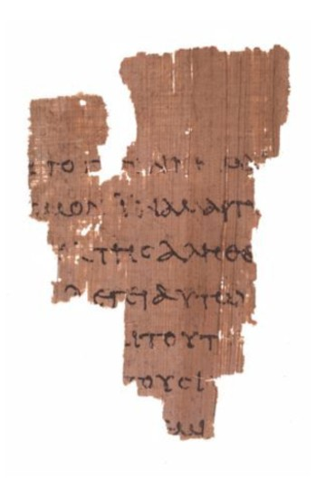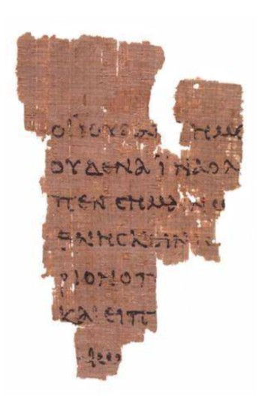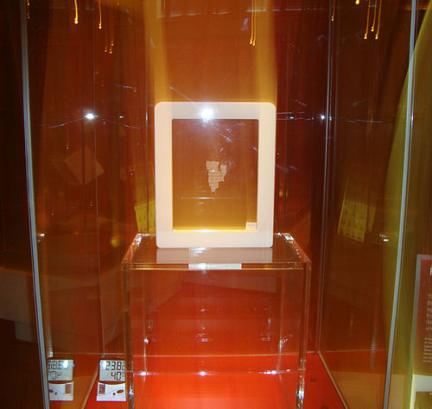

B- Papyrus (P64):
The date of its writing is controversial; some theologians date it back to the fourth century, others date it back to the third century, and others date it back to the second century, and all of these speculations were according to the palaeography. This scrap was discovered in Egypt, and it contains a few intermittent words from the Gospel of Matthew, chapter 26, verse 23, and verse 31.
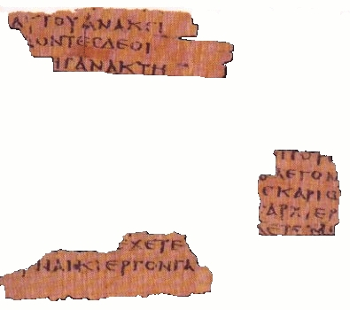

C- Papyrus (P67):
This papyrus is a complement to the papyrus above (P64), that is, they are from the same book, and contains a few intermittent words from the Gospel of Matthew from chapter 3.
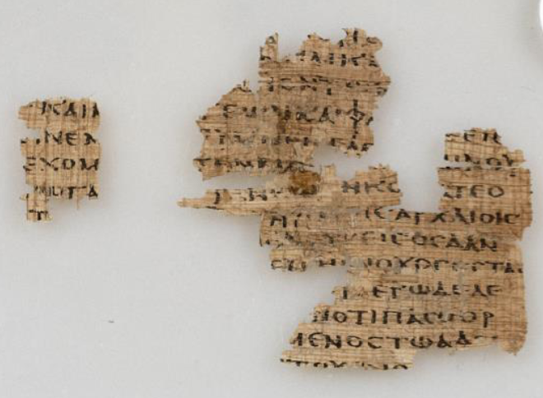

D- Papyrus (P90):
Some theologians date it back to the end of the second century, according to the palaeography. It was discovered in Egypt, and it contains a few intermittent words from the Gospel of John, chapter 18 from verse 36 to chapter 19 verse 7.
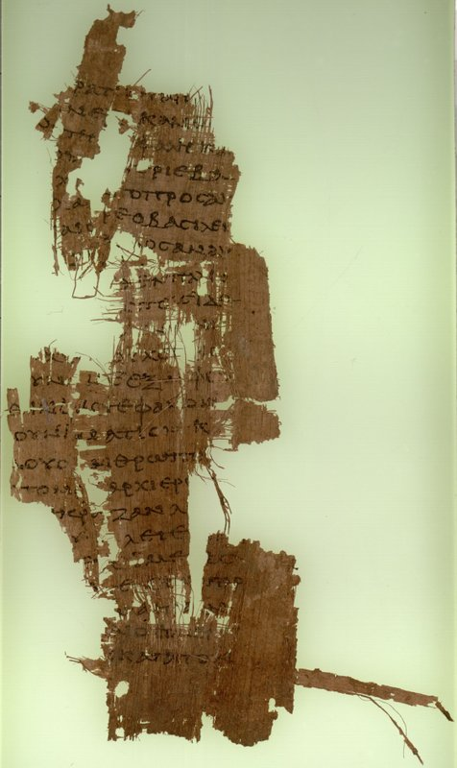

E- Papyrus (P104):
Some theologians date it back to the end of the second century, according to the palaeography. It was discovered in Egypt, and the front side contains a few intermittent words from the Gospel of Matthew, chapter 21 from verse 34 to verse 37, while the backside contains traces of unclear writing of verses 43 and 45 from the same chapter. It is crucial to mention here that verse 44 is not mentioned in that papyrus, which means that it is a forged verse that was added in other versions later.
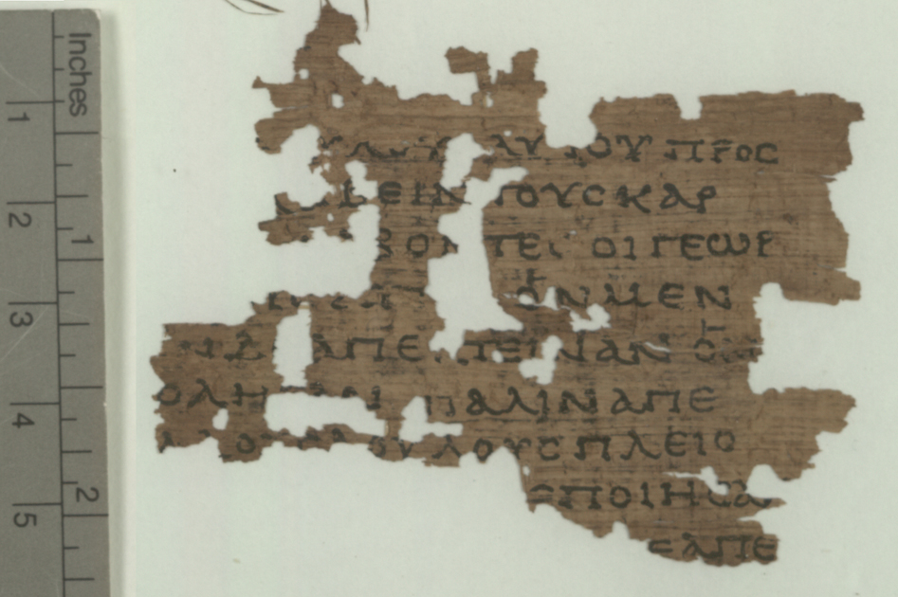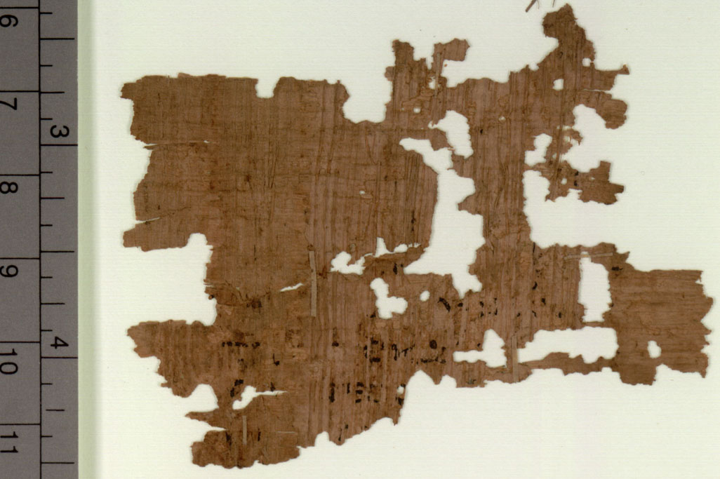

F- Papyrus (P77):
Some theologians date it back to the end of the second century or early third century, according to palaeography. This papyrus contains a few intermittent words from the Gospel of Matthew from chapter 23 from verse 30 to verse 39.
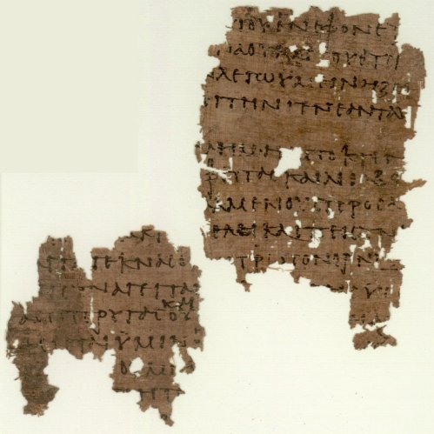

G- Papyrus (P103):
Some theologians see that this papyrus is a complement to the previous papyrus (P77), that is, they are from the same book. This papyrus contains a few intermittent words from the Gospel of Matthew from chapter 13 verse 55 and verse 56, and from chapter 14 from verse 3 to verse 5.
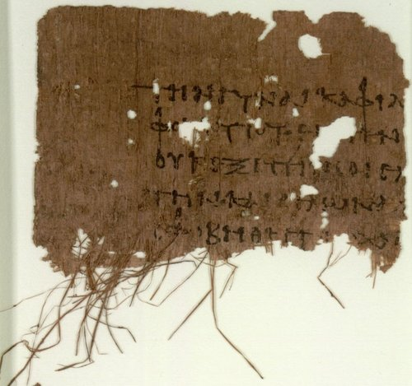

H- Papyrus (P66):
This papyrus is one of Bodmer papyri, which were discovered in Egypt in 1952. They were named after their buyer Martin Bodmer. According to Martin Bodmer, this papyrus dates back to the early third century, according to the palaeography. However, theologian Brent Nongbri and after an extensive study on that papyrus confirmed that it dates back to the middle of the fourth century, after taking into account the form of that papyrus, its literary structure, its way of writing and its origin. As for Herbert Hunger, the researcher in the Byzantine history, claimed that this papyrus may date back to the second century.
As for the Institute for New Testament Textual Research (INTF) ignored the date set by Martin Bodmer, which is the third century, and the date that Dr. Brent Nongbri determined after extensive studies, which is the middle of the fourth century, and clung to the date set by Herbert Hunger who is not a specialist in the palaeography but rather a researcher in Byzantine history, which is the second century.
This papyrus contains parts of John's Gospel, namely: from chapter 1 verse 1 to chapter 6 verse 11, from chapter 6 verse 35 to chapter 14 verse 26, and from chapter 14 also contains verse 29 and verse 30, and from chapter 15 verse 2 to verse 26, and from chapter 16 also contains verse 2, verse 3, verse 4, verse 6, and verse 7, and from chapter 16 verse 10 to chapter 20 verse 20, and from chapter 20 also contains verse 22 and verse 23, and from chapter 20 verse 25 to chapter 21 verse 9, and from chapter 21 it also contains verse 12 and verse 17.
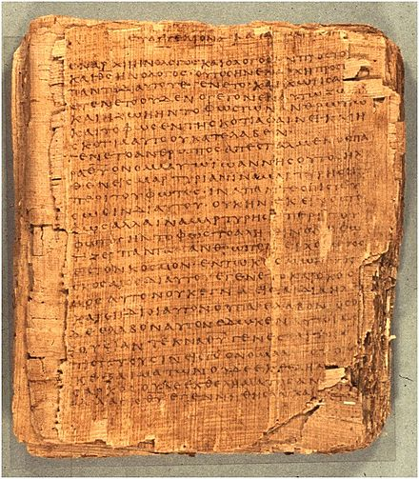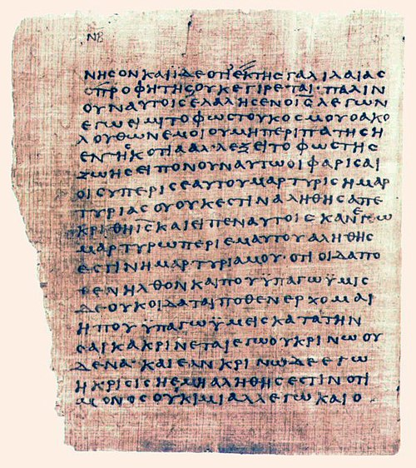

I- Papyrus (P 75):
This papyrus is one of Bodmer papyri, and according to Martin Bodmer, this papyrus dates back to the late second century or early third century. However, the theologian Brent Nongbri stressed that the writing style in that papyrus is similar to the writing style used in the fourth century, it is very similar to the style of Codex Vaticanus, dating back to the fourth century.
This papyrus contains parts of Luke's Gospel: from chapter 3 verse 18 to chapter 4 verse 2, from chapter 4 verse 34 to chapter 5 verse 10, from chapter 5 verse 37 to chapter 18 verse 18, and from chapter 22 verse 4 to chapter 24 verse 53.
Also, this papyrus contains parts of John's Gospel: from chapter 1 verse 1 to chapter 11 verse 45, from chapter 11 verse 48 to verse 57, from chapter 12 verse 3 to chapter 13 verse 19, and from chapter 14 verse 8 to chapter 15 verse 10.
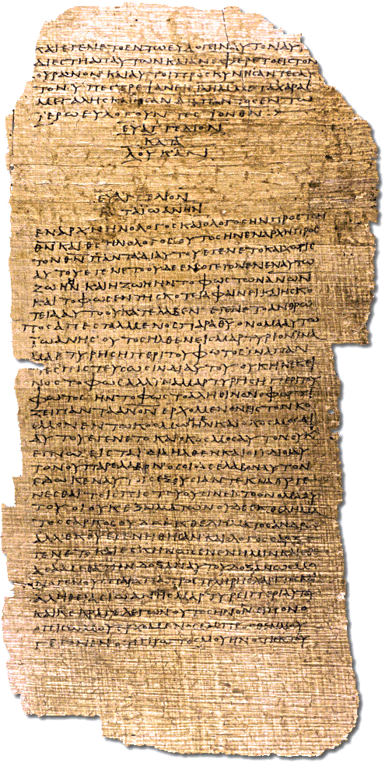

J- Papyrus (P98):
It is a small scrap from the Book of Revelation from chapter 1 verse 13 to chapter 2 verse 1. Some theologians suggest that according to the palaeography, it dates back to the second century. Since it does not concern the four Gospels that are the subject of this book, we will not elaborate on it.
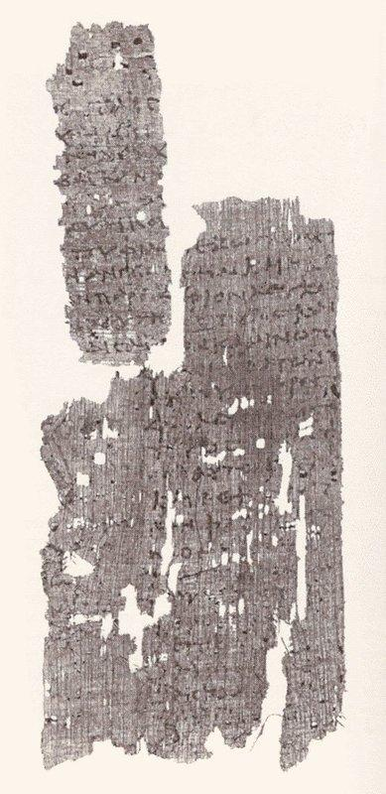

K- Papyrus (P46):
This papyrus contains a few Epistles of Paul. Some theologians suggest that according to the palaeography, it dates back to the end of the second century or early third century. Since it does not concern the four Gospels that are the subject of this book, we will not elaborate on it.

L- Manuscript (0189):
This manuscript contains the Acts from chapter 5 verse 3 to verse 21, and some theologians suggest that according to the palaeography, it dates back to the end of the second or early third century. Since it does not concern the four Gospels that are the subject of this book, we will not elaborate on it.

Conclusion:
1- These ten papyri identified by the Institute for New Testament Textual Research (INTF) are just scraps that can denote nothing.
2- All that was mentioned about the date of writing these scraps is only speculations based on the palaeography.
3- The early Church did not preserve any of these papyri, and they were lost for centuries until they were discovered in Egypt in the twentieth century.
4- Looking carefully at the pictures of these papyri, we ask: How can the contemporary Church consider these scraps that were not preserved by the early Church Fathers as evidence on the four Gospels canonicity?
5- These scraps have no known source; we do not know who wrote them, and under the supervision of which church he wrote them. In our present time in the modern editions of the Bible, we find the signature of one of the priests and the stamp of his Church on that edition, and even an introduction from this priest or the Church about that edition or the New Testament in general. As for these ten papyri, we do not find in them any phrase that says, for example, “It was copied -or translated- by the priest so and so and under the supervision of the priests so and so and approved by the review and audit Committee, and transcription -or translation- was done based on the original version so and so which kept in the Church so and so under the supervision of the priest so and so.

Chapter Four
There is no so-called the original Gospel of the Four Gospels
Neither the Church nor one of the early Church Fathers bothered to preserve the original Gospels because there was no so-called "The Original Gospel". The term "Original Gospel" means that one of the disciples of Christ wrote an original Gospel, and then one of his followers from the early Church Fathers received it from him, or one of the early Churches received it from him and preserved it in her library. However, that was not the case with any of the four gospels.
Unknown people in hundreds of books wrote the content of the stories and incidents that occurred to Jesus, and in the late second century four books were chosen from them and were attributed to the disciples of Christ to give those books the character of sacredness and to win people's acceptance of them.

Rational questions about the original Gospels:
As is well known, all the Gospels were written on papyrus and were not just oral sayings that people transmitted on their tongues, therefore, where are the original copies of those Gospels? If John the disciple was the author of the Gospel of John, then where did he write it, and to whom did he deliver it? Did he give it to a particular church? How did this original Gospel appear later? Did that church announce that it had the original copy of John's Gospel and that it received it from John hand to hand? Are there any witnesses to that? Where is the original copy of John's Gospel? How did that Church not preserve its most important book? If John the disciple was the author of the Gospel of John, then how is it possible that we find in the Church's definition of this Gospel the phrase "the author of this Gospel is likely John, the disciple"? Is it doubtful, or is it clear?

Chapter Five

Anonymous Epistles within the New Testament

The Epistle to the Hebrews is an anonymous epistle that has neither a known source nor writer:
Yes, the Church has collected its Bible from anonymous books that have neither a known source nor a known writer. Evidence on this, is the Epistle to the Hebrews, that currently exist inside the Bible, despite the fact that the Church does not know who wrote it. Several names were proposed to choose from them a name of the writer of this anonymous letter, such as: Pope Clement I, Barnabas, Paul, Luke, Apollos, Priscilla, and others. The Western Churches until the fourth century claimed that the writer is Pope Clement I, but later they changed their opinion and claimed that Paul the Apostle is the real writer. As for Tertullian attributed this letter to Barnabas, while Origen believed that the writer might be Luke the Evangelist.
We ask; from where did this epistle appear? Why does the Church not know the name of its author? Where did the Church find that epistle? Did one Church present it without mentioning the name of the author? Why did the Church place that letter in its holy book, attributing it to the word of God and claiming that the Holy Spirit inspired it?
Although the author's name is not known, the original King James translation of the Bible has titled that letter "Paul's Letter to the Hebrews," even though the attribution to Paul was merely a guess without evidence, and recent studies have shown that the attribution to Paul is incorrect. The writing style of that letter and Paul's writing style are very different, the theological focus is different between them, the spiritual experience is different, the Greek vocabulary used is different. Nowadays, the current Church and theologians are rejecting that the author of that letter to be Paul.

Chapter six

A quick tour in the history of the New Testament

The apparent disconnect between the four Gospels and the second century:
In this explanation of the history of the New Testament, we will limit ourselves solely to the points that are subject of consensus in the Church, to be deterministic points of significance, so the matter to be definitively clarified to the reader, God willing:

1- The current Greek Orthodox Church in Greece wrote in the introduction of its latest edition of the Bible in modern Greek language:
"After Christ and in the first century, the Bible for Christians that approved by all churches was the Old Testament only, and any phrase like, “the Bible says” or, “the Law says” or “as it was said in the Prophets,” was intended as the Old Testament."

2- Writer Karen Armstrong says:
"During the late Second Temple period, the Jesus movement had been just one of a multitude of fiercely competing sects. It had some unusual features, but, like several of the other groups, the first Christians regarded themselves as the true Israel, and had no intention of breaking away from Judaism ... they (Christians) continued to live as devout, orthodox Jews ... Jesus’s followers continued to revere the Torah, keep the Sabbath, and the observance of the dietary laws was a matter of extreme importance to them."

3- Karen Armstrong also says:
"(Paul) had joined the Christian movement some three years after Jesus. He had never known Jesus personally, and had initially hostile to the sect, but had been converted by a revelation, which convinced him the Christos had appointed him to be the apostle to the gentiles (non-Jewish nations). Paul travelled widely in the diaspora in Syria, Asia Minor, and Greece, determined to spread the gospel the bible. He wrote letters to his converts, answering their questions, exhorting them and explaining the faith. Paul did not think for a moment that he was writing 'scripture'; because he was convinced that Jesus would return in his own lifetime, he never imagined that future generations would pore over his epistles."

4- The Jesuit Arabic translation of the Bible says in its introduction about the New Testament:
"The sayings of Christ and what the apostles preached were transmitted by the tongues for a long time, and only after the death of the last apostle did the early Christians feel the need to write down what the Apostles taught. The question of the status of these new works had to be raised one day, even if the oral tradition at the beginning enjoyed a better place than the written works.
It seems that Christians, until about the year 150, gradually without they feel -except very little- started to create a new set of Scriptures. Most probably they gathered together, in the beginning, Paul's letters and they used them in their Church life. Their goal was never to create a complement to the Bible (the Old Testament), but instead, they let the incidents direct them. Paul's Epistles were written while the evangelical tradition was still mostly transmitted on the tongues of people. Paul himself had recommended that his letters be read and circulated among the adjacent churches ... Although these letters had a high standing, there is no testimony before the beginning of the second century that these letters were considered sacred or had the same standing of the Bible (the Old Testament).
Throughout this period, the significance of the Gospels does not appear as clear as it appears in the case of Paul's letters. Yes, the writings of the early Christians scribes always had passages from the evangelical tradition, but it is difficult every time to confirm whether the evidence was taken from written texts that were in the hands of these scribes, or did they merely recall parts of the oral tradition. Whatever the case, there is no testimony before the year 140 that proves that people knew a set of written Biblical texts. At that period nobody had mentioned that any of these Biblical texts had a mandatory character, only in the second half of the second century started to appear some testimonies that gradually over time started to become clearer that there is a group of gospels and that they have a mandatory character, and that adjective was recognized gradually.
Around the year 150, a decisive era began to form the New Testament Law. St. Justin Martyr (who lived between the years 100-165) was the first to mention that "Christians read gospels in Sunday's meetings (without specifying what those gospels were and without specifying if between them any of the four Gospels) and that they consider them works of the Apostles -or at least people who had a closely connection with the Apostles- and they treat those works as they treat the Holy Book (Old Testament)."
If these books were given such high status, it is not primarily due to their apostolic origin (i.e., because they were written from any of the Apostles), but rather because it tells the story of "the Lord" according to the transmitted tradition.
Then people started quickly to emphasize the attribution of these writings to the Apostles, in particular for the need to protect them from the spreading of similar publications that were similar from outside while in content were just a silly tradition similar to what weaves imagination in the state of delirium.
The four Gospels around the year 140 were considered as ‘canonical literature,’ even though that word was not used until then. As for the Pauline Epistles, they were fully incorporated into the Law when that opinion inside the Church prevailed that a law for the New Testament must be obtained."

5- The appearance of dozens of Bibles:
- Many people wrote what they heard from stories about Jesus on papyrus manuscripts; evidence for this is what was mentioned in the Gospel of Luke chapter 1 verse 1: "¹ Forasmuch as many have taken in hand to set forth in order a declaration of those things which are most surely believed among us, ² Even as THEY delivered them unto us, which from the beginning were eyewitnesses, and ministers of the word; ³ It seemed good to me also, having had perfect understanding of all things from the very first, to write unto thee in order, most excellent Theophilus, ⁴ That thou mightest know the certainty of those things, wherein thou hast been instructed."
- Helmy El-Kommos Yaacoub, the Coptic researcher, said in his answer to the question, ‘What were the motives that prompted the church to collect the canonical books?’:
"The emergence of a huge number of Apocryphal books that were attributed to the apostles falsely, so dozens of Bibles appeared that contained false stories, especially to cover the period of Christ childhood, the life of Mary the Christ’s Mother and whatever else that the canonical books did not write down, so the canonical books had to be sorted from the Apocrypha, so the Church approved the canonicity of the canonical holy books and excluded all the Apocrypha."
- The British Encyclopedia mentioned the following:
"Indeed, until the year 150, Christians could produce writings either anonymously or pseudonymously—i.e., using the name of some acknowledged important biblical or apostolic figure. The practice was not believed to be either a trick or fraud. Apart from letters in which the person of the writer was clearly attested—as in those of Paul, which have distinctive historical, theological, and stylistic traits peculiar to Paul—the other writings (i.e., Gospels) placed their emphases on the message or revelation conveyed, and the author was considered to be only an instrument or witness to the Holy Spirit or the Lord. When the message was committed to writing, the instrument (i.e., the writer) was considered irrelevant, because the true author was believed to be the Spirit. By the mid-2nd century, however, with the delay of the final coming (the Parousia) of the Messiah as the victorious eschatological (end-time) judge and with a resulting increased awareness of history, increasingly a distinction was made between the apostolic time and the present. There also was a gradual cessation of “authentically pseudonymous” writings in which the author could identify with Christ and the Apostles and thereby gain ecclesiastical recognition."

6- The spread of heresy:
In his answer to the question, ‘What were the motives that prompted the church to collect the canonical books?’ Helmy El-Kommos Yaacoub, the Coptic researcher, said:
"There was a need to define the canonical holy books because of some heresies that started to spread."
Examples of these heresies include: 1) The heresy of Marcion (Marcion of Sinope) and the spread of his Gospel, which was widespread and known in many Churches in many countries as the "Gospel of the Lord" or the "Gospel of Marcion". 2) The heresy of the Ebionites, and the spread of their Gospel, which was known as the "Gospel of the Ebionites," some claim that the Ebionites were following the "Gospel of the Hebrews." 3) The heresy of Cerinthus and the spread of his Gospel, which was called the "Gospel of Cerinthus." And many other heresies that were wide-spread.

7- The struggle between beliefs, heresies, and Gospels:
Due to the spread of heresies, especially in the first and second centuries, a fierce conflict erupted between beliefs. Thus, dozens of Bibles emerged and were attributed falsely to any of the twelve disciples to obtain the characteristic of sacredness and the acceptance of people and to become proof for each side against the others. Among the most critical conflicts was the one regarding the deity of Christ, on which the Gospel of John specifically played an important role.

Chapter Seven

The Gospel of John and the Greek Philosophy

1- The sudden appearance of John's Gospel:
As we mentioned earlier, the first person to mention the existence of a Gospel written by one of the disciples was Irenaeus in the year 180. Some claim that because of the emergence of heresies at the time of John, the disciple, the Church Fathers of Asia Minor, asked John to write a Gospel to respond to these heresies, but this claim is invalid and has no evidence. Besides, how there is no Church in Asia Minor -or even anywhere else- has heard about the existence of this Gospel if they indeed asked John to write it? Why did not any of the Church Fathers in the first century or at the beginning of the second century cite it, while we find that the first indication of its existence was in the year 180?

2- Using the Gospel of John to respond to the deniers of the deity of Christ and heresies:
All the information that reached the current Church about heresies that appeared in the late first and second centuries depends on what Irenaeus wrote in his book "Against Heresies."
Although the original copy of "Against Heresies" has never reached the Church and the Church has relied on a Latin translation of it, the Church believed all that was mentioned in that Latin translation, even though the Church neither knew who was Irenaeus nor who translated that Latin translation.
Irenaeus launched a war against a number of the early Church Fathers and many of the early Christian groups, and many of the Gospels, which were widespread and were attributed to any of the disciples of Christ.
On this, Irenaeus called one of the Christian groups "Ebionites," (which means the poor) and criticized them and their creed calling it "the heresy of the Ebionites," he also criticized their Gospel calling it "Gospel of the Ebionites." Irenaeus also criticized Marcion and his doctrine, calling it "the heresy of Marcion," and criticized the gospel that Marcion was following, which was widespread in many countries and churches, and called it "Gospel of Marcion". Irenaeus also criticized Cerinthus and the gospel that Cerinthus was following, and called it the "Gospel of Cerinthus.” Irenaeus also criticized Carpocrates, who was also following the "Gospel of Cerinthus,” and criticized Saturninus, and Basilides and their beliefs.
Thus, Irenaeus criticized many of the early Church Fathers and wrote about them and their beliefs. Therefore, we do not know what they believed in except for what Irenaeus wrote about them, and as for their writings, nothing of them has reached us. Based on this; we will never know whether they were heretics or if they were on the right creed because we will never be able to reach their authentic writings and sayings. As for the current Church, it repeats the words of Irenaeus without questioning any of what he mentioned. For example, the current church says about Cerinthus that the early Church Fathers criticized him and criticized his heresy, but if you search more on this topic, you will found out that the Church means by "the early Church Fathers," only Irenaeus.
Irenaeus relied mainly on the Gospel of John in his responses to all what he called heresies. Based on this, it is very likely, as we mentioned earlier that he attributed the Gospel which he was following it and quoting from it, to John the disciple of Christ, and claimed that his teacher Polycarp was a disciple of John, so that his sayings become the correct sayings in front of people, and to establish the doctrine that he sees as the correct one.

3- The difference between the Gospel of John and the other three gospels:
The Church calls the three Gospels Matthew, Mark, and Luke, the "Bodily Gospels,” while the Gospel of John calls the "Spiritual Gospel."
The Church also calls the three Gospels Matthew, Mark, and Luke the "Synoptic Gospels" because they are similar, they include many of the same stories, often in a similar sequence and in similar or sometimes identical wording. This similarity is known as the "Synoptic Problem," and these three gospels stand in contrast to the gospel of John, whose content is mainly distinct; therefore, the Gospel of John is called the "Independent Gospel."

4- The reason for writing the Gospel of John:
The author of this Gospel explains the purpose of writing it in chapter 20 verse 31: "³¹ But these are written, that ye might believe that Jesus is the Christ, the Son of God; and that believing ye might have life through his name."
Thus, the Church sees that this gospel was written to prove the divinity of Christ and that he is the Messiah expected by the Jews.
Whereas the other Gospels did not proclaim the divinity of Christ, we find that the Gospel of John began by claiming the deity of Christ, in chapter 1, verse 1 it says: "¹ In the beginning was the Word, and the Word was with God, and the Word was God."

5- The place of writing of the Gospel of John and its writing style:
Scholars differed significantly in determining the place of writing, as it was said that it might was written in Ephesus, Antioch, or in Alexandria, Egypt, as the oldest manuscript copied from it was found in Alexandria, and this Gospel bears a Hellenic (Greek) character that fits Alexandria's thought affected by Philo of Alexandria, the Alexandrian Jewish philosopher (20 BCE- 45 CE).

6- The author of the Gospel of John was quoting from the Greek philosophy:
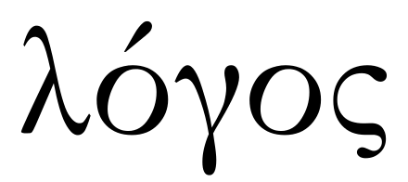
John's Gospel began with the words: "¹ In the beginning was the Word, and the Word was with God, and the Word was God."
In reality, however, the first who invented the term “WORD” (‘logos’, in Greek language ‘λόγος’) was the Greek philosopher Heraclitus who lived from 535 to 475 B.C. He considered the “WORD” as the “Whole Law of the Universe” and also said that the world was in a fluid state and was incoherent, but the impersonal and unchanging ‘divine Logos’ held it tightly and led the process of change.
Many Greek philosophers have used the term "Word" in different ways, and among these philosophers: Aristotle, the sophists, and Plato who defined the "Word" as "The impersonal and unchanging Logos that kept the planets in their orbits and defined the seasons."
Also, the term "Word" was used by the Stoic philosophers, who defined it as "The moving divine principle that permeates the universe,” and also defined it as "The effective principle in the world, or ‘the mind of the world’ or its director, and it is the one who popularizes life in the world, and organizes the negative element in the world that is the ‘Material’."
In Hellenic Judaism (i.e., Judaism influenced by Greek philosophy and culture), Philo of Alexandria, the Alexandrian Jewish philosopher, adopted this term in Jewish philosophy, and defined it as: "The first force emanating from God, and that it is the place of all images, and the first paradigm of all things, and it is the inner force that revives things and connects them. It interferes in the formation of the world, but it is not a creator. It is the mediator between God and people, and it guides the people and enables them to rise to see God. But its role is always the role of the mediator."
Philo defined the ‘Word’ (logos) as "deity" but distinguished it from God by using the definite article that is added to God "The Deity,” and did not use definite article to logos.
As for the writer of the Gospel of John, he defined the term "Word" as being the God Himself, and then defined Christ as "the incarnate word".

7- Church Fathers who followed and supported the Gospel of John, were all influenced by the Greek Philosophy and the Apocryphal Jewish Books:
1) Many of the early Church Fathers were influenced by Philo of Alexandria, the Alexandrian Jewish philosopher:
As mentioned above, the Gospel of John bears a Hellenic (Greek) character and is influenced by the writings of Philo of Alexandria, the Alexandrian Jewish philosopher. Philo used philosophical allegory to harmonize Jewish scripture, mainly the Torah, with Greek philosophy. His allegorical exegesis was very important for some early Church Fathers who received his works with great enthusiasm, and they claimed that Philo might be Christian hiding his Christian faith. Many scholars say that Philo's concept of the "Word" as ‘God's creative principle’ greatly influenced early Christianity and that the writer of the Gospel of John quoted this concept from Philo, but while Philo had expressed it in a Jewish philosophical concept, the author of the Gospel of John has expressed it in a Christian philosophical concept.
Matt Stefon mentioned in his book “Judaism: History, Belief, and Practice”:
"Philo’s use of Greek philosophy, especially of Plato’s philosophy, in aligning the Torah ideas with his concept of the “Word” as a mediator between God and the world, has caused the founding of Neoplatonism, Gnosticism and the philosophical view of the early Church Fathers."
2) St. Justin Martyr, influenced by Greek philosophy:
As we mentioned earlier, the Jesuit translation mentioned in its introduction about the New Testament that St. Justin Martyr (who lived between the years 100-165) was the first to mention that "Christians read Gospels in Sunday's meetings and that they consider them works of the Apostles."
The Church relies upon what St. Justin Martyr mentioned to prove the existence of Bibles in the middle of the second century. But if we review the biography of St. Justin Martyr, we find that he was greatly influenced by Greek philosophy and was one of the most prominent who interpreted the concept of "Word" (logos) in the second century.
St. Justin Martyr also mentioned the existence of the ‘True Religion’ that preceded Christianity, saying that ‘the seeds of Christianity’ (manifestations of works of the "Word" throughout history), had already preceded the incarnation of Christ, and that many known Greek philosophers (including Socrates and Plato), whose philosophical works he learnt well, are considered unaware Christians (i.e., they followed Christian faith without they realize that).
3) Papias, influenced by the Apocryphal Jewish books:
As we mentioned in chapter one; Eusebius of Caesarea wrote about Papias that ‘he was a man of very little intelligence’ who was influenced by the Apocryphal Jewish books and believed in the Millennial Kingdom heresy in its literal sense.
4) Clement of Alexandria, influenced by Greek philosophy:
He was one of the most prominent advocates of the Gospel of John and was the head of the Cathedral School of Alexandria. Through his three most important books, it is apparent how deeply influenced by Greek philosophy and literature, especially Plato's philosophy and Stoic philosophy, more than any other Christian thinker of his time. His teacher was St. Pantaenus, who was a famous Greek Stoic philosopher, and he (i.e., St. Pantaenus) was a pagan who converted to Christianity, and tried hard to reconcile the Greek philosophy he excels in with his new religion, Christianity. St. Pantaenus greatly influenced Christian theology through his work as head of the Cathedral School of Alexandria, and after his death, he was succeeded by Clement of Alexandria as head of the school.
Clement of Alexandria was considered a saint in all of the Coptic Church, the Ethiopian Church, and the Anglican Church, just as the Roman Catholic Church previously considered him a saint and celebrated his feast on the fourth of December. However suddenly his name was erased from the record of the martyrs in the Roman Catholic Church in 1586 by order of the Pope Clement IV, moreover, Pope Benedict XIV wrote a letter to the king of Portugal, John V, explaining enthusiastically that the reason behind this omission is based on the existence of some corrupt teachings in his writings.
Among the pupils of Clement of Alexandria is Origen of Alexandria, who was one of the most influential figures in early Christian theology, and was described as the most brilliant genius produced by the Early Church. Origen of Alexandria succeeded Clement of Alexandria as head of the cathedral school of Alexandria. However, the Coptic Church later deprived Origen of his priestly rank, and so did the Chalcedonian Churches because of the dogmatic errors found in his writings, as well as he had castrated himself as a young man so that he could preach to women freely (as Eusebius of Caesarea mentioned about him) and the eunuch may not receive a priestly rank.
5) Many early Church Fathers, influenced by Greek philosophy:
Many of the early Church Fathers who followed and supported the Gospel of John, by reviewing their biographies, we find how they were influenced by Greek philosophy (but will not mention them all here so that the book does not last long).
6) Tertullian’s hostility to Greek philosophy:
Tertullian (who was dubbed “the father of Latin Christianity” and also “the founder of Western theology”) criticized the Church Fathers who were philosophers or influenced by Greek philosophy and criticized the heresies and myths that they brought into Christianity, saying:
"What kind of relationship can be between Athens and Jerusalem? Between the Academy and the Church? Between heretics and believers? ... We are innocent of those who invented Stoic Christianity, Platonic Christianity, Epicurean Christianity, or Dialectical Christianity after Christ and the Gospel. We do not need anything, is there any room for the analogy between the Christian and the philosopher, between the disciple of Heaven and the disciple of Greece, between who aims life and who aims fame, between who builds and who destroys, between who maintains the truth and preaches it and who spoils it?"
The strange thing is that Tertullian himself fell into heresies and used Greek philosophy and the Apocryphal Jewish books, as he was a believer in the "Millennial Kingdom" in its literal sense, and he was also one of the founders of the doctrine of the Trinity (Holy Trinity) and incorporated it into the Christian religion. In the end, Tertullian fell into severe heresy and was a follower of the Montanian doctrine (Montanism) founded by Montanus, who falsely claimed prophecy, and Tertullian strongly defended Montanism and attracted many followers to it.

8- Attribution to Christ phrases beginning with the word "I" in John's Gospel:
John's Gospel is the only one that attributed many phrases to Jesus, starting with the word "I," although none of these phrases was mentioned in any other Gospel. These phrases are always used by priests who support the idea of deity of Christ in their debates with priests and churches that oppose the deity of Christ. Among these phrases:
"³⁵ I am the bread of life: he that cometh to me shall never hunger; and he that believeth on me shall never thirst." (John 6:35)
"²⁹ I know him: for I am from him, and he hath sent me." (John 7:29)
"¹² I am the light of the world." (John 8:12)
"¹⁹ Then said they unto him, Where is thy Father? Jesus answered, Ye neither know me, nor my Father: if ye had known me, ye should have known my Father also." (John 8:19)
"²³ And he said unto them, Ye are from beneath; I am from above: ye are of this world; I am not of this world." (John 8:23)
"⁵⁸ Jesus said unto them, Verily, verily, I say unto you, Before Abraham was, I am." (John 8:58)
"¹¹ I am the good shepherd: the good shepherd giveth his life for the sheep." (John 10:11)
"³⁰ I and my Father are one." (John 10:30)
"³⁸ But if I do, though ye believe not me, believe the works: that ye may know, and believe, that the Father is in me, and I in him." (John 10:38)
"²⁵ I am the resurrection, and the life: he that believeth in me, though he were dead, yet shall he live." (John 11:25)
"⁴⁵ And he that seeth me seeth him that sent me." (John 12:45)
"⁶ I am the way, the truth, and the life: no man cometh unto the Father, but by me." (John 14:6)
"⁷ If ye had known me, ye should have known my Father also: and from henceforth ye know him, and have seen him. ⁸ Philip saith unto him, Lord, show us the Father, and it sufficeth us. ⁹ Jesus saith unto him, Have I been so long time with you, and yet hast thou not known me, Philip? he that hath seen me hath seen the Father; and how sayest thou then, Show us the Father? ¹⁰ Believest thou not that I am in the Father, and the Father in me? the words that I speak unto you I speak not of myself: but the Father that dwelleth in me, he doeth the works. ¹¹ Believe me that I am in the Father, and the Father in me: or else believe me for the very works' sake. ¹² Verily, verily, I say unto you, He that believeth on me, the works that I do shall he do also; and greater works than these shall he do; because I go unto my Father. ¹³ And whatsoever ye shall ask in my name, that will I do, that the Father may be glorified in the Son." (John 14:7-13)
The American Bishop John Shelby Spong said:
"Among the conclusions that I have reached in my intensive five-year-long study of John’s Gospel are these:
1) There is probably not a single word attributed to Jesus in this book that the Jesus of history actually spoke. This includes all the “I Am” sayings and all of the “Farewell Discourses.” 2) There is no way that the Fourth Gospel was written by John Zebedee or by any of the disciples of Jesus. The author of this book is not a single individual, but is at least three different writers/editors, who did their layered work over a period of 25 to 30 years."

9- The Church's Dependence on John's Gospel to Resist Heresies:
The term "Church," which is used by many who talk about the Church's war with heresies, is deceptive. Because it makes us imagine that there was one united Church, and it was resisting those who went astray from the straight path and the right creed. Moreover, the truth is that the Churches at that time were in a constant struggle with each other, divided and dispersed, without a clear or firm belief.
Example of this is, most Churches and early Church Fathers believed in the Millennial Kingdom in its literal sense, and among them are: Papias, Polycarp, Irenaeus, St. Justin Martyr, Melito, Bishop of Sardis, Tertullian, Hippolytus of Rome, Ambrose, Bishop of Milan, Nepos of Egypt, and others, while their opponents were very few. Thus, the belief of the Millennial Kingdom in its literal meaning prevailed and lasted for four centuries, and it was not denounced in any of the Ecumenical Councils. However, the law of Nicene Faith (Nicene Creed) which was formulated in the Council of Nicaea in the year 325 CE at the invitation of Emperor Constantine the Great, strengthened the doctrine of the Trinity and added a phrase saying "Whose kingdom never ends," and this tacitly indicates that Jesus will not come to rule the earth for a thousand years, as it was believed.
The question that arises now is:
If the term "Church" means the presence of one and united Church and that whoever opposes it is a heretic; then why did the doctrine of that united Church change from faith in the Millennial Kingdom in its literal sense and became after the passing of four centuries faith in its symbolic meaning?
The answer to this question is:
Any change happened to the doctrine of the Church, in general, was due to power and authority and not unanimity and argument. For example, the Council of Nicaea was held by order of Emperor Constantine the Great and under his direct supervision, thus, the Churches that could rely on the power of the emperor were the victorious at the end. That is why, although the doctrine of the Millennium Kingdom in its literal sense expresses the opinion of the majority of the early Church Fathers, the opinion of the minority of the early Church Fathers is what ultimately triumphed. Thus, who was previously called "heretic" because of his belief in the symbolic meaning of the Millennial kingdom, which is a belief contrary to the faith of most Churches, he became called "Saint," and whoever believed in the literal meaning of the Millennial Kingdom became called "heretic."
As for the term "heresy" also is deceptive, because the victor who relied on the power of the emperor or king called those who opposed him "heretics" and described them as deviating from the correct doctrine of the Church.
As for us in our time, we cannot know who was right and who was a heretic in the early centuries of the church, because the victor has always burnt the books of opponents and exiled them or even imprisoned them, and persecuted their followers. Thus, we do not know what the opponents' arguments were, except for what the victor wrote about them. Based on this, who can guarantee if the victor was mentioning the true sayings of his opponents, or he just affixed false statements to them to distort their image and their arguments!
Moreover, if we condemn one of the early Church Fathers that he was a heretic without hearing his arguments, and based solely on the statements of the victorious one, then we will be like the judge who heard from one part without hearing the other.
The best example of this is the so-called "Arius heresy,” if we ask any of the priests of our time about Arius, we will find that their response is one, namely that Arius was the greatest heretic in the history of humanity. However, if we ask them; what the evidence of his heresy is? The response will be to invoke what his enemies wrote about him and what they attributed to him from sayings and creed.
What is not known to many Christians today is that Arianism was not just a sect of Christianity, but was the dominant belief in most Churches. Most European countries followed the Arius doctrine, and many European kings, emperors, and patriarchs were Arians. St. Jerome said his famous saying, which shows how Arianism was the dominant doctrine:
"The world awoke with a groan to find itself Arian."

Chapter Eight

Were the scribes of the four Gospels, disciples of Jesus Christ?

Names of the Four Gospels:
1- The Gospel according to Matthew’s account, 2- The Gospel according to Mark’s account, 3- The Gospel according to Luke’s account, 4- The Gospel according to John’s account.
Were Matthew, Mark, Luke, and John, to whom these four Gospels were attributed, disciples of Jesus?

The names of the disciples of Jesus according to the four gospels:
"² Now the names of the twelve apostles are these; The first, Simon, who is called Peter, and Andrew his brother; James the son of Zebedee, and John his brother; ³ Philip, and Bartholomew; Thomas, and Matthew the publican; James the son of Alphaeus, and Lebbaeus, whose surname was Thaddaeus; ⁴ Simon the Canaanite, and Judas Iscariot, who also betrayed him." (Mathew 10:2-4)
"¹⁶ And Simon he surnamed Peter; ¹⁷ And James the son of Zebedee, and John the brother of James; and he surnamed them Boanerges, which is, The sons of thunder: ¹⁸ And Andrew, and Philip, and Bartholomew, and Matthew, and Thomas, and James the son of Alphaeus, and Thaddaeus, and Simon the Canaanite, ¹⁹ And Judas Iscariot, which also betrayed him: and they went into a house." (Mark 3:16-19)
"¹⁴ Simon, (whom he also named Peter,) and Andrew his brother, James and John, Philip and Bartholomew, ¹⁵ Matthew and Thomas, James the son of Alphaeus, and Simon called Zelotes, ¹⁶ And Judas the brother of James, and Judas Iscariot, which also was the traitor." (Luke 6:14)
"⁴⁵ Philip findeth Nathanael, and saith unto him, We have found him, of whom Moses in the law, and the prophets, did write, Jesus of Nazareth, the son of Joseph." (John 1:45)
"² There were together Simon Peter, and Thomas called Didymus, and Nathanael of Cana in Galilee, and the sons of Zebedee, and two other of his disciples." (John 21:2)

Luke and Mark are not from the twelve disciples:
As we see, neither the name of Luke nor Mark exists between the names of the disciples of Christ.
Therefore, who were Luke and Mark, and why did they write their Gospels, as long they were not disciples of Christ? Why did the Church accept their Gospels, as long there were other Gospels that the church ascribed to John and Mathew (if they ‘John and Matthew’ were truly disciples of Christ)?
If the Church claims that the Holy Spirit had inspired the disciples of Christ to write Gospels, thus, why then has also inspired both Luke and Mark as long they were not disciples of Christ?
It is agreed among theologians that Mark's Gospel was the first Gospel to be written (written almost in the year 70 CE) and that it was the primary source for both the Gospel of Matthew and the Gospel of Luke (they were written almost in the year 90). How is it possible that the Holy Spirit revealed first to Mark who is not one of the disciples of Christ, preferring him above the disciples who lived with Christ and were eyewitnesses to the incidents that occurred to him?
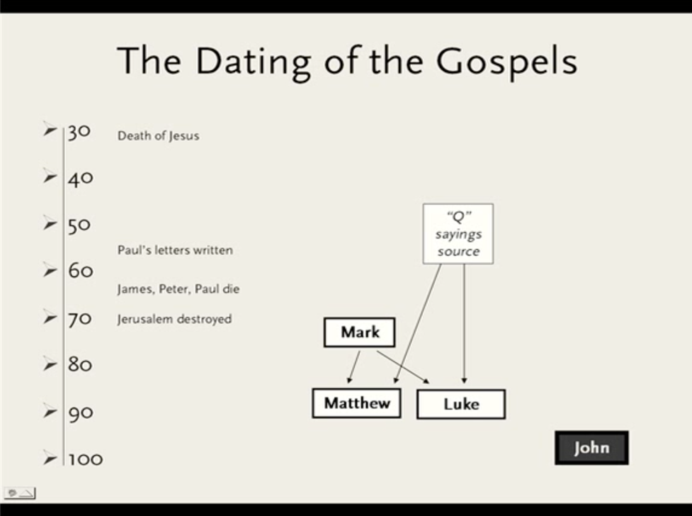

Both Matthew and John, the two disciples of Christ, did not write any Gospel:
As for the Gospel of Matthew and the Gospel of John, we will review in the coming chapters, God willing, evidence that they were not written, neither from Matthew nor from John, the two disciples of Christ.

Two new disciples of Christ in the Gospels:
1- ‘Judah, brother of James’, OR ‘Lebbaeus, whose surname was Thaddaeus’?
- The Gospel of Luke has mentioned the name "Judas, brother of James" among the names of the disciples -meaning James the son of Alphaeus-, while did not mention the name of "Lebbaeus, whose surname was Thaddaeus." However, the Gospel of Matthew and the Gospel of Mark have mentioned the name "Lebbaeus, whose surname was Thaddaeus," while did not mention the name "Judas, brother of James".
I looked into the responses of many priests to this contradiction, and I found them claiming the following:
1) That the name “Lebbaeus” or “Thaddaeus” is the second name for “Judas,” the brother of James. This is because the custom took place among the Jews that one person may have two names.
2) The Gospel of Matthew has mentioned the name "Lebbaeus, whose surname was Thaddaeus" among the names of the disciples, and the same Gospel has mentioned his other name "Judas" when it spoke about the brothers of Christ in chapter 13, verse 55: "⁵⁵ Is not this the carpenter's son? is not his mother called Mary? and his brethren, James, and Joses, and Simon, and Judas?" Hence, Judas, the brother of Christ, is himself Lebbaeus, the disciple of Jesus.
Response to this claim:
1) As for “Lebbaeus” that he had a second name as was the custom of the Jews; we say yes, he had two names, that were "Lebbaeus" and "Thaddeus" and this is clearly stated in the Bible, moreover, there is no need to create for him a third name which is "Judas" to cover this apparent contradiction between the Gospels regarding the names of the disciples.
2) As for the claim that the Gospel of Matthew mentioned the name "Lebbaeus, whose surname was Thaddaeus" in the names of the disciples of Christ, then it mentioned his other name "Judas" when it spoke about the brothers of Christ, accordingly, Judas, the brother of Christ, is himself Lebbaeus, the disciple of Jesus. We say; that this is an apparent forgery and an attempt to delude the reader that the disciple of Christ "Lebbaeus" and the brother of Christ "Judas" were the same person. The Gospel of Luke (6:16) mentioned that Judas is the brother of James and not Jesus. Moreover, The brothers of Christ were not among the twelve disciples, as mentioned in the Gospel of John, chapter 6, verse 67, which spoke about the twelve disciples of Christ who believed in him:
"⁶⁷ Then said Jesus unto the twelve, Will ye also go away? ⁶⁸ Then Simon Peter answered him, Lord, to whom shall we go? thou hast the words of eternal life. ⁶⁹ And we believe and are sure that thou art that Christ, the Son of the living God. ⁷⁰ Jesus answered them, Have not I chosen you twelve, and one of you is a devil?"
Then the same Gospel in chapter 7, verse 3-5, described the brothers of Christ as not believing in him: "³ His brethren therefore said unto him, Depart hence, and go into Judaea, that thy disciples also may see the works that thou doest. ⁴ For there is no man that doeth anything in secret, and he himself seeketh to be known openly. If thou do these things, shew thyself to the world. ⁵ For neither did his brethren believe in him."
The strange thing is that I found many popular Christian websites that had invented a new name for Lebbaeus, which is "Judas Thaddaeus". In other words, they created this new name so that they would delude the reader that the disciple of Christ "Lebbaeus, whose surname was Thaddaeus" is he himself "Judas" the brother of Christ, thus, the contradiction between the gospels in the names of the disciples would be covered.
3) The Gospel of Luke mentioned that “Judas” is the brother of James the son of Alphaeus, whereas the two Gospels of Matthew and Mark did not claim that “Thaddaeus” or “Lebbaeus” is the brother of James the son of Alphaeus. The two gospels of Matthew and Mark were very caring to mention who is brother to whom. For example, they mentioned that Andrew is the brother of Simon who is called Peter, and John the son of Zebedee is the brother of James the son of Zebedee. However, they neither mentioned that James the son of Alphaeus had a brother, nor that Thaddaeus or Lebbaeus had any relationship with James, the son of Alphaeus.
4) The Gospel of John chapter 14, verse 22 says: "²² Judas saith unto him, not Iscariot, Lord, how is it that thou wilt manifest thyself unto us, and not unto the world?" As we see here that the writer of the Gospel of John mentioned the name "Judas," but out of his fear that the reader might be confused with "Judas Iscariot", the writer resorted to define Judas that he is not Iscariot.
If it was true that Judas the brother of James had two other names, namely, Lebbaeus and Thaddaeus, the writer of the Gospel of John would use either of them, for example he could say, "Thaddaeus saith unto him" or "Lebbaeus saith unto him" or "Lebbaeus, whose surname was Thaddaeus saith unto him" or "Judas, whose surname was Thaddaeus saith unto him" or "Judas Thaddaeus saith unto him" or " Judas Lebbaeus saith unto him.” However, instead, he said, "Judas, not Iscariot."

2- Nathanael:
The Gospel of John mentioned a new name that was not mentioned in any other Gospel, which is "Nathanael."
That is why the American bishop John Shelby Spong said:
"Among the conclusions that I have reached in my intensive five-year-long study of John’s Gospel are these:
1) There is no way that the Fourth Gospel was written by John Zebedee or by any of the disciples of Jesus.
2) Many of the characters who appear in the pages of the Fourth Gospel are literary creations of its author and were never intended to be understood as real people, who actually lived in history. This includes Nathaniel, who is introduced with great fanfare in chapter one and is treated in John’s Gospel as one of “the Twelve,”
3) There is probably not a single word attributed to Jesus in this book that the Jesus of history actually spoke. This includes all the “I Am” sayings and all of the “Farewell Discourses.”
4) Not one of the signs (the Fourth Gospel’s word for miracles) recorded in this book was, in all probability, something that actually happened. This means that Jesus never changed water into wine (which is neither mentioned nor hinted in any of the other three gospels), fed a multitude with five loaves and two fish or raised Lazarus from the dead (which is neither mentioned nor hinted in any of the other three gospels and was only mentioned in the Gospel of John, even though it was written the last)."

Conclusion:
On this, it is clear that the scribes of those four gospels neither knew each other, nor saw each other, nor were disciples of Jesus. They floundered even in mentioning the names of the disciples of Jesus. If both John and Mathew were indeed disciples of Christ, how then did the Gospel of John mention the name of ‘Nathanael’, whereas the Gospel of Matthew neither mentioned it nor knew it?

Chapter nine

Who wrote the Gospel according to Matthew’s account?
Regarding the Gospel of Matthew, it was not written from Matthew the publican, the disciple of Christ, for the following reasons:
1- Date of writing the Gospel of Matthew:
Christian theologians state that the Gospel of Matthew was written in the year 90 CE, and that Christ died at the age of 33, and his death was in the year 30 CE, meaning that the Gospel of Matthew was written 60 years after Jesus. Therefore, if Matthew the publican was the author of the Gospel of Matthew, how old was he at the time of writing it? If we assume that Matthew the publican was about the age of Christ -with slightly more or less- when they met, accordingly, his age at the time of writing that Gospel was 90 years old, which is unreasonable for a ninety-year-old man to write a Gospel. Moreover, if we accept that he wrote that Gospel at the age of ninety; why he waited for sixty years to write his Gospel? Was it not better to write it immediately after the incidents that occurred to Christ, in order not to forget any of them or to write them wrongly while recalling them? If the Holy Spirit were the one who inspired him to write, then why did it not reveal to him before and waited all of this time, preferring to reveal first to Mark who was not even a disciple?

2- The writer spoke in the absent form about Matthew the publican and the disciples of Jesus Christ:
The writer of the Gospel of Matthew spoke about Matthew the publican, the disciple of Christ, in the form of the absent, which means that Matthew the publican is not the author of the Gospel according to Matthew's account. Moreover, the writer of this Gospel spoke about the disciples of Christ in the form of the absent, and sometimes as if he did not know them, which means that he is not one of them.
"⁹ And as Jesus passed forth from thence, he saw a man, named Matthew, sitting at the receipt of custom: and he saith unto him, Follow me. And he arose, and followed him." (Matthew 9:9)
Important note: This verse is written in the Greek Bible, but as follows: "And that man rose up and followed him." The word "that man" here is conclusive evidence that the writer of the Gospel of Matthew was not Matthew the publican.
"⁵⁰ And Jesus said unto him, Friend, wherefore art thou come? Then came they, and laid hands on Jesus and took him. ⁵¹ And, behold, one of them which were with Jesus stretched out his hand, and drew his sword, and struck a servant of the high priest's, and smote off his ear." (Matthew 26:50)
Note: As we see here, he spoke of the disciples of Christ in the form of the absent, saying, "one of them which were with Jesus." However, Matthew the publican was present with the rest of the disciples when Jesus was arrested.
Besides, why did the author of this Gospel not mention the name of the disciple who drew his sword and struck the servant? Why did he say "one of them" and did not say his name directly? Did he not know him?
"⁵⁶ But all this was done, that the scriptures of the prophets might be fulfilled. Then all the disciples forsook him, and fled. ⁵⁷ And they that had laid hold on Jesus led him away to Caiaphas the high priest, where the scribes and the elders were assembled. ⁵⁸ But Peter followed him afar off unto the high priest's palace, and went in, and sat with the servants, to see the end." (Matthew 26:56-58)
Note: The Gospel writer mentioned here that all the disciples left Christ and fled, even Peter had followed him from afar. Therefore, if as claimed that the writer of the Gospel of Matthew was Matthew the publican, the disciple of Christ, how can we trust a gospel written by a man who left Christ, abandoned him and fled? How can this man be filled with the Holy Spirit as they claim and then leave everything he believes in and escapes to save his life? Do not Christians claim that Jesus is God? How can they trust someone who left their God and fled?
One may say: "The disciples had to flee to save their lives to continue preaching the religion of Christ." However, this is invalid claim because there is no evidence that any of the twelve disciples of Christ had preached the religion of Christ; nevertheless, who preached and spread the religion of Christianity was Paul, who never met Christ in his life.
"¹ And when he had called unto him his twelve disciples, he gave them power against unclean spirits, (so they) to cast them out, and to heal all manner of sickness and all manner of disease. ² Now the names of the twelve apostles are these; The first, Simon, who is called Peter, and Andrew his brother; James the son of Zebedee, and John his brother; ³ Philip, and Bartholomew; Thomas, and Matthew the publican; James the son of Alphaeus, and Lebbaeus, whose surname was Thaddaeus; ⁴ Simon the Canaanite, and Judas Iscariot, who also betrayed him. ⁵ These twelve Jesus sent forth, and commanded them, saying, Go not into the way of the Gentiles, and into any city of the Samaritans enter ye not." (Matthew 10:1-5)
Thus, we find that the writer of this Gospel did not talk about the disciples of Christ in the form of the present, such as "called us" or "gave us," however, he spoke in the form of the absent and said "called them" and "gave them". Even when he mentioned the name of Matthew, the disciple of Christ, he spoke in the form of the absent, "Matthew the publican", instead of saying "and me Matthew". If you, dear reader, continue to read that Gospel, you will find that the writer always used the form of the absent when talking about the disciples of Jesus.

3- The author's name was not mentioned inside the Gospel:
No mention of the author's name anywhere in this Gospel. In fact, this Gospel was an anonymous book, just like dozens of other books that were widespread in the middle of the second century, and they were all called Gospels. Later, some of those Gospels were chosen to be canonical Gospels, while the others were called Apocrypha. Choosing any Gospel to be canonical or Apocrypha was subject to whims and not to evidence. The Gospel which was considered as canonical for some early Church Fathers, was considered Apocrypha to the others. It was all a struggle between the views of the early Church Fathers, and there was no clear definitive evidence. As for the phrase "the Gospel according to Matthew’s account," it was invented in the second century by Irenaeus. There is no evidence of the attribution of this Gospel to Matthew the publican except Irenaeus’s claim.

4- Not mentioning vital incidents that Jesus did in front of his disciples:
One of the most peremptory evidence that both the Gospel of Matthew and the Gospel of John were not written by Matthew the publican and John the son of Zebedee, the two disciples of Christ, is that both of these Gospels did not mention the incident of Christ's ascension to heaven after he appeared to his disciples after the crucifixion incident. This incident was mentioned in both the Gospel of Luke (chapter 24, verse 51) and the Gospel of Mark (chapter 16, verse 19). How come such a vital incident not be mentioned by the Gospel of Matthew and the Gospel of John if the authors were indeed disciples of Christ?
"⁵¹ And it came to pass, while he blessed them, he was parted from them, and carried up into heaven." (Luke 24:51)
"¹⁹ So then after the Lord had spoken unto them, he was received up into heaven, and sat on the right hand of God." (Mark 16:19)

5- Not mentioning the miracle of reviving Lazarus and the miracle of turning water into wine:
The miracle of Lazarus' resurrection after his death that mentioned in the Gospel of John (chapter 11, verse 1) is a fundamental miracle to the Church because it is the basis on which the Church relies to claim the divinity of Christ. Indeed, in all Hollywood films about Christ that are broadcasting in all Christian countries during Easter, filmmakers never forgot to add the scene of Lazarus when he rose from the death and got out of his grave. Therefore, how can the Gospel of Matthew not mentioning this miracle or even hinting about it, if the writer of this Gospel is indeed Matthew the publican, the disciple of Christ?
The same thing happened with the miracle of turning water into wine, that mentioned in the Gospel of John (chapter 2, verse 2). How can the Gospel of Matthew not mentioning this significant miracle or even hinting about it, if the writer of this Gospel is indeed Matthew the publican, the disciple of Christ?
Either that the writer of the Gospel of Matthew is not Matthew the publican, the disciple of Christ, or that those miracles mentioned in the Gospel of John and were not mentioned in any of the other three Gospels did not happen at all, or both.

6- Mention a false genealogy of Jesus Christ:
The writer of the Gospel of Matthew began his Gospel by mentioning a false genealogy of Jesus Christ (Matthew 1:1). As long as the Christians believe that Jesus Christ did not has a human father, how did the author of this Gospel attribute this genealogy to him, and from where did he learn it with such extreme detail, beginning from Abraham down to Jesus Christ?
The evidence that this genealogy is false; is the extreme contradiction between it and the one mentioned in the Gospel of Luke. Whereas the Gospel of Matthew mentioned that king David had born Solomon and from Solomon the lineage extended to Christ, the Gospel of Luke mentioned that king David had born Nathan and from Nathan the lineage extended to Christ, but with totally different names from those mentioned in the Gospel of Matthew. Which of them is telling the truth and which is lying?
Furthermore, another peremptory evidence that this genealogy is false; is that the author of the Gospel of Matthew intentionally has put names of prostitutes in this genealogy. For example, he mentioned in Chapter 1: "³ Judas begat Phares and Zara of Thamar,” and "⁵ Salmon begat Booz of Rachab,” and "⁶ David the king begat Solomon of her that had been the wife of Urias."
The people, in general, are attributed to the names of their fathers and not to their mothers, and indeed, the author of this gospel mentioned the genealogy of Christ extending through the line of the male fathers, however, what is his intention to mention into the genealogy of Christ the names of those adulterous women "Thamar and Rachab and the woman that had been the wife of Urias"?
For the story of Thamar, the adulterer who committed adultery with her father-in-law and conceived, look (Genesis 38:6-18).
For the story of Rachab the adulterer, look (Joshua 2:1)
For the story of the wife of Urias (Uriah the Hittite), whose name was Bathsheba look (II Samuel 11:1). Bathsheba has betrayed her husband with King David, while her husband was a loyal leader in King David's army in the war, and after she committed adultery with King David and conceived, King David conspired against her husband to be killed in the war. After her husband was killed, King David took her to his palace and married her.
The author of the Gospel of Matthew, mentioned as well the name of Ruth in the genealogy of Christ, "⁵ Booz begat Obed of Ruth" (Chapter 1:5).
For the story of Ruth with Booz (Boaz) look (book of Ruth 3:2), however, the story was mentioned with much ambiguity in words. It is not known with such ambiguity what happened between Boaz and Ruth before their marriage. That is why we find that many critics are accusing Ruth of adultery with Boaz before their marriage, while others are denying that accusation and describing her as a saint. This is because the context of the words does not show what happened.
But after the author of the Gospel of Matthew mentioned her name in the genealogy of Christ, with the other three adulterous women, he likely believed that she might have committed adultery with Boaz, thus, he mentioned her name to defame the genealogy of Christ.
Among the critics who accused Ruth of adultery with Boaz before their marriage, is the American author, Jonathan Kirsch, in his book "The Harlot by the Side of the Road: Forbidden Tales of the Bible," he said:
"Some passages of the Bible are bawdier than we suspect because idiomatic expressions in the text are translated literally in order to conceal their real meaning. The best example is found in the familiar story of Ruth, where the young widow's mother-in-law sends her to the threshing-floor of a wealthy landowner named Boaz. “And it shall be, when he lieth down,” says the wily mother-in-law, “thou shalt go in, and uncover his feet, and lay thee down; and he will tell thee what thou shalt do” (Ruth 3:4). The scene is a bit baffling —why, after all, is she uncovering his feet?—until we discover what the translators have failed to tell us: the word “feet” (or “legs”) in biblical Hebrew is sometimes a euphemism for the male sexual organ. What Naomi is telling Ruth to do to Boaz, we realize now, is to expose his genitalia while he sleeps—and see what happens when he wakes up: “[H]e will tell thee what thou shalt do.” What actually happens between Boaz and Ruth is obscured by yet another untranslated euphemism. Boaz wakes up to find his genitals exposed and lovely young Ruth beside him. “Who art thou?” he asks. “I am Ruth thy handmaid,” she replies, “spread therefore thy skirt over thy handmaid” (Ruth 3:9). But, once again, the translator neglects to tell us that “spreading one’s skirt” is a biblical euphemism for sexual intercourse: “For a man to spread his ‘skirt’ over a woman,” cracks Bible scholar Marvin H. Pope, “meant more than merely preventing a chill."

7- The writer of the Gospel of Luke not knowing the existence of a Gospel written by Matthew, the disciple:
As we mentioned before, both the Gospel of Matthew and the Gospel of Luke have mentioned genealogy of Christ, but with very different and contradictory names. If Matthew, the disciple, was the one who wrote the Gospel according to Matthew's account, and he mentioned the genealogy of Christ, would not Luke (who was not a disciple of Christ) follow what mentioned by Matthew the disciple and write the same genealogy for Christ?
This affirms that Luke did not know that there was any Gospel written by Matthew, the disciple of Christ.

8- Mentioning myths in the Gospel of Matthew:
"⁵⁰ Jesus, when he had cried again with a loud voice, yielded up the ghost. ⁵¹ And, behold, the veil of the temple was rent in twain from the top to the bottom; and the earth did quake, and the rocks rent; ⁵² And the graves were opened; and many bodies of the saints which slept arose, ⁵³ And came out of the graves after his resurrection, and went into the holy city, and appeared unto many. ⁵⁴ Now when the centurion, and they that were with him, watching Jesus, saw the earthquake, and those things that were done, they feared greatly, saying, Truly this was the Son of God." (Matthew 27:50-54)
This exciting story that says that the graves were opened and the rotting bodies of the saints came out of the graves and entered the city and appeared to the people, makes us feel like if we are watching ‘the Lord of the Rings’ movie or one of the science fiction movies. There is no evidence that this story has occurred; besides, this story was not mentioned in any of the other Gospels, only the Gospel of Matthew exclusively mentioned it.
Also, the thrilling story of the split of the Temple veil, although it was mentioned in the three Gospels, Matthew, Mark, and Luke, it was not mentioned in the Gospel of John. If that story was not science fiction, then how did not the Gospel of John mention it?

Chapter Ten

Who wrote the Gospel according to John’s account?
Concerning the Gospel according to John's account, it was not written from John the son of Zebedee, the disciple of Christ, for the following reasons:
1- Date of writing of the Gospel according to John's account:
Christian theologians state that the Gospel of John was written in the year 100 CE and that Christ died at the age of 33, and his death was in the year 30 CE, meaning, that the Gospel of John was written 70 years after Jesus. Therefore, if John the disciple was the author of the Gospel of John, how old was he at the time of writing it? If we assume that John the disciple was about the age of Christ -with slightly more or less- when they met, then his age at the time of writing that gospel was 100 years old, which is unreasonable for a hundred-year-old man to write a gospel.

2- The writer spoke in the absent form about John the son of Zebedee, and the disciples of Jesus Christ:
Meaning, that the author of this Gospel is not one of the disciples of Christ.
"²² When therefore he was risen from the dead, his disciples remembered that he had said this unto them; and they believed the scripture, and the word which Jesus had said." (John 2:22)

3- Confession of the writer of the Gospel of John that he is not one of the disciples of Christ:
"²⁰ Then Peter, turning about, seeth the disciple whom Jesus loved following; which also leaned on his breast at supper, and said, Lord, which is he that betrayeth thee? ²¹ Peter seeing him saith to Jesus, Lord, and what shall this man do? ²² Jesus saith unto him, If I will that he tarry till I come, what is that to thee? follow thou me. ²³ Then went this saying abroad among the brethren, that that disciple should not die: yet Jesus said not unto him, He shall not die; but, If I will that he tarry till I come, what is that to thee? ²⁴ This is the disciple which testifieth of these things, and wrote these things: and we know that his testimony is true. ²⁵ And there are also many other things which Jesus did, the which, if they should be written every one, I suppose that even the world itself could not contain the books that should be written. Amen." (John 21:20-25)
As we mentioned earlier in chapter two of this book, that the Church claims that the writer of the Gospel of John identified himself by mentioning himself as “the disciple whom Jesus loved,” however, this claim is invalid because the writer of this Gospel was talking about the disciple whom Jesus loved in the form of the absent. Besides, where is the name of John in that phrase, "The disciple whom Jesus loved"?
The phrase “And we know that his testimony is true,” is a clear evidence that the author of this gospel is not the disciple whom Jesus loved, but rather another unknown person. Based on this, how could we believe what is written by an unknown person who was not even an eyewitness to the events?
Also, see what Jesus said to Peter: "²² Jesus saith unto him, If I will that he tarry till I come, what is that to thee? follow thou me. ²³ Then went this saying abroad among the brethren, that that disciple should not die: yet Jesus said not unto him, He shall not die; but, If I will that he tarry till I come, what is that to thee?" This phrase means that that disciple whom Jesus loved has died already, and the writer of this Gospel was trying to justify his death, because of what was believed that he would not die. This affirms that that disciple was not the one who wrote this Gospel because he could not Justify his death after his death.

4- The author's name was not mentioned inside the gospel:
No mention of the author's name anywhere in this Gospel. This Gospel was an anonymous book, just like dozens of other books that were widespread in the middle of the second century, and they were all called Gospels. Later some of them were chosen to be canonical Gospels, while the others called Apocrypha. As for the phrase "the Gospel according to John’s account,” it was invented in the second century by Irenaeus, and there is no evidence of this attribution except Irenaeus’s claiming.

5- Not mentioning the story of ascending to heaven after the fiction of crucifixion and resurrection from the dead:
One of the most peremptory evidence that both the Gospel of Matthew and the Gospel of John, were not written by Matthew the publican and John the son of Zebedee, the two disciples of Christ, is that both of them did not mention the story of Christ's ascension to heaven after the fiction of crucifixion and resurrection from the dead.
This story was mentioned in the Gospel of Luke and the Gospel of Mark, that all of Jesus’s disciples stood to say goodbye to Jesus when he was ascending to heaven. If the Gospel of Matthew and the Gospel of John were written by the two Christ’s disciples, Matthew and John, then how did they not mention in their Gospels such critical incident?
"⁵¹ And it came to pass, while he blessed them, he was parted from them, and carried up into heaven. ⁵² And they worshipped him, and returned to Jerusalem with great joy:" (Luke 24:51-52)
"¹⁹ So then after the Lord had spoken unto them, he was received up into heaven, and sat on the right hand of God. ²⁰ And they went forth, and preached every where, the Lord working with them, and confirming the word with signs following. Amen." (Mark 16:19-20)

6- Not mentioning the miracle of reviving the dead girl:
"³⁵ While he yet spake, there came from the ruler of the synagogue's house certain which said, Thy daughter is dead: why troublest thou the Master any further? ³⁶ As soon as Jesus heard the word that was spoken, he saith unto the ruler of the synagogue, Be not afraid, only believe. ³⁷ And he suffered no man to follow him, save Peter, and James, and John the brother of James. ³⁸ And he cometh to the house of the ruler of the synagogue, and seeth the tumult, and them that wept and wailed greatly. ³⁹ And when he was come in, he saith unto them, Why make ye this ado, and weep? the damsel is not dead, but sleepeth. ⁴⁰ And they laughed him to scorn. But when he had put them all out, he taketh the father and the mother of the damsel, and them that were with him, and entereth in where the damsel was lying. ⁴¹ And he took the damsel by the hand, and said unto her, Talitha cumi; which is, being interpreted, Damsel, I say unto thee, arise. ⁴² And straightway the damsel arose, and walked; for she was of the age of twelve years. And they were astonished with a great astonishment." (Mark 5:35)
"⁴⁹ While he yet spake, there cometh one from the ruler of the synagogue's house, saying to him, Thy daughter is dead; trouble not the Master. ⁵⁰ But when Jesus heard it, he answered him, saying, Fear not: believe only, and she shall be made whole. ⁵¹ And when he came into the house, he suffered no man to go in, save Peter, and James, and John, and the father and the mother of the maiden. ⁵² And all wept, and bewailed her: but he said, Weep not; she is not dead, but sleepeth. ⁵³ And they laughed him to scorn, knowing that she was dead. ⁵⁴ And he put them all out, and took her by the hand, and called, saying, Maid, arise. ⁵⁵ And her spirit came again, and she arose straightway: and he commanded to give her meat." (Luke 8:49-55)
"²³ And when Jesus came into the ruler's house, and saw the minstrels and the people making a noise, ²⁴ He said unto them, Give place: for the maid is not dead, but sleepeth. And they laughed him to scorn. ²⁵ But when the people were put forth, he went in, and took her by the hand, and the maid arose." (Matthew 9:23-25)
Although John the son of Zebedee was an eyewitness to that unique miracle, the Gospel according to John’s account did not mention it, and it was mentioned in the other three Gospels. Take into consideration that both Mark and Luke are not among the names of Christ’s disciples, and as for Matthew the publican (if we assume that he is the writer of the Gospel of Matthew) did not witness that unique miracle.

7- Not mentioning the transfiguration incident:
"¹ And after six days Jesus taketh Peter, James, and John his brother, and bringeth them up into an high mountain apart, ² And was transfigured before them: and his face did shine as the sun, and his raiment was white as the light. ³ And, behold, there appeared unto them Moses and Elias talking with him. ⁴ Then answered Peter, and said unto Jesus, Lord, it is good for us to be here: if thou wilt, let us make here three tabernacles; one for thee, and one for Moses, and one for Elias. ⁵ While he yet spake, behold, a bright cloud overshadowed them: and behold a voice out of the cloud, which said, This is my beloved Son, in whom I am well pleased; hear ye him." (Matthew 17:1-5)
"²⁸ And it came to pass about an eight days after these sayings, he took Peter and John and James, and went up into a mountain to pray. ²⁹ And as he prayed, the fashion of his countenance was altered, and his raiment was white and glistering. ³⁰ And, behold, there talked with him two men, which were Moses and Elias: ³¹ Who appeared in glory, and spake of his decease which he should accomplish at Jerusalem. ³² But Peter and they that were with him were heavy with sleep: and when they were awake, they saw his glory, and the two men that stood with him. ³³ And it came to pass, as they departed from him, Peter said unto Jesus, Master, it is good for us to be here: and let us make three tabernacles; one for thee, and one for Moses, and one for Elias: not knowing what he said. ³⁴ While he thus spake, there came a cloud, and overshadowed them: and they feared as they entered into the cloud. ³⁵ And there came a voice out of the cloud, saying, This is my beloved Son: hear him." (Luke 9:28-35)
Although John the son of Zebedee was an eyewitness to that unique miracle, the Gospel according to John’s account did not mention it, and it was mentioned in the Gospel of Matthew and Luke. This is a conclusive evidence that the author of the Gospel of John is not John the son of Zebedee.

8- Not mentioning the story of how Jesus met for the first time John the son of Zebedee and his brother James:
This story is mentioned in the Gospels of Matthew, Mark, and Luke, but it is not mentioned in the Gospel of John. If John the son of Zebedee, the disciple of Jesus, was the one who wrote the Gospel of John, would not he mention how he met with Jesus for the first time?

9- Sharp difference between the Gospel of John and the other three Gospels in stating the story of Jesus' encounter with Simon (Peter), Andrew, James, and John:
"¹⁸ And Jesus, walking by the sea of Galilee, saw two brethren, Simon called Peter, and Andrew his brother, casting a net into the sea: for they were fishers. ¹⁹ And he saith unto them, Follow me, and I will make you fishers of men. ²⁰ And they straightway left their nets, and followed him. ²¹ And going on from thence, he saw other two brethren, James the son of Zebedee, and John his brother, in a ship with Zebedee their father, mending their nets; and he called them. ²² And they immediately left the ship and their father, and followed him." (Matthew 4:18-22)
"¹⁶ Now as he walked by the sea of Galilee, he saw Simon and Andrew his brother casting a net into the sea: for they were fishers. ¹⁷ And Jesus said unto them, Come ye after me, and I will make you to become fishers of men. ¹⁸ And straightway they forsook their nets, and followed him. ¹⁹ And when he had gone a little farther thence, he saw James the son of Zebedee, and John his brother, who also were in the ship mending their nets. ²⁰ And straightway he called them: and they left their father Zebedee in the ship with the hired servants, and went after him." (Mark 1:16-20)
"² And saw two ships standing by the lake: but the fishermen were gone out of them, and were washing their nets. ³ And he entered into one of the ships, which was Simon's, and prayed him that he would thrust out a little from the land. And he sat down, and taught the people out of the ship. ⁴ Now when he had left speaking, he said unto Simon, Launch out into the deep, and let down your nets for a draught. ⁵ And Simon answering said unto him, Master, we have toiled all the night, and have taken nothing: nevertheless at thy word I will let down the net. ⁶ And when they had this done, they inclosed a great multitude of fishes: and their net brake. ⁷ And they beckoned unto their partners, which were in the other ship, that they should come and help them. And they came, and filled both the ships, so that they began to sink. ⁸ When Simon Peter saw it, he fell down at Jesus' knees, saying, Depart from me; for I am a sinful man, O Lord. ⁹ For he was astonished, and all that were with him, at the draught of the fishes which they had taken: ¹⁰ And so was also James, and John, the sons of Zebedee, which were partners with Simon. And Jesus said unto Simon, Fear not; from henceforth thou shalt catch men. ¹¹ And when they had brought their ships to land, they forsook all, and followed him." (Luke 5:2-11)
"³⁵ Again the next day after John (the Baptist) stood, and two of his disciples; ³⁶ And looking upon Jesus as he walked, he saith, Behold the Lamb of God. ³⁷ And the two disciples heard him speak, and they followed Jesus. ³⁸ Then Jesus turned, and saw them following, and saith unto them, What seek ye? They said unto him, Rabbi, (which is to say, being interpreted, Master,) where dwellest thou? ³⁹ He saith unto them, Come and see. They came and saw where he dwelt, and abode with him that day: for it was about the tenth hour. ⁴⁰ One of the two which heard John speak, and followed him, was Andrew, Simon Peter's brother. ⁴¹ He first findeth his own brother Simon, and saith unto him, We have found the Messias, which is, being interpreted, the Christ. ⁴² And he brought him to Jesus. And when Jesus beheld him, he said, Thou art Simon the son of Jona: thou shalt be called Cephas, which is by interpretation, A stone." (John 1:35-42)
Thus, the Gospel of John is the only Gospel that did not mention the true story that the other three Gospels agreed upon, namely that Simon (Peter) and his brother Andrew and both John and James the sons of Zebedee were fishers whom Jesus met with on the beach (according to the Gospel of Matthew and the Gospel of Mark) or inside the ship at the sea (according to the Gospel of Luke).
As we see, the Gospel of John is the only one that did not mention the story of Jesus' encounter with John and James, the sons of Zebedee. Therefore, how could we accept that the writer of the Gospel of John is John the son of Zebedee, the disciple of Christ? Was he not supposed to mention the most crucial moment in his life, that changed his entire life, namely, how he met with Christ and how was that meeting?

10- Not mentioning the names of Jesus' disciples:
The other three gospels had mentioned the names of the disciples of Christ in detail. As for the Gospel of John, it is the only one that did not mention the names of the twelve disciples, except for Andrew, Peter, and Philip. And the issue of mentioning the names of the disciples is crucial, and there is no justification for its absence unless the author of this Gospel did not know their names well. Moreover, he added a new name that was not mentioned in any other Gospel, namely, "Nathanael."

11- James, the brother of John the son of Zebedee, never be mentioned in the Gospel of John:
John and James, the sons of Zebedee, were two of the disciples of Christ. If John the son of Zebedee was the one who wrote the Gospel of John, would not he mention his brother's name in his Gospel? Not even how his brother met with Jesus?

12- The author of the Gospel of John did not know Salome, the mother of John the son of Zebedee:
If John the son of Zebedee, was the author of the Gospel of John, would not he know what his mother Salome did in the service of Christ and would mention this in his Gospel?
Although Salome, the mother of John the son of Zebedee, went to the grave of Christ to anoint him with sweet spices with Mary Magdalene and Mary mother of James the less and of Joses, the writer of the Gospel of John did not mention this at all, while the Gospel of Mark had mentioned it.
"¹ And when the sabbath was past, Mary Magdalene, and Mary the mother of James, and Salome, had bought sweet spices, that they might come and anoint him. ² And very early in the morning the first day of the week, they came unto the sepulchre at the rising of the sun. ³ And they said among themselves, Who shall roll us away the stone from the door of the sepulchre? ⁴ And when they looked, they saw that the stone was rolled away: for it was very great. ⁵ And entering into the sepulchre, they saw a young man sitting on the right side, clothed in a long white garment; and they were affrighted. ⁶ And he saith unto them, Be not affrighted: Ye seek Jesus of Nazareth, which was crucified: he is risen; he is not here: behold the place where they laid him. ⁷ But go your way, tell his disciples and Peter that he goeth before you into Galilee: there shall ye see him, as he said unto you." (Mark 16:1-7)
"¹ The first day of the week cometh Mary Magdalene early, when it was yet dark, unto the sepulchre, and seeth the stone taken away from the sepulchre. ² Then she runneth, and cometh to Simon Peter, and to the other disciple, whom Jesus loved, and saith unto them, They have taken away the Lord out of the sepulchre, and we know not where they have laid him. ³ Peter therefore went forth, and that other disciple, and came to the sepulchre. … ¹¹ But Mary stood without at the sepulchre weeping: and as she wept, she stooped down, and looked into the sepulchre, ¹² And seeth two angels in white sitting, the one at the head, and the other at the feet, where the body of Jesus had lain. ¹³ And they say unto her, Woman, why weepest thou? She saith unto them, Because they have taken away my Lord, and I know not where they have laid him. ¹⁴ And when she had thus said, she turned herself back, and saw Jesus standing, and knew not that it was Jesus." (John 20:1-3, 4-11)
"¹ In the end of the sabbath, as it began to dawn toward the first day of the week, came Mary Magdalene and the other Mary to see the sepulchre. ² And, behold, there was a great earthquake: for the angel of the Lord descended from heaven, and came and rolled back the stone from the door, and sat upon it. ³ His countenance was like lightning, and his raiment white as snow: ⁴ And for fear of him the keepers did shake, and became as dead men." (Matthew 28:1-4)
"⁵⁵ And the women also, which came with him from Galilee, followed after, and beheld the sepulchre, and how his body was laid. ⁵⁶ And they returned, and prepared spices and ointments; and rested the sabbath day according to the commandment. ¹ Now upon the first day of the week, very early in the morning, they came unto the sepulchre, bringing the spices which they had prepared, and certain others with them. ² And they found the stone rolled away from the sepulchre. … ⁹ And returned from the sepulchre, and told all these things unto the eleven, and to all the rest. ¹⁰ It was Mary Magdalene and Joanna, and Mary the mother of James, and other women that were with them, which told these things unto the apostles. ¹¹ And their words seemed to them as idle tales, and they believed them not. ¹² Then arose Peter, and ran unto the sepulchre; and stooping down, he beheld the linen clothes laid by themselves, and departed, wondering in himself at that which was come to pass." (Luke 23:55-56, - 24:1-3,9-12)
Among the peremptory evidence that all the writers of the Gospels neither were disciples of Christ nor eye-witnesses, is their tremendous contradictions in each story. Whereas the writer of the Gospel of Mark mentioned that three women went to the grave of Christ, including Salome, the mother of John the son of Zebedee, the writer of the Gospel of John did not know that the mother of John the son of Zebedee went to the grave, thus, he mentioned that only one woman went to the grave, namely, Mary Magdalene. As for the Gospel of Luke, it mentioned that many women went to the grave, including Mary Magdalene, Joanna, and Mary the mother of James. Thus, the Gospel of Luke mentioned three names of the women that went to the grave, but different from the Gospel of Mark, namely it mentioned the name of Joanna instead of the name of Salome. This Joanna is the wife of Chuza Herod's steward, whose name is mentioned in (Luke 8:3). As for the Gospel of Matthew, it mentioned that only two women went to the grave, namely, Mary Magdalene and the other Mary.
According to the Gospel of Mark, they found that the stone had rolled and inside the tomb there was an angel in the form of a young man, who told them that Jesus is not here inside the tomb and they have to tell the disciples to go to Galilee to meet him. As for the Gospel of John, the stone had also rolled, but it mentioned that Peter and another disciple also went to the tomb, and that Mary Magdalene saw two angels inside the grave and Christ appeared to her outside the grave. As for the Gospel of Luke, the stone had also rolled, but later only Peter went there, and there is no mention of another disciple with him. As for the Gospel of Matthew, the stone had not rolled when the two women went there, but a great earthquake occurred because an angel had descended from the heaven and rolled the stone in front of everyone, and for fear of him the keepers did shake and became as dead men.

13- Not mentioning the genealogy of Jesus and his miraculous birth from a virgin and the incident of Temptation of Christ by Satan:
These are critical stories and incidents that have been mentioned in the other three Gospels, therefore, how did the writer of the Gospel of John not mention them if he was indeed John, the disciple? Look the incident of ‘Temptation of Christ’ (Matthew 4:1-11), (Mark 1:12-13), (Luke 4:1-13).

14- The author of this Gospel spoke the Greek language fluently:
Theologians have unanimously agreed that this Gospel was written in the eloquent and high-level Greek language, therefore, how could it be that John the son of Zebedee, the simple fisherman, was the one who wrote this Gospel in that high-level Greek language and a refined style that the great Greek poets could envy him about it? How could a simple fisherman quote from Greek philosophy?
Christian theologians have admitted that the disciples did not know the Greek language, for example, Peter needed Mark as a translator. Following is a description of John the son of Zebedee and Peter in the Acts of the Apostles chapter 4, verse 13: "¹³ Now when they saw the boldness of Peter and John, and perceived that they were unlearned and ignorant men, they marvelled; and they took knowledge of them, that they had been with Jesus."
‘Uunlearned and ignorant,’ this is the description of John the son of Zebedee in the book of Acts. Such description is sufficient to demonstrate the impossibility of being the author of the Gospel attributed to him. That Gospel which begins with a phrase quoted from the words of Philo, the Alexandrian Jewish philosopher.

15- Not mentioning the miracle of Peter walking on water:
"²⁶ And when the disciples saw him walking on the sea, they were troubled, saying, It is a spirit; and they cried out for fear. ²⁷ But straightway Jesus spake unto them, saying, Be of good cheer; it is I; be not afraid. ²⁸ And Peter answered him and said, Lord, if it be thou, bid me come unto thee on the water. ²⁹ And he said, Come. And when Peter was come down out of the ship, he walked on the water, to go to Jesus." (Matthew 14:26-29)

16- Mentioning myths in the Gospel of John:
"³ In these lay a great multitude of impotent folk, of blind, halt, withered, waiting for the moving of the water. ⁴ For an angel went down at a certain season into the pool, and troubled the water: whosoever then first after the troubling of the water stepped in was made whole of whatsoever disease he had." (John 5:3-4)
However, the Gospel of John did not tell us whether that angel was still going down into the pool at the time of writing this Gospel or stopped to do so? The phrase "at a certain season" indicates that the angel stopped going down into the pool at the time of writing that gospel. Is that angel still doing so nowadays, or that was for a temporary period that ended?

Chapter Eleven

Did the Holy Spirit inspire the four Gospels?

1- The Church’s need to claim that the New Testament was inspired by the Holy Spirit:
We always find in the Church's introduction of each Gospel this phrase, "He wrote it with the inspiration of the Holy Spirit". Although there is no evidence on that, by repeating this phrase everywhere, the average Christian people become accustomed to it and be deceived by it and accordingly repeat it without verifying its authenticity. The reason why the Church attributes those four Gospels to the Holy Spirit is to affix the character of sacredness to them, thus, they become divine books written by divine inspiration and not historical books written by men. Moreover, these Gospels would have authority over Christian people, and they would adhere to them and their teachings.

2- None of the four Gospels mentioned that it was inspired by the Holy Spirit:
How can the Church claim on every occasion that the four Gospels were inspired by the Holy Spirit, whereas the gospels themselves did not claim that?

3- Why was it revealed to four people?
It is unreasonable for the Holy Spirit to inspire four people four times to write the same book. Even the strange thing about this is that the first Gospel to be written was the Gospel of Mark. Therefore, how could the Holy Spirit inspire first a person named Mark who was not one of the disciples, preferring him over the disciples who were eyewitnesses to the incidents?

4- The contradiction between the four gospels:
If the Holy Spirit were the one who inspired the four Gospels, then how could be there all these contradictions? In every story mentioned in two or more Gospels, we find sharp contradictions. Is it reasonable that the Holy Spirit inspired false information? Or did the Holy Spirit forget what it inspired before and accordingly inspired other details later? If the Holy Spirit were the one who indeed inspired those gospels, then they would be identical, without any difference in the number of chapters, verses, or even in wording and their arrangement.
"⁵⁴ Now when the centurion, and they that were with him, watching Jesus, saw the earthquake, and those things that were done, they feared greatly, saying, Truly this was the Son of God." (Matthew 27:54)
"⁴⁷ Now when the centurion saw what was done, he glorified God, saying, Certainly this was a righteous man." (Luke 23:47)

5- The Gospel of Luke admits that it was not written with a revelation from the Holy Spirit:
At the beginning of Luke’s Gospel, there is a critical confession that destroys the claim that the Gospels were inspired by the Holy Spirit, and affirms that those Gospels are not Gospels, but rather letters, declarations, and historical records. This is what we will cover in detail in the next chapter, God willing.

Chapter Twelve

Confessions of the Gospel of Luke
"¹ Forasmuch as many have taken in hand to set forth in order a declaration of those things which are most surely believed among us, ² Even as they delivered them unto us, which from the beginning were eyewitnesses, and ministers of the word; ³ It seemed good to me also, having had perfect understanding of all things from the very first, to write unto thee in order, most excellent Theophilus, ⁴ That thou mightest know the certainty of those things, wherein thou hast been instructed." (Luke 1:1-4)
Now let us analyze the confession of Luke that he wrote in that introduction, to see what Luke said by himself about himself, and not what the Church said about Luke:
1- Forasmuch as many have taken in hand to set forth in order a declaration of those things which are most surely believed among us:
This means that many people wrote Gospels on their own, and not with inspiration from the Holy Spirit. The word "many" means the presence of many Gospels, not just four Gospels. Moreover, Luke did not criticize those many gospels that appeared before him and in his time, he did not say, "However, only three of them are canonical, and my gospel is the fourth one, and the rest are not canonical Gospels; but Apocrypha."

2- Luke's confession that there were no Gospels written by the disciples of Christ:
Even surprisingly, Luke did not refer to the name of any writer of those many Gospels that were widespread. Therefore, those Gospels were written by unknown people; unknown even to Luke himself. If there were any Gospel written by any of the disciples, Luke would not dare to write a Gospel after him. He would rather mention the existence of a Gospel written by one of the disciples of Christ, or he would send to his friend Theophilus a copy of that Gospel written by one of the disciples instead of writing him a letter.

3- Luke's confession that he wrote on his own and not inspired by the Holy Spirit:
The phrase "It seemed good to me also" confirms beyond any doubt that Luke wrote this letter to his friend Theophilus without any revelation from the Holy Spirit.

4- Luke's confession that he is writing just a letter, not a gospel:
Neither did he say, "This is the gospel according to Luke's account," nor did he give his letter any sacred character. Instead, he clearly stated that he writes only a letter to his friend Theophilus, in which he tells him about the information that reached him regarding the life of Jesus.

Chapter Thirteen

The Church admits that there are forged additions in the New Testament
When you, dear reader, read one of the four Gospels, you would find in many places the presence of an asterisk (*), or note between parentheses, or note in the margin about that phrase that you read. However, many of us may pass that sign or brackets without giving it any attention and without thinking what it could mean and why it is inside that Bible. Note that this mark may not be present in some editions; because the publisher wanted to hide the problems related to that phrase.

That mark or parentheses means that there is a problem related to that word, phrase, or paragraph you read. For example, the word you read in English may be is an incorrect translation of the Hebrew Old Testament, but the Church is determined to keep it and not modify it to the correct translation. Moreover, that word or phrase or paragraph you read may be a forgery that was added in the late centuries and has no origin in the old manuscripts from the early centuries.

1- "The Virgin" is a forged translation of the Hebrew word "Almah":
"²² Now all this was done, that it might be fulfilled which was spoken of the Lord by the prophet, saying, ²³ ‘Behold, a virgin(*) shall be with child, and shall bring forth a son, and they shall call his name Emmanuel,’ which being interpreted is, God with us." (Matthew 1:22-23)
"¹⁴ Therefore the Lord himself shall give you a sign; Behold, a virgin(*) shall conceive, and bear a son, and shall call his name Immanuel." (Isaiah 7:14)
The word “Virgin” in the various translations of the Book of Isaiah is a false translation of the word “Almah” mentioned in the Book of Isaiah in the Hebrew language, which means “a young girl of childbearing age” whether she is married or not, and it has nothing to do with virginity. For example, a person might say to a family: “Behold, your young daughter has grown up and gave birth to a son.” This means that she got already married and got pregnant. However, the writer of the Gospel of Matthew to confirm that the prophecy of the prophet Isaiah applies entirely to Christ; he translated the word “Almah” with the word “Virgin”. Though Christ was never called “Emmanuel.”
Moreover, in the Book of Song of Solomon, the word “Almah” was mentioned but in the plural form “Almot.” However, whereas the English translation “International Standard Version (ISV)” translated it “young women,” “King James Version (KJV)” translated it “virgins.”
"³ The fragrance of your perfumed oil is wonderful. Your name is perfume poured out. Therefore the young women love you." (Song of Solomon 1:3 - International Standard Version (ISV))
"³ Because of the savour of thy good ointments thy name is as ointment poured forth, therefore do the virgins love thee." (Song of Solomon 1:3 - King James Version (KJV))

2- The end of the Gospel of Mark, chapter 16 from verse 9 to verse 20 are forged verses:
Chapter 16 of Mark's Gospel begins with verse 1, which says: "¹ And when the sabbath was past, Mary Magdalene, and Mary the mother of James, and Salome, had bought sweet spices, that they might come and anoint him." The church admits that this Chapter ends at verse 8, which says: "⁸ And they went out quickly, and fled from the sepulchre; for they trembled and were amazed: neither said they anything to any man; for they were afraid." On this, Mary Magdalene did not say anything to anyone because she was afraid.
Nevertheless, the Church in the late centuries did not like the story ending here without emphasizing the appearance of Christ to the disciples; thus, added Twelve additional verses to this chapter and woven an end to this chapter from the revelation of its imagination and not from the revelation of the Holy Spirit.
Thus, the Church claimed that Mary Magdalene told the disciples what happened, that Christ appeared to the disciples, that he rose to heaven and sat on the right of the Lord, and that Christ commanded them to preach the Gospel throughout the world.
The proof that these twelve verses are forged is:
1- Those twelve verses do not exist in any of the earliest and best manuscripts.
2- Their writing style is different from the rest of the Gospel of Mark.
3- There are inconsistencies between this ending and the verses that preceded. Here are the forged twelve verses that the Church added to the Gospel of Mark and still keeping them there:
"⁹ Now when Jesus was risen early the first day of the week, he appeared first to Mary Magdalene, out of whom he had cast seven devils. ¹⁰ And she went and told them that had been with him, as they mourned and wept. ¹¹ And they, when they had heard that he was alive, and had been seen of her, believed not. ¹² After that he appeared in another form unto two of them, as they walked, and went into the country. ¹³ And they went and told it unto the residue: neither believed they them. ¹⁴ Afterward he appeared unto the eleven as they sat at meat, and upbraided them with their unbelief and hardness of heart, because they believed not them which had seen him after he was risen. ¹⁵ And he said unto them, Go ye into all the world, and preach the gospel to every creature. ¹⁶ He that believeth and is baptized shall be saved; but he that believeth not shall be damned. ¹⁷ And these signs shall follow them that believe; In my name shall they cast out devils; they shall speak with new tongues; ¹⁸ They shall take up serpents; and if they drink any deadly thing, it shall not hurt them; they shall lay hands on the sick, and they shall recover. ¹⁹ So then after the Lord had spoken unto them, he was received up into heaven, and sat on the right hand of God. ²⁰ And they went forth, and preached everywhere, the Lord working with them, and confirming the word with signs following. Amen." (Mark 16:9-20)
The question that arises now is: Why does the church still keep these forged verses in the Gospel of Mark despite knowing that they are forged and not divine inspiration?

3- The verse upon which the Church relies to establish the doctrine of the Trinity is a forged:
"⁷ For there are three that bear record in heaven, the Father, the Word, and the Holy Ghost: and these three are one." (1 John 5:7)
This verse was not mentioned in any of the ancient Greek manuscripts of John's first epistle, but rather it was a comment written in the side margin of the page in a Latin translation dating back to the fifth century, but over time, it seemed good to the Catholic Church to add this comment inside the Bible and to give it the character of sacredness to convince people about the doctrine of the Trinity.
In 1502 CE, Cardinal Francisco Jiménez de Cisneros commissioned a group of Spanish translators to compile the Bible in four languages, Greek, Hebrew, Aramaic, and Latin, so that each page to have four languages in four parallel columns, to create what is known as a "Complutensian Polyglot Bible." Desiderius Erasmus was in charge of the Greek edition, which is the first edition of the Bible in the Greek language. The first and second editions of Erasmus Greek Bible were issued without containing this verse (Chapter 5 verse 7) in John's first epistle, but the Catholic Church pressed Erasmus to add it in the third edition, but he refused that, saying that he did not find that verse mentioned in any of the Greek manuscripts, but after continuing pressure on him from the Catholic Church, he was forced to agree, therefore, the third edition was issued containing that verse.
Since the ‘King James version’ was based on an English translation that was based on the third edition of Erasmus, it does contain this verse. As for the German translation by Martin Luther that was based on the second edition of Erasmus, it does not contain this verse.
That verse is still present in most editions of the Bible around the world despite the Church's knowledge that it is a forged statement that has no basis in any of the earliest manuscripts.

4- The story of the adulterous woman is a forged:
All editions of the Gospel of John nowadays contain in chapter 8 verse 3 the story of the adulterous woman, however, this story was not mentioned in any of the earliest Greek papyri which the Church cites. It was neither mentioned in the papyrus (P66) nor the papyrus (P75) nor Codex Sinaiticus nor Codex Vaticanus. Moreover, the writing style of that story differs from the writing style of the rest of the Gospel of John. Below is the papyri (P66) image without this forged story.
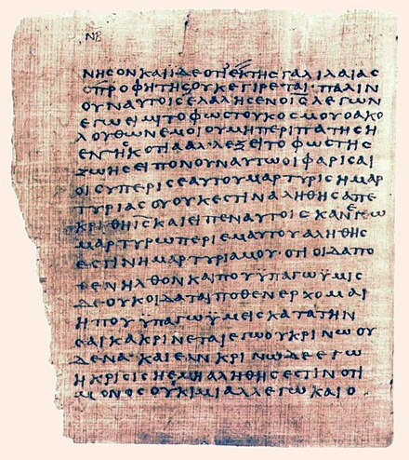
"³ And the scribes and Pharisees brought unto him a woman taken in adultery; and when they had set her in the midst, ⁴ They say unto him, Master, this woman was taken in adultery, in the very act. ⁵ Now Moses in the law commanded us, that such should be stoned: but what sayest thou? ⁶ This they said, tempting him, that they might have to accuse him. But Jesus stooped down, and with his finger wrote on the ground, as though he heard them not. ⁷ So when they continued asking him, he lifted up himself, and said unto them, He that is without sin among you, let him first cast a stone at her. ⁸ And again he stooped down, and wrote on the ground. ⁹ And they which heard it, being convicted by their own conscience, went out one by one, beginning at the eldest, even unto the last: and Jesus was left alone, and the woman standing in the midst. ¹⁰ When Jesus had lifted up himself, and saw none but the woman, he said unto her, Woman, where are those thine accusers? hath no man condemned thee? ¹¹ She said, No man, Lord. And Jesus said unto her, Neither do I condemn thee: go, and sin no more." (John 8:3-11)
Chapter Fourteen

The Gospel of Jesus Christ

The Muslims Gospel (Al-Injeel):
Muslims believe that God Almighty has sent a Gospel with His prophet Jesus Christ, peace be upon him, to guide the children of Israel to the straight path of God after they went astray and departed from the teachings of Moses, peace be upon him, and the teachings of the prophets whom God sent after Moses, peace be upon him.
God Almighty says in the Noble Qur’an in Surat Al-Mâ’idah (No. 5) verse 46: {And in their footsteps, We sent 'Iesa (Jesus), son of Maryam (Mary), confirming the Taurat (Torah) that had come before him, and We gave him the Injeel (Gospel), in which was guidance and light and confirmation of the Taurat (Torah) that had come before it, a guidance and an admonition for the pious.}
Muslims believe that every Muslim must believe in the Gospel that was revealed to the Prophet Jesus Christ, peace be upon him. The point of disagreement between Muslims and Christians over the Gospel is; whereas Christians call on Muslims to believe in the four Gospels, Muslims answer them that "How do you want us to believe in anonymous Gospels that are according to the account of anonymous people, whereas you do not want to believe in the Gospel according to the narration of Jesus, peace be upon him, which God Almighty revealed to him?"

Where is the Gospel of Christ now?
As for the Gospel which God inspired to His Prophet Jesus, peace be upon him, there is no definitive evidence of how it disappeared. Was it a written Gospel, therefore, it was whether lost from the hands of the Christians or burnt by the Jews? Or was it an oral Gospel that Jesus, peace be upon him, taught people verbally, therefore, after God saved Christ from the hands of the Jews and raised him to Heaven, -without being crucified or dying-, it disappeared because it was an oral Gospel?
However, the good news is that many of the teachings of Christ, peace be upon him, are now between our hands, and we can read them. God Almighty revealed in the Noble Qur’an the truth about Jesus, peace be upon him, about his message, about his sayings to the people, and about his miracles. Moreover, God Almighty revealed the truth about Mary, the mother of Jesus, peace be upon him.
God Almighty said in the Noble Qur’an in Surat Al-Mâ’ida (No. 5) verse 75: {The Messiah (Jesus), son of Maryam (Mary), was no more than a Messenger; many were the Messengers that passed away before him. His mother (Mary) was a believing woman. They both used to eat food (as any other human being, while Allah does not eat). Look how We make the Ayat (proofs, verses, lessons, signs, revelations, etc.) clear to them, yet look how they are deluded away (from the truth).}
God Almighty said in the Noble Qur’an in Surat Al-Mâ’ida (No. 5) verse 116: {And (remember) when Allah will say (on the Day of Resurrection): "O 'Iesa (Jesus), son of Maryam (Mary). Did you say unto men: 'Worship me and my mother as two gods besides Allah?' " He will say: "Glory be to You. It was not for me to say what I had no right (to say). Had I said such a thing, You would surely have known it. You know what is in my inner-self though I do not know what is in Yours, truly, You, only You, are the All-Knower of all that is hidden and unseen.}

The Four Gospels recognize the existence of the Gospel of Christ:
The Gospel of Christ was clearly mentioned in the four Gospels. Whereas many priests admit that there was a Gospel with Christ -without knowing how it was lost or disappeared-, other priests deny this, saying: "There was no Gospel with Christ, and the phrase "the Gospel of Christ" which mentioned in the four Gospels does not mean that he was carrying a book in his hands called "the Gospel," but he was carrying ‘good news’ for the people, for the word "Gospel (evangel)" is a translation of the Greek word (εὐαγγέλιον) that means ‘good news.’
However, what was mentioned by those priests who deny the existence of the Gospel of Christ, is incorrect according to the Greek language. Because the Greek word (εὐαγγέλιον) means "the good news" but in its literal sense, however, its real meaning is only "the Gospel" and was never used in the sense of "good news."
For example, if a Greek father said to his son, bring me the (Ευαγγέλιο), he would bring him the Bible, and he would never understand that his father asked him to bring him ‘good news’. Also, if a Greek person wants to say that he has good news, he would never use the word (Ευαγγέλιο); instead, he would use other two words, namely, "Kala Nea" (in Greek Καλά Νέα).
Now, let us see how the four Gospels have mentioned the existence of a Gospel with Christ, and to see whether the word Gospel here in the following phrases means ‘the Gospel’ that was revealed to Christ or means ‘good news’:
1- "⁶ I marvel that ye are so soon removed from him that called you into the grace of Christ unto another gospel: ⁷ Which is not another; but there be some that trouble you, and would pervert the Gospel of Christ. ⁸ But though we, or an angel from heaven, preach any other gospel unto you than that which we have preached unto you, let him be accursed. ⁹ As we said before, so say I now again, if any man preach any other gospel unto you than that ye have received, let him be accursed." (Galatians 1:6-9)
When Paul said here, "I marvel that ye are so soon removed from him that called you into the grace of Christ unto another gospel,” did he mean that they deserted the good news from Christ and went to another good news, or that they moved from the Gospel of Christ to another Gospel? Because if they moved from good news to another good news, then what is wrong with that? Both are good news. Moreover, if he meant by the Greek word (εὐαγγέλιον) ‘good news,’ then he should say that they moved from the good news from Christ to bad news. Because if they moved from the good news of Christ, sure they went to bad news, not good news.
Moreover, when he said, "there be some that trouble you, and would pervert the Gospel of Christ," does the word "Gospel" here mean ‘good news’?
Although most of Bible versions in the most languages of the world translated the Greek word (εὐαγγέλιον) with ‘Gospel,’ some versions in order to hide that there was a Gospel with Christ, they translated the Greek word with ‘good news.’ When reading those versions (some are in the English language), you would feel that the translation is unreasonable and ridiculous.
2- "¹⁰ And the Gospel must first be published among all nations." (Mark 13:10)
As we see here that Christ, commanded his disciples to preach his Gospel among the twelve tribes of children of Israel.
What is meant by ‘all nations’ here is ‘the twelve tribes of Israel,’ and not all the nations of the world. Some translations have manipulated the translation of the word 'all nations' to deceive the reader that the message of Christ is universal and that he was not only sent to the lost sheep of the Children of Israel (as mentioned in Matthew 15:24).
Certainly, Christ did not command them at that time to preach the Gospel according to the account of Matthew, Mark, Luke, or John, but he was instructing them to preach the original Gospel that God inspired him, among the twelve tribes of children of Israel.
3- "¹¹ But I certify you, brethren, that the Gospel which was preached of me is not after man. ¹² For I neither received it of man, neither was I taught it, but by the revelation of Jesus Christ." (Galatians 1:11-12)
4- "¹³ In whom ye also trusted, after that ye heard the word of truth, the gospel of your salvation: in whom also after that ye believed, ye were sealed with that holy Spirit of promise," (Ephesians 1:13)
5- "¹⁰ But is now made manifest by the appearing of our Saviour Jesus Christ, who hath abolished death, and hath brought life and immortality to light through the gospel:" (2 Timothy 1:10)
Here, did Christ abolished death and brought life through the good news, or the Gospel?
6- "¹⁷ But the other of love, knowing that I am set for the defence of the gospel." (Philippians 1:17)
7- "¹⁵ And how shall they preach, except they be sent? as it is written, How beautiful are the feet of them that preach the gospel of peace, and bring glad tidings of good things. ¹⁶ But they have not all obeyed the gospel. For Esaias saith, Lord, who hath believed our report? ¹⁷ So then faith cometh by hearing, and hearing by the word of God." (Romans 10:15-17)
As we see here, he said, "preach the gospel of peace, and bring glad tidings," so, they are two different things, therefore, ‘gospel’ does not mean ‘glad tidings’ or ‘good news’ as some may claim.
The translation above is from King James Version, and if you compare it with some other translations, you will find that they omit the word "preach the gospel of peace,” and they replaced the word "hearing by the word of God" with "the message comes through preaching Christ" or "hearing by the word of Christ" or "through the word of the Messiah".
8- "³ And I intreat thee also, true yokefellow, help those women which laboured with me in the gospel, with Clement also, and with other my fellowlabourers, whose names are in the Book of life." (Philippians 4:3)
As for “the Book of Life” mentioned above, where is it? Why is it not in the Bible today? How was it disappeared?
9- "⁹ (Jesus said, …) Verily I say unto you, Wheresoever this gospel shall be preached throughout the whole world, this also that she hath done shall be spoken of for a memorial of her." (Mark 14:9)
10- "¹³ Verily I say unto you, Wheresoever this gospel shall be preached in the whole world, there shall also this, that this woman hath done, be told for a memorial of her." (Matthew 26:13)
11- "¹⁵ And saying, The time is fulfilled, and the kingdom of God is at hand: repent ye, and believe the gospel." (Mark 1:15)
12- "³⁵ Whosoever shall lose his life for my sake and the gospel's, the same shall save it." (Mark 8:35)
13- "29 And Jesus answered and said, Verily I say unto you, There is no man that hath left house, or brethren, or sisters, or father, or mother, or wife, or children, or lands, for my sake, and the gospel's, ³⁰ But he shall receive an hundredfold now in this time, houses, and brethren, and sisters, and mothers, and children, and lands, with persecutions; and in the world to come eternal life." (Mark 10:29-30)
14- "1 And it came to pass, that, as the people pressed upon him to hear the word of God" (Luke 5:1)
15- "² And straightway many were gathered together, insomuch that there was no room to receive them, no, not so much as about the door: and he preached the word unto them." (Mark 2:2)
16- "⁴⁹ For I have not spoken of myself; but the Father which sent me, he gave me a commandment, what I should say, and what I should speak. ⁵⁰ And I know that His commandment is life everlasting: whatsoever I speak therefore, even as the Father said unto me, so I speak." (John 12:49-50)
17- "³¹ He that cometh from above is above all: he that is of the earth is earthly, and speaketh of the earth: he that cometh from heaven is above all. ³² And what he hath seen and heard, that he testifieth; and no man receiveth his testimony. ³³ He that hath received his testimony hath set to his seal that God is true. ³⁴ For he whom God hath sent speaketh the words of God." (John 3:31-34)
18- "⁶ I have manifested thy name unto the men which thou gavest me out of the world: thine they were, and thou gavest them me; and they have kept thy word. ⁷ Now they have known that all things whatsoever thou hast given me are of thee. ⁸ For I have given unto them the words which thou gavest me; and they have received them, and have known surely that I came out from thee, and they have believed that thou didst send me. … ¹⁴ I have given them thy word." (John 17:6-8,14)
19- "²¹ And he answered and said unto them, My mother and my brethren are these which hear the word of God, and do it." (Luke 8:21)
20- "²² When therefore he was risen from the dead, his disciples remembered that he had said this unto them; and they believed the scripture, and the word which Jesus had said." (John 2:22)
21- "²⁴ He that loveth me not keepeth not my sayings: and the word which ye hear is not mine, but the Father's which sent me." (John 14:24)
22- "⁷ And when there had been much disputing, Peter rose up, and said unto them, Men and brethren, ye know how that a good while ago God made choice among us, that the Gentiles by my mouth should hear the word of the gospel, and believe." (Acts 5:7)
23- "⁵ For the hope which is laid up for you in heaven, whereof ye heard before in the word of the truth of the gospel;" (Colossians 1:5)
24- "²³ If ye continue in the faith grounded and settled, and be not moved away from the hope of the gospel, which ye have heard, and which was preached to every creature which is under heaven; whereof I Paul am made a minister;" (Colossians 1:23)
25- "⁸ So being affectionately desirous of you, we were willing to have imparted unto you, not the gospel of God only, but also our own souls, because ye were dear unto us." (1 Thessalonians 2:8)
26- "² And sent Timotheus, our brother, and minister of God, and our fellowlabourer in the gospel of Christ, to establish you, and to comfort you concerning your faith:" (1 Thessalonians 3:2)
27- "¹⁵ And your feet shod with the preparation of the gospel of peace;" (Ephesians 6:15)
28- "⁷ And to you who are troubled rest with us, when the Lord Jesus shall be revealed from heaven with his mighty angels, ⁸ In flaming fire taking vengeance on them that know not God, and that obey not the gospel of our Lord Jesus Christ:" (2 Thessalonians 1:7-8)
Here, did he mean that they obey not the ‘good news’ of Christ or they obey not the Gospel of Christ? Do the ‘good news’ to be obeyed or to be preached? Sure, he meant the Gospel of Christ that should be obeyed.
29- "¹¹ According to the glorious gospel of the blessed God, which was committed to my trust." (1 Timothy 1:11)
30- "⁴ But as we were allowed of God to be put in trust with the gospel, even so we speak; not as pleasing men, but God, which trieth our hearts." (1 Thessalonians 2:4)
31- "⁸ Be not thou therefore ashamed of the testimony of our Lord, nor of me his prisoner: but be thou partaker of the afflictions of the gospel according to the power of God;" (2 Timothy 1:8)
32- "¹² … but suffer all things, lest we should hinder the gospel of Christ. … ¹⁴ Even so hath the Lord ordained that they which preach the gospel should live of the gospel. … ¹⁸ What is my reward then? Verily that, when I preach the gospel, I may make the gospel of Christ without charge, that I abuse not my power in the gospel. … ²³ And this I do for the gospel's sake, that I might be partaker thereof with you." (1 Corinthians 9:12,14,18,23)
33- "² And I went up by revelation, and communicated unto them that gospel which I preach among the Gentiles, but privately to them which were of reputation, lest by any means I should run, or had run, in vain." (Galatians 2:2)
34- "⁵ To whom we gave place by subjection, no, not for an hour; that the truth of the gospel might continue with you." (Galatians 2:5)
35- "¹⁴ But when I saw that they walked not uprightly according to the truth of the gospel, I said unto Peter before them all, If thou, being a Jew, livest after the manner of Gentiles, and not as do the Jews, why compellest thou the Gentiles to live as do the Jews?" (Galatians 2:14)
Did he mean here that “they walked not uprightly according to the truth of the Gospel” or the ‘good news’?
36- "¹⁹ And for me, that utterance may be given unto me, that I may open my mouth boldly, to make known the mystery of the gospel," (Ephesians 6:19)
Does it fit here to say, the mystery of the ‘good news’ or the mystery of the Gospel?
37- "⁷ Even as it is meet for me to think this of you all, because I have you in my heart; inasmuch as both in my bonds, and in the defense and confirmation of the gospel, ye all are partakers of my grace." (Philippians 1:7)
38- "¹² But I would ye should understand, brethren, that the things which happened unto me have fallen out rather unto the furtherance of the gospel;" (Philippians 1:12)
39- "²⁷ Only let your conversation be as it becometh the gospel of Christ: that whether I come and see you, or else be absent, I may hear of your affairs, that ye stand fast in one spirit, with one mind striving together for the faith of the gospel;" (Philippians 1:27)
40- "²² But ye know the proof of him, that, as a son with the father, he hath served with me in the gospel." (Philippians 2:22)
41- "¹ Paul, a servant of Jesus Christ, called to be an apostle, separated unto the gospel of God," (Romans 1:1)
42- "⁹ For God is my witness, whom I serve with my spirit in the gospel of his Son, that without ceasing I make mention of you always in my prayers;" (Romans 1:9)
43- "²⁹ And I am sure that, when I come unto you, I shall come in the fulness of the blessing of the gospel of Christ." (Romans 15:29)
44- "¹² Furthermore, when I came to Troas to preach Christ's gospel, and a door was opened unto me of the Lord," (2 Corinthians 2:12)
45- "¹⁴ For we stretch not ourselves beyond our measure, as though we reached not unto you: for we are come as far as to you also in preaching the gospel of Christ:" (2 Corinthians 10:14)
Now, dear reader, after all these testimonies about Christ’s Gospel, what do you think? Had Christ had a Gospel, or he was talking about the Gospel according to the account of Matthew, Mark, Luke, or John, which was not yet written?
Do you, dear reader, want to believe in and follow the Gospel of Christ, or do you want to follow any of the other anonymous Gospels? If you want to follow the Gospel of Christ, peace be upon him, then you must believe in the Noble Qur’an to know through it the truth about Christ, his call, what he said to people, and what his miracles were. You should start by reading Surat Aal-Imran (No.3), then Surat Maryam (No. 19), then Surat Al-Maidah (No. 5), and may God open your heart and guide you, so that you would read the entire Noble Qur’an, the book of God Almighty, which was revealed after the Torah and the Injeel (Bible).

Chapter Fifteen

Who wrote the Old Testament?

Pentateuch, the five books attributed to Moses:
The church claims that the first five books of the Old Testament (Genesis, Exodus, Leviticus, Numbers, Deuteronomy) were written by the Prophet of God, Moses. However, this claim is incorrect, because it is mentioned in those five books what belies such a claim. Examples of this:
1- "⁵ So Moses the servant of the Lord died there in the land of Moab, according to the word of the Lord. ⁶ And he buried him in a valley in the land of Moab, over against Bethpeor: but no man knoweth of his sepulchre unto this day. ⁷ And Moses was an hundred and twenty years old when he died: his eye was not dim, nor his natural force abated. ⁸ And the children of Israel wept for Moses in the plains of Moab thirty days: so the days of weeping and mourning for Moses were ended. … ¹⁰ And there arose not a prophet since in Israel like unto Moses, whom the Lord knew face to face." (Deuteronomy 34:5-8,10)
How could Moses be the one who wrote the Book of Deuteronomy, if the Book of Deuteronomy talks about the death of Moses and the place of his burial? It mentioned his death even in a way that indicates that there was a long time between the death of Moses and the time of writing the Book of Deuteronomy.
The phrases "Moses died there," "no man knoweth of his sepulchre unto this day,” "Moses was an hundred and twenty years old when he died," and "And there arose not a prophet since in Israel like unto Moses," are indicating that the writer speaks about an event that occurred long time ago.
2- "¹ These be the words which Moses spake unto all Israel on this side Jordan in the wilderness, ... ³ (..) Moses spake unto the children of Israel, according unto all that the Lord had given him in commandment unto them; ... ⁵ On this side Jordan, in the land of Moab, began Moses to declare this law," (Deuteronomy 1:1,3,5)
3- "¹ And Miriam and Aaron spake against Moses because of the Ethiopian woman whom he had married: for he had married an Ethiopian woman. ² And they said, Hath the Lord indeed spoken only by Moses? hath he not spoken also by us? And the Lord heard it. ³ (Now the man Moses was very meek, above all the men which were upon the face of the earth.) ⁴ And the Lord spake suddenly unto Moses, and unto Aaron, and unto Miriam, Come out ye three unto the tabernacle of the congregation. And they three came out. ⁵ And the Lord came down in the pillar of the cloud, and stood in the door of the tabernacle, and called Aaron and Miriam: and they both came forth. ⁶ And he said, Hear now my words: If there be a prophet among you, I the Lord will make myself known unto him in a vision, and will speak unto him in a dream. ⁷ My servant Moses is not so, who is faithful in all mine house. ⁸ With him will I speak mouth to mouth, even apparently, and not in dark speeches; and the similitude of the Lord shall he behold: wherefore then were ye not afraid to speak against my servant Moses? ⁹ And the anger of the Lord was kindled against them; and he departed. ¹⁰ And the cloud departed from off the tabernacle; and, behold, Miriam became leprous, white as snow: and Aaron looked upon Miriam, and, behold, she was leprous." (Numbers 12:1-10)
The writer talked about Moses in the form of the absent, and accordingly, the writer cannot be Moses. Therefore, how did the Church attribute these five books to Moses without providing any evidence on this? How could the Church say that those unknown books are a divine revelation and sacred books?

The rest of the books of the Old Testament:
The same is the case with all the books of the Old Testament without exception. All of them are books of unknown origin that no one knows who wrote them, where they came from, or the date or place of their writing.
Dear reader, try today to choose any of the books of the Old Testament and search for the name of its writer. You will always find that he is unknown. How could Christians, without any evidence, attribute these books to God Almighty? One of the most severe sins is to attribute words to God Almighty without any evidence. If someone attributed to you words that you did not say or a book that you did not write, you would be very mad on him, and you would say that he is a liar.

Chapter Sixteen

Loss of the Torah (Old Testament)

Muslims Torah:
Muslims believe that God Almighty has sent a book called the ‘Torah’ to His Prophet Moses, peace be upon him, to guide the Children of Israel to the straight path of God and the commandments of His righteous religion. Muslims believe that every Muslim must believe in that Torah, which was revealed to the Prophet of God, Moses, peace be upon him.
Muslims also believe that that Torah was lost and disappeared after the Children of Israel changed it and distorted it over time according to their interests and personal whims. The point of disagreement between Muslims and Christians about the Torah is, whereas Christians call on Muslims to believe in the Bible including the Torah (Old Testament), Muslims respond to them that how do you want us to believe in a distorted Torah that you have it from anonymous source, while you do not want to believe in the Torah of Moses, peace be upon him and its teachings and commandments?
God Almighty says in Surat Al-Isra’ (17:2): {And We gave Musa (Moses) the Scripture (Torah) and made it a guidance for the Children of Israel (saying): "Take not other than Me as (your) Lord and Disposer of your affairs.}
God Almighty says in Surat Al-Baqara (2:53): {And (remember) when We gave Musa (Moses) the Scripture (Torah) and the criterion (of right and wrong) so that you may be guided aright.}
God Almighty says in Surat Al-Maidah (5:44): {Verily, We did send down the Taurat (Torah) (to Moses), therein was guidance and light, by which the Prophets, who submitted themselves to Allah's Will, judged the Jews. And the rabbis and the priests (too judged the Jews by the Torah after those Prophets) for to them was entrusted the protection of Allah's Book, and they were witnesses thereto. Therefore fear not men but fear Me (O Jews) and sell not My Verses for a miserable price. And whosoever does not judge by what Allah has revealed; such are the disbelievers.}
God Almighty says in Surat Al-Baqara (2:75): {Do you (faithful believers) covet that they will believe in your religion in spite of the fact that a party of them (Jewish rabbis) used to hear the Word of Allah (the Torah), then they used to change it knowingly after they understood it?}
God Almighty says in Surat An-Nisa’ (4:46): {Among those who are Jews, there are some who displace words from (their) right places and say: "We hear your word (O Muhammad) and disobey," and "Hear and let you (O Muhammad) hear nothing." And Ra'ina with a twist of their tongues and as a mockery of the religion (Islam). And if only they had said: "We hear and obey,” and "Do make us understand," it would have been better for them, and more proper, but Allah has cursed them for their disbelief, so they believe not except a few.}
God Almighty says in Surat Aal-Imran (3:77): {Verily, those who purchase a small gain at the cost of Allah's Covenant and their oaths, they shall have no portion in the Hereafter (Paradise). Neither will Allah speak to them, nor look at them on the Day of Resurrection, nor will He purify them, and they shall have a painful torment.}

The importance of the Torah in Christianity and Judaism:
Christians call the Torah also "the book of the law of the Lord" or "the book of the law" or "the book of the covenant.” Average Christians believe that the Torah since the time of Moses, peace be upon him, has not been altered, distorted, or lost at any time. The Torah is of great importance to both Christians and Jews because they believe that it is the Holy Book written by Moses.
"⁹ And they taught in Judah, and had the book of the law of the Lord with them, and went about throughout all the cities of Judah, and taught the people." (2 Chronicles 17:9)
"⁷ And he (Moses) took the book of the covenant, and read in the audience of the people: and they said, All that the Lord hath said will we do, and be obedient." (Exodus 24:7)

The Old Testament confesses the loss and disappearance of the Torah:
Despite the extreme importance of the Torah, the Bible has exposed a painful fact, namely the loss of the Torah.
"¹⁴ And when they brought out the money that was brought into the house of the Lord, Hilkiah the priest found a book of the law of the Lord given by Moses. ¹⁵ And Hilkiah answered and said to Shaphan the scribe, I have found the book of the law in the house of the Lord. And Hilkiah delivered the book to Shaphan. ¹⁶ And Shaphan carried the book to the king, and brought the king word back again, saying, All that was committed to thy servants, they do it. ¹⁷ And they have gathered together the money that was found in the house of the Lord, and have delivered it into the hand of the overseers, and to the hand of the workmen. ¹⁸ Then Shaphan the scribe told the king, saying, Hilkiah the priest hath given me a book. And Shaphan read it before the king. ¹⁹ And it came to pass, when the king had heard the words of the law, that he rent his clothes. ²⁰ And the king commanded Hilkiah, and Ahikam the son of Shaphan, and Abdon the son of Micah, and Shaphan the scribe, and Asaiah a servant of the king's, saying, ²¹ Go, enquire of the Lord for me, and for them that are left in Israel and in Judah, concerning the words of the book that is found: for great is the wrath of the Lord that is poured out upon us, because our fathers have not kept the word of the Lord, to do after all that is written in this book." (2 Chronicles 34:14-21)
As we see here, this is an explicit and clear confession that the Torah, the book of the law of the Lord, or the five books of Moses, was missing and for a long time, that maybe for hundreds of years. The king was significantly rejoiced for finding the Torah; he tore his garments out of the fear of God's wrath because their fathers did not keep the word of the Lord and did not act according to what is written in the Torah.
"⁸ And Hilkiah the high priest said unto Shaphan the scribe, I have found the book of the law in the house of the Lord. And Hilkiah gave the book to Shaphan, and he read it. ⁹ And Shaphan the scribe came to the king, and brought the king word again, and said, Thy servants have gathered the money that was found in the house, and have delivered it into the hand of them that do the work, that have the oversight of the house of the Lord. ¹⁰ And Shaphan the scribe shewed the king, saying, Hilkiah the priest hath delivered me a book. And Shaphan read it before the king. ¹¹ And it came to pass, when the king had heard the words of the book of the law, that he rent his clothes. ¹² And the king commanded Hilkiah the priest, and Ahikam the son of Shaphan, and Achbor the son of Michaiah, and Shaphan the scribe, and Asahiah a servant of the king's, saying, ¹³ Go ye, enquire of the Lord for me, and for the people, and for all Judah, concerning the words of this book that is found: for great is the wrath of the Lord that is kindled against us, because our fathers have not hearkened unto the words of this book, to do according unto all that which is written concerning us. ¹⁴ So Hilkiah the priest, and Ahikam, and Achbor, and Shaphan, and Asahiah, went unto Huldah the prophetess, the wife of Shallum the son of Tikvah, the son of Harhas, keeper of the wardrobe; (now she dwelt in Jerusalem in the college;) and they communed with her. ¹⁵ And she said unto them, Thus saith the Lord God of Israel, Tell the man that sent you to me, ¹⁶ Thus saith the Lord, Behold, I will bring evil upon this place, and upon the inhabitants thereof, even all the words of the book which the king of Judah hath read: ¹⁷ Because they have forsaken me, and have burned incense unto other gods, that they might provoke me to anger with all the works of their hands; therefore my wrath shall be kindled against this place, and shall not be quenched. ¹⁸ But to the king of Judah which sent you to enquire of the Lord, thus shall ye say to him, Thus saith the Lord God of Israel, As touching the words which thou hast heard; ¹⁹ Because thine heart was tender, and thou hast humbled thyself before the Lord, when thou heardest what I spake against this place, and against the inhabitants thereof, that they should become a desolation and a curse, and hast rent thy clothes, and wept before me; I also have heard thee, saith the Lord. ²⁰ Behold therefore, I will gather thee unto thy fathers, and thou shalt be gathered into thy grave in peace; and thine eyes shall not see all the evil which I will bring upon this place. And they brought the king word again." (2 Kings 22:8-20)

Pastor Anthony Fikry says in his interpretation of the book of Kings:
"The Book of the Law is the five books of Moses. There were very few copies of the law. At the time of the evil kings, they neglected it, and no one asked about it. Before they discovered the Book of the Law, they were following the instructions of the rabbis."

Hilkiah the high priest:
As for Hilkiah, the high priest, it is unreasonable that he found the Torah of Moses after it had been lost for hundreds of years, but he likely invented this Torah and hid it; then he claimed that he found it so that he can bring the people back to the teachings of the religion of their fathers after people had turned towards worshipping other gods.
As for the content of that Torah written by Hilkiah, it is a little of the truth which was passed down to the generations orally, mixed with a lot of falsehood, lies, and fictitious stories.
For this reason, many of the events that occurred during the time of the Prophet Moses and written within the Torah that written by Hilkiah, we find that they are mentioned in the Noble Qur’an, but with a significant difference in detail. God Almighty revealed the truth in His book the Noble Qur’an to clarify the extent of misguidance found in the so-called Old Testament, so we know the truth and distinguish it from falsehood and follow the truth and the path of guidance.

The King's admission of their parents' reckless disregard of the Torah:
The phrase, which the king said, "for great is the wrath of the Lord that is kindled against us, because our fathers have not hearkened unto the words of this book, to do according unto all that which is written concerning us" indicates the extent of their parents' recklessness and their deliberate failure to keep the word of the Lord. Also, it indicates the concealment and destruction of the holy books that did not conform to their interests and whims.

Where is the Torah of Moses now:
Many of the original teachings of the Torah are now between our hands, and we can read them. God, the Almighty, mentioned in the Noble Qur’an the truth about Moses, peace be upon him, his message, what he said to the people and commanded them, and about his miracles. Dear reader, you may start reading Surat Al-Baqara, and may God open for you the path of guidance, so that you would read the entire book of God, the Exalted, the Noble Qur’an.

Chapter seventeen

Loss of a large number of the Bible's Books
The Bible itself testifies that many of its books were lost; nevertheless, the Church still gives the character of sacredness to the Bible, claiming that it is the inspired word of God. If the Bible is incomplete, wouldn't God resend us those missing books, so that the Holy Scripture in our hands to be complete? Or send another complete book without any missing books?
1- Paul’s Epistle to Laodicea: "¹⁵ Salute the brethren which are in Laodicea, and Nymphas, and the church which is in his house. ¹⁶ And when this epistle is read among you, cause that it be read also in the church of the Laodiceans; and that ye likewise read the epistle from Laodicea." (Colossians 4:15-16)
2- The Book of Life: "³ And I intreat thee also, true yokefellow, help those women which laboured with me in the gospel, with Clement also, and with other my fellowlabourers, whose names are in the Book of life." (Philippians 4:3)
3- The Book of the wars of the Lord: "¹⁴ Wherefore it is said in the book of the wars of the Lord, What he did in the Red sea, and in the brooks of Arnon," (Numbers 21:14)
4- The book of Jasher: "¹³ And the sun stood still, and the moon stayed, until the people had avenged themselves upon their enemies. Is not this written in the book of Jasher? So the sun stood still in the midst of heaven, and hasted not to go down about a whole day." (Joshua 10:13)
"¹⁷ And David lamented with this lamentation over Saul and over Jonathan his son: ¹⁸ Also he bade them teach the children of Judah the use of the bow: behold, it is written in the book of Jasher. ¹⁹ The beauty of Israel is slain upon thy high places: how are the mighty fallen." (2 Samuel 1:17-19)
5- The book of Nathan the prophet,
6- The prophecy of Ahijah the Shilonite,
7- The visions of Iddo the seer: "²⁹ Now the rest of the acts of Solomon, first and last, are they not written in the book of Nathan the prophet, and in the prophecy of Ahijah the Shilonite, and in the visions of Iddo the seer against Jeroboam the son of Nebat?" (2 Chronicles 9:29)
8- The book of Samuel the seer,
9- The book of Gad the seer: "²⁹ Now the acts of David the king, first and last, behold, they are written in the book of Samuel the seer, and in the book of Nathan the prophet, and in the book of Gad the seer," (1 Chronicles 29:29)
10- The book of Shemaiah the prophet,
11- The book of Iddo the seer concerning genealogies: "¹⁵ Now the acts of Rehoboam, first and last, are they not written in the book of Shemaiah the prophet, and of Iddo the seer concerning genealogies?" (2 Chronicles 12:15)
12- The story of the prophet Iddo: "²² And the rest of the acts of Abijah, and his ways, and his sayings, are written in the story of the prophet Iddo." (2 Chronicles 13:22)
13- The book of the acts of Solomon: "⁴¹ And the rest of the acts of Solomon, and all that he did, and his wisdom, are they not written in the book of the acts of Solomon?" (1 Kings 11:41)
14- The sayings of the seers: "¹⁹ His prayer also, and how God was intreated of him, and all his sins, and his trespass, and the places wherein he built high places, and set up groves and graven images, before he was humbled: behold, they are written among the sayings of the seers." (2 Chronicles 33:19)

It is worth mentioning that many priests admit the loss of those books, but they claim that it have been omitted from the Bible because it were Apocryphal books.
If their claim is valid, how then were the names of those books cited in other canonical books and mentioned as also canonical books?
For example, in Paul's Epistle to the Colossians, he instructed them also to read the Epistle that he sent to the Laodiceans. Is it reasonable to say that he instructed them to read an Apocryphal Epistle that he sent?

About the book:
Who wrote the Bible?
This book refutes the Church's claims about the four Gospels and their attribution to the disciples of Jesus, peace be upon him.
This book discusses several points, including:
- A quick tour in the history of the New Testament.
- Were the scribes of the four Gospels, disciples of Jesus Christ?
- The names of the disciples of Christ are mentioned in the four Gospels, but there is neither Luke's name nor Mark’s name among them. Who are they?
- The author of the Gospel of John did not know Salome, the mother of John the son of Zebedee, the disciple of Jesus.
- Confessions of the Gospel of Luke.
- There is no so-called the original Gospel of the Four Gospels.
- Were the four Gospels inspired by the Holy Spirit? The Church’s need to claim that.
- The four Gospels recognized the existence of the Gospel according to the narration of Jesus Christ, peace be upon him (The Muslims Gospel).
- Dozens of anonymous gospels appeared in the second century and were used in the struggle between the beliefs of the early church fathers.
- Irenaeus was the one who named these four Gospels (according to the account of Matthew, Mark, Luke, and John).
- Polycarp and Papias are imaginary figures of the imagination of Irenaeus that did not exist in reality.
- The ten papyri from the second century cannot be evidence.
- Dating the papyri through paleography is a deception.
- The Church admits that there are forged additions in the New Testament.
- The early church fathers were influenced by Greek philosophy, and they merged it into the Christian faith.
- The author of the Gospel of John was quoting from the Greek philosophers and Philo, the Alexandrian Jewish philosopher.
- Who wrote the Old Testament?
- The mystery of Loss of the Torah (Old Testament).
- The Church does not know who wrote the letter to the Hebrews, but it added it to the Bible because it liked it.
- The disappearance and loss of many books of the Bible.

Eusebius of Caesarea, 260-339.
Church History, Chapter VIII, Irenaeus's Remarks on the Divine Books, Eusebius of Caesarea.
Saint Polycarp Bishop of Smyrna, 70-166.
155-240.
Church History of Eusebius, chapter xxxix, the writings of Papias. Aeterna Press.
Church History of Eusebius, chapter xxxix, the writings of Papias. Aeterna Press.
Millennialism, The Millennial Kingdom.
St. Justin Martyr, (Latin: Iustinus Martyr), 100-165.
Origen of Alexandria (c. 184 – c. 253).
Saint Dionysius of Alexandria.
Basil of Caesarea (c. 330 - c. 379).
Gregory of Nyssa (c. 335 – c. 395).
St. Augustine of Hippo (c. 354 – c. 430.
Canonicity describes the standard that books had to meet to be recognized as scripture.
John 21:20 & John 21:24.
Chapter xxiii, Narrative concerning John the Apostle.
Instituts für Neutestamentliche Textforschung (INTF).
https://st-takla.org/Full-Free-Coptic-Books/FreeCopticBooks-002-Holy-Arabic-Bible-Dictionary/07_KH/NT-manuscripts.html
Desiderius Erasmus.
https://www.youtube.com/watch?v=rhM5lbVBgkk
Ellingworth, Paul (1993). The New International Greek Testament Commentary: The Epistle to the Hebrews. Grand Rapids, MI: Wm. B. Eardmans Publishing Co. p. 3.
At that time it was not called the ‘Old Testament’ because the term ‘New Testament’ did not appear yet; for this reason, the Old Testament then was called the ‘Holy Book’ or ‘The Law and the Prophets.’
Not to eat pork or other foods forbidden to the Jews.
The Bible: A Biography, Chapter 3 ‘Gospel,’ pages 55-57, Karen Armstrong.
The Bible: A Biography, Chapter 3 ‘Gospel,’ pages 60-61, Karen Armstrong.
By Jesuit Fathers: Augustin Rodet, Philippe Cuche, Joseph Roze and Joseph van Ham.
http://www.coptology.com/Bible/downloads/Jesuit_Arabic_Bible.pdf
King James Version (KJV).
Coptic researcher and teacher in the Theological faculties and Bible institutes in Egypt.
‘Biblical Criticism, Schools of Criticism and Skepticism and Answering them (New Testament - Part One – Chapter Three)’ Helmy El-Kommos Yaacoub, available in Arabic version only: "النقد الكتابي: مدارس النقد والتشكيك والرد عليها (العهد الجديد – الجزء الأول)"
https://www.britannica.com/topic/biblical-literature/New-Testament-canon-texts-and-versions
Coptic researcher and teacher in the Theological faculties and Bible institutes in Egypt.
‘Biblical Criticism, Schools of Criticism and Skepticism and Answering them (New Testament - Part One – Chapter Three)’ Helmy El-Kommos Yaacoub, available in Arabic version only: "النقد الكتابي: مدارس النقد والتشكيك والرد عليها (العهد الجديد – الجزء الأول)"
“On the Embassy to Gaius,” by Philo of Alexandria, Taylor Anderson.
“Judaism: History, Belief, and Practice,” by Matt Stefon, Hellenistic Judaism page 39.
St. Justin Martyr, (Latin: Iustinus Martyr), 100-165.
I.e., St. Justin Martyr.
Saint Pantaenus the Philosopher.
(c. 184 – c. 253).
Although the word "Trinity" neither mentioned by Jesus nor by any of his disciples, nor mentioned in any Gospel.
https://www.huffpost.com/entry/gospel-of-john-what-everyone-knows-about-the-fourth-gospel_b_3422026?guccounter=1
Melito of Sardis (died c. 180).
Hippolytus of Rome (c. 170 – c. 235).
Ambrose (c. 340 – c. 397).
Nepos ( http://www.biblicalcyclopedia.com/N/nepos.html )
http://www.bc.edu/schools/stm/crossroads/resources/birthofjesus/intro/the_dating_of_thegospels.html
https://www.huffingtonpost.com/john-shelby-spong/gospel-of-john-what-everyone-knows-about-the-fourth-gospel_b_3422026.html
Writer in the Los Angeles Times.
‘The Harlot By The Side Of The Road: Forbidden Tales of the Bible,’ The Translator as Censor, by Jonathan Kirsch.
https://www.biblegateway.com/resources/all-women-bible/Salome-No-2
https://www.biblegateway.com/passage/?search=Song%20of%20Songs+1&version=ISV
https://www.biblegateway.com/passage/?search=Song%20of%20Songs+1&version=KJV
https://www.noblequran.com/translation/
The interpretation of the Old Testament from the Bible, chapter: The interpretation of the book of Kings, by Anthony Fekry.

